SUSAK KEMANE
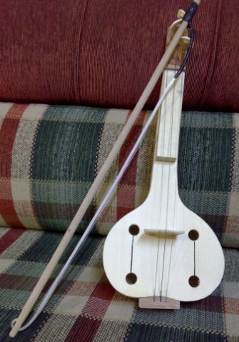
Required Materials
1- Calabash ( Water Pumpkin)
2- Wood Adhesive
3- Spray Varnish
4-Violin and Baglama Strings
5- Slim Wood (30*30 cm)
6-Violin Bridge
8- Walnut Tree
9-Marker Pen

Step 1

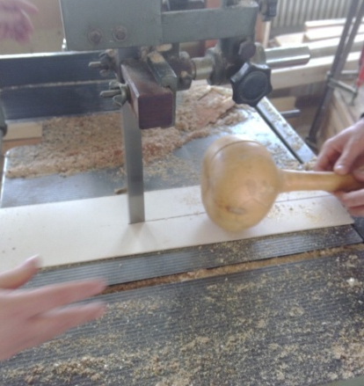
Calabash is cut 2 pieces by fretsaw

Step 2

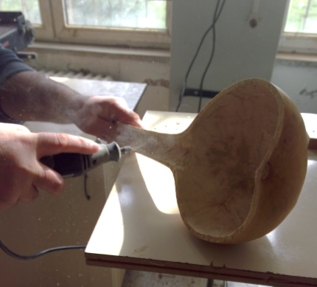
Inside of Calabash is cleaned.

Step 3
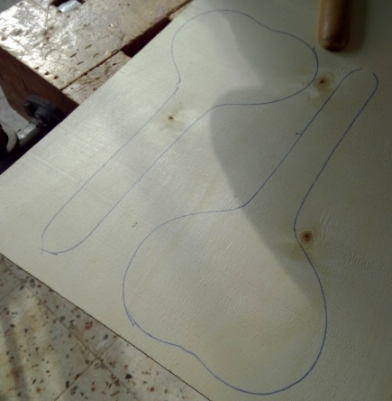
Shape of Pumpkin Violin is drawn by pencil.

Step 4 (Kemane Shape)

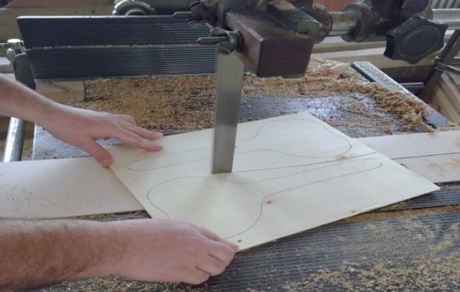
Shape of Pumpkin Violin is cut.

Step 5

The cut shape is sticked with wood adhesive and it is pressed. (Leave to wait for 1 day)

Step 6 (Make Tuning Pegs for Tune)

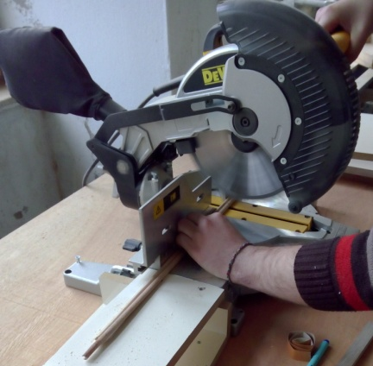
Roller stick is cut each 4 cm, inside of them are carved.

Step 7
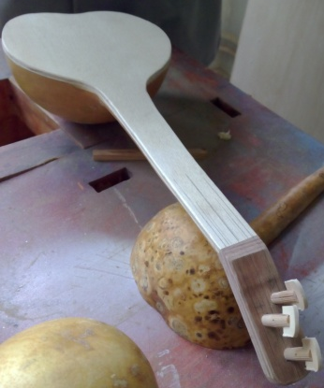
Surface of Pumpkin is varnished by spray varnish. It’s strings and bridge affixed.

