GPE CHALLENGERS- ACTIONBOUND DIRECTIONS
- First, get the ActionBound application free in the Apple AppStore or at the Google Play Store. Scan this QR Code to test it yourself before running it with your students. I’ve added the necessary stuff down below to print out. The students can run the challenge in groups. Don’t forget to take photos or videos while they are running the challenge. If you have any questions or problems, do not hesitate to ask it on Facebook or Messenger group, please. I hope you have fun! ;)
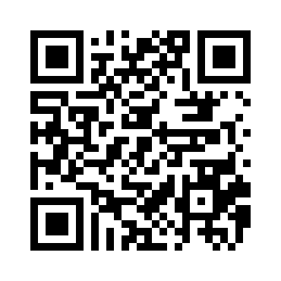

- Print the QR code below and hang the paper in or on the door of a class starting with C (e.g. 7/C, 3/C etc.)
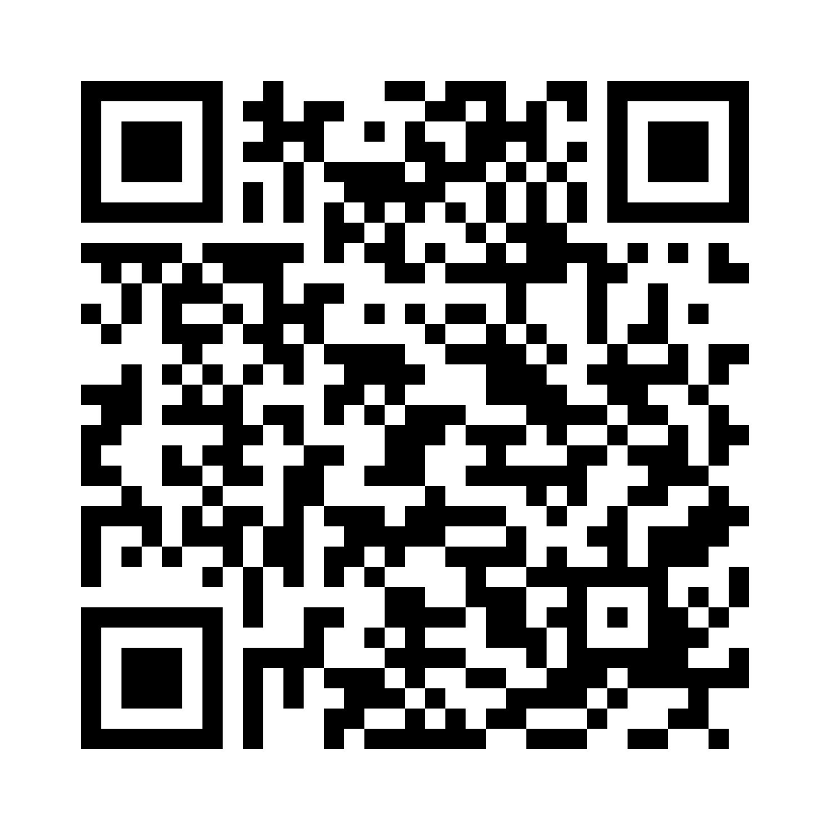
Print this flag of Greece and hide it somewhere in your classroom.

- 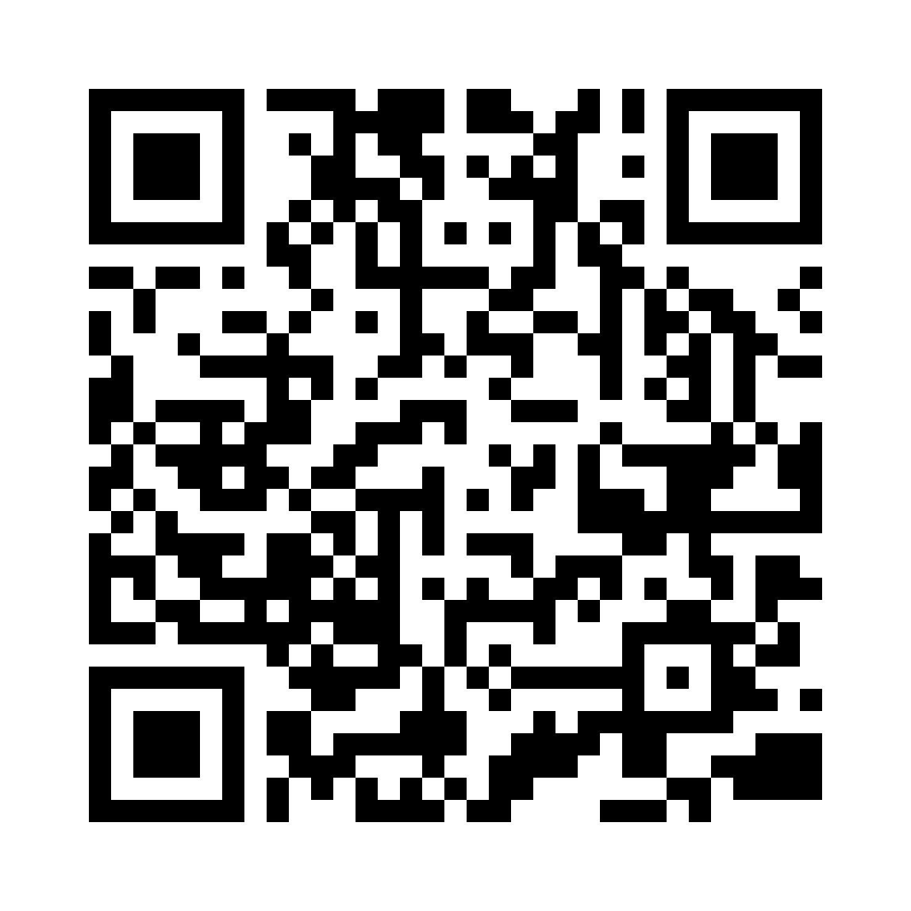
Print this qr code and hang it at the door of Teachers’ Room.

- Print this QR Code and hide or hang it in the Principal’s Room.
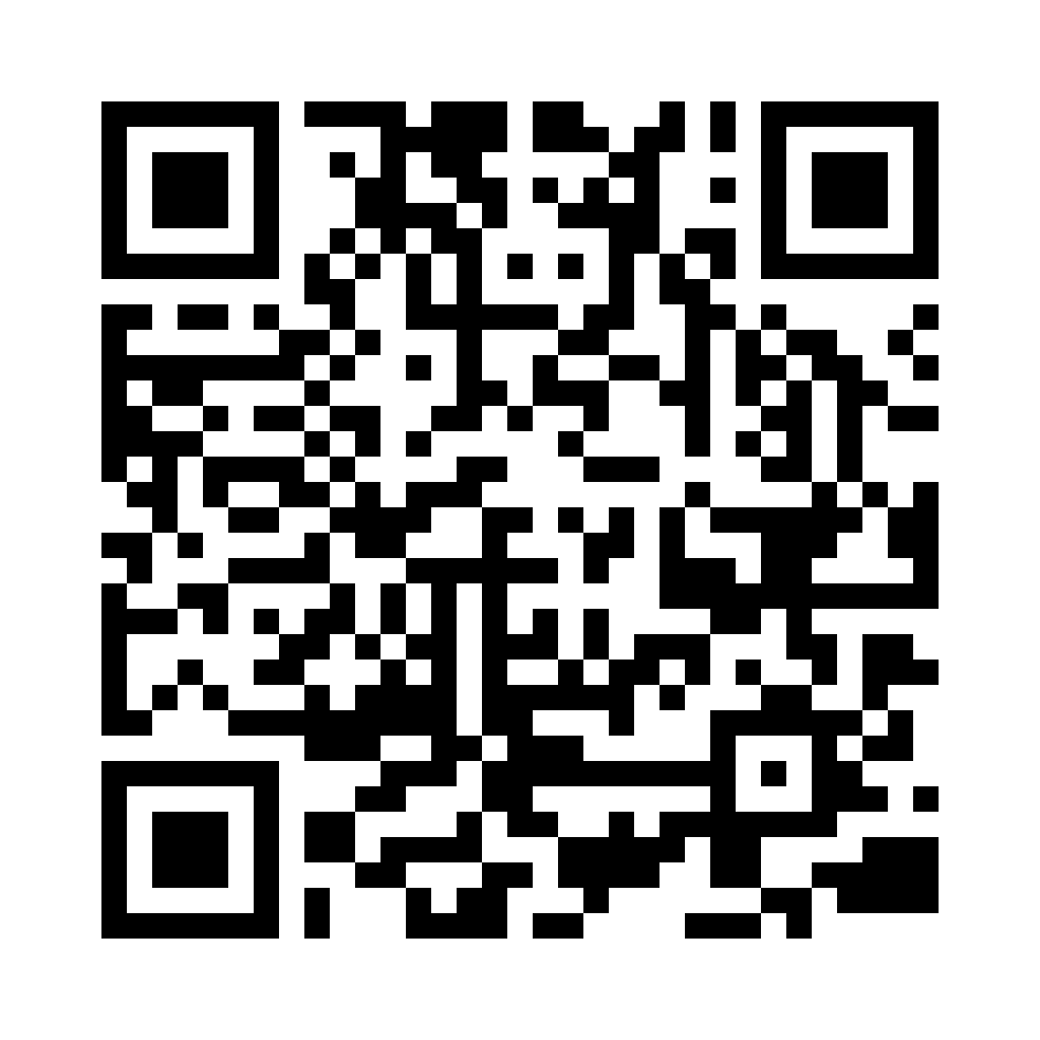

Print the flag and hide it behind your classroom door.

