A Knitting Questionnaire for Kalymnos Answer it!
by Chrysopigi- Irene- Anastasia- AndreasMichael-Alexander-Faneroula

- Anagnostirion “Ae Mousae” is :
  - a museum in Kalymnos?
  - a cultural center ?
  - a beautiful beach? 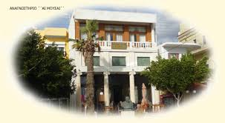
- Here is the photo of saint :
  - Savvas of Kalymnos
  - Panteleimon of Vathys
  - c. Angels of Vathys
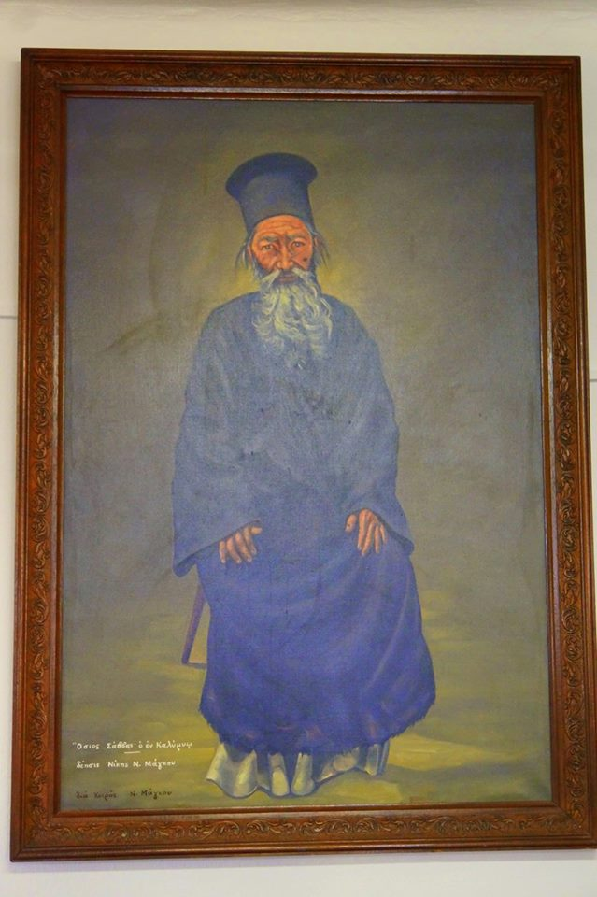

- This is the icon of :
  - Saint Panteleimon of Vathys
  - Saint Savvas of Kalymnos
  - saint John the Vaptist Folk Architecture of Kalymnos.
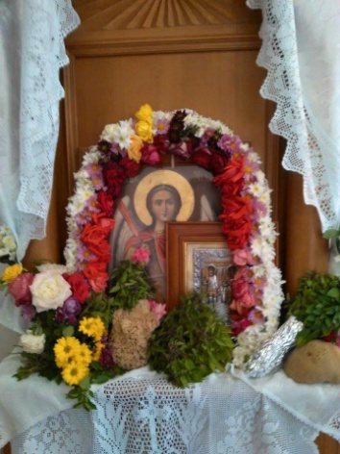
- What of the three pictures shows
Newclassic Kalymnian House ?
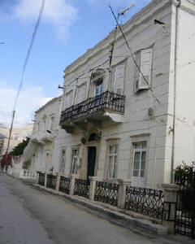
- Which of two pictures shows Kalymnian “krevatos”?
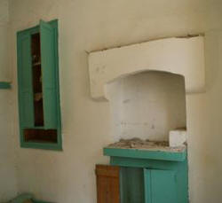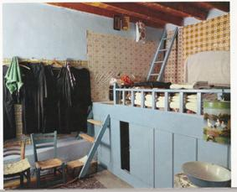
- See the picture and answer : “Klaofores” were Kalymnian women who:
  - They picked up woods for ovens
  - They swewed clothes
  - They made bread
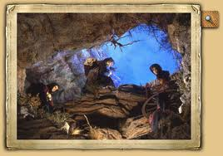

- What is the picture shows a Kalymnian traditional bride?
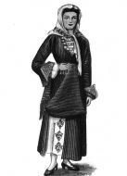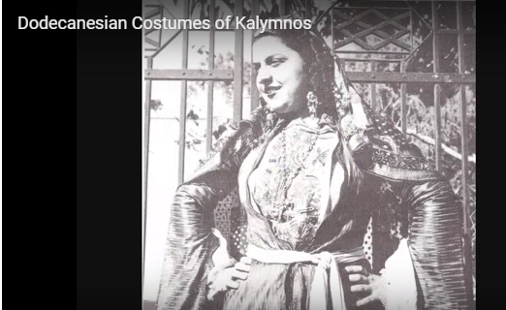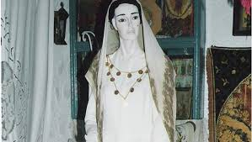
- How can we call this traditional dance of Kalymnos?
  - Syrtos
  - Issios
  - Sousta
  - Engineer’s
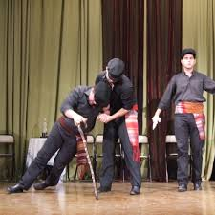
- Which of the pictures shows a cycladic idol found at a cave of Kalymnos?
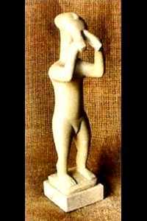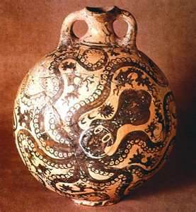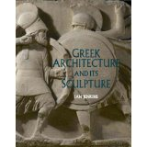
- Fix the names of Kalymnian sports with their pictures
  - climbing 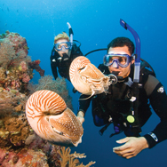
  - diving b. 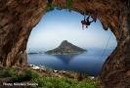
- What pictures show kalymnian traditional food?
a 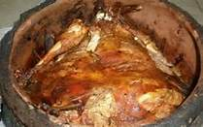b. 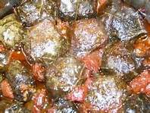 c. 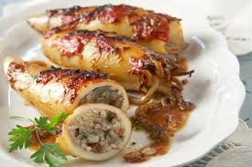kalymnian mouri stuffed vine leaves stuffed squids
d. 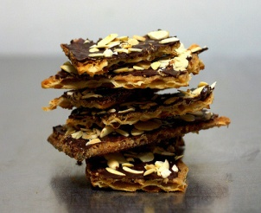e. 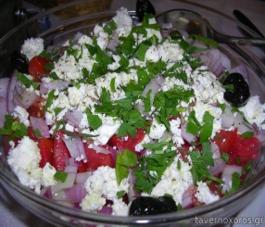 f. 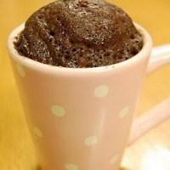caramelised crackersmermizeli salad microwave cake

