eTwinning -Science Project – itec
GUIDE
Step 1 – Preparing to Start …
Please, check the tasks already done by the groups (students)

Check list_1 - BLOGUE OR WEBSITE (Students)
1- Goal: to start a blog/website … from each school/team to include the activities developed in the project
1-Instructions (to create an email account):
- The members of the group create na e-mail for the group (e.g.: group 1_name_School@gmail.com)
- Each member of the group must have the passwords to enter (The account)
- They must give the entry register and passwords to the teachers that are involved in the project
- Each member of the group must enter the site and confirm if they are able to edit it
- The link must be sent to the teachers of the class (to the teachers that are involved in the project)
2- Instructions (to create a blog or a website):
- To create a blogue from the email of the group (https://www.blogger.com) or website (http://www.weebly.com/?lang=pt)
- each member of the group must keep the website/blog address (and the passwords)
- they must give the address of the site and the passwords of the blog or website to the teachers that are involved in the project
3-Instructions (content blog or website):
- To find an original name to the blog/website of the group
e.g. http://etwinning-82-g1.weebly.com/ (science Project - team 1 – class 8º2, School Braga - Portugal)
- To choose the “Templates”, …. to add a picture of the group, …
- To put “marks” in the blog/website (e.g.: presentation, Team, Researches, Math Subjects, …)
- To write titles of the Science Project, the subject that is going to be developed , the school subjects that are involved, …)
- To put links for the blogs/websites of the class, …
- To put links for the sites of interest related to the theme
NOTE: They will have to translate some parts so that the students from other countries can follow the group work and comment the blogs/websites

Check list_2 - Team up (Teachers - Form teams of students)
2- Goal: organizes students into small groups. You can use Team UP - http://teamup.aalto.fi/ to form teams
1- Form small groups of students mixing those who show they know certain concepts well with others who do not.
2-Instructions (to create teams at team up) – For teachers - manual - http://teamup.aalto.fi/TeamUp-Manual.pdf and for a quick tutorial, insert: http://youtu.be/qIqxZJf-6I8
- Navigate to http://teamup.aalto.fi/
• Enter your classroom name and click “Go to classroom” (e.g.: Class_name_School_name )
• If you are new to TeamUp, create a new classroom with a name, your email address and a list of names, e.g. the learners in your class.
• An admin and a non-admin link will be send to your email address for future reference. Please store this message safely.
• Entering the first names of learners in your class during the classroom creation process saves time
later. Separate the names with “,”.
• Clicking “Create classroom” directs you to your classroom.
e.g. Teams of Science project – School of Braga
Class 8º2
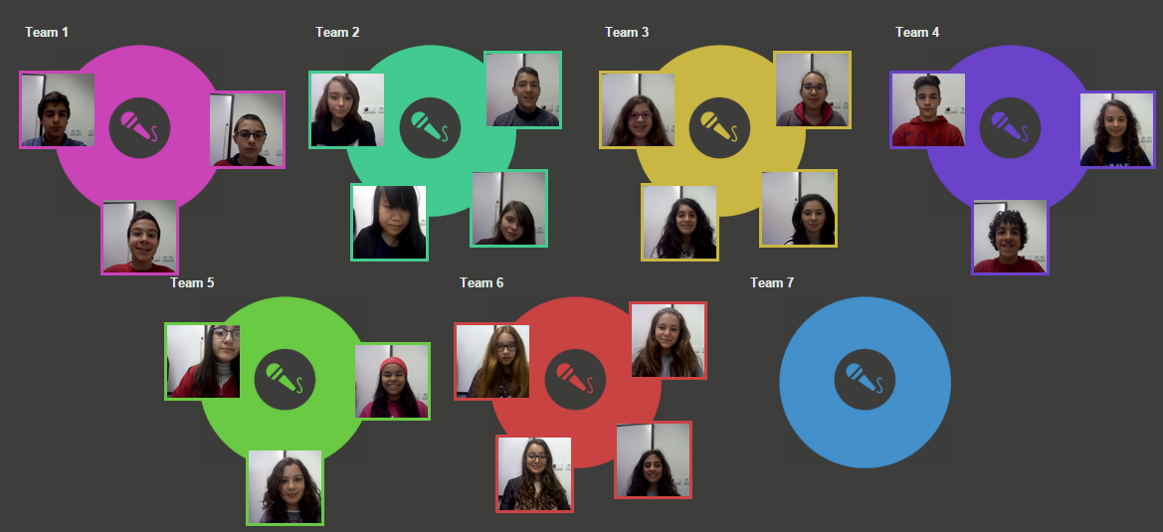
Class 8º5
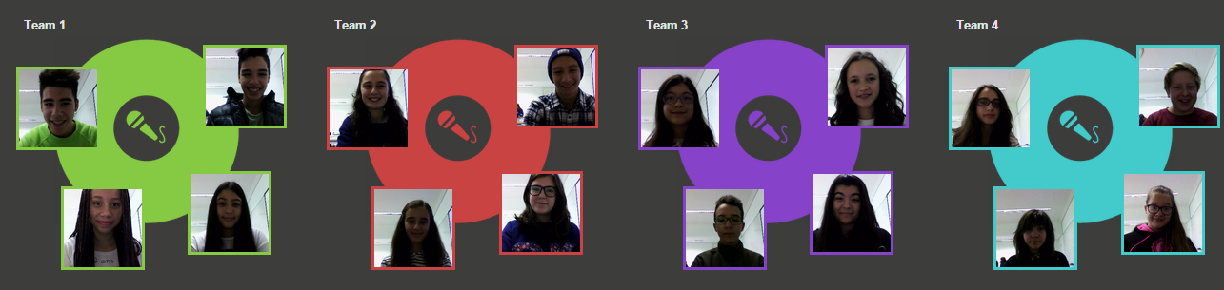
• To add an image to a learner click on the icon and follow the prompted instructions.
• Provide your permission for Flash to use the camera by clicking the green button “allow”.
3-Put the link accessible to the students
• You can give the address of « the Team Up classroom» as a link for the students to enter this classroom
• If you are using Moodle you can put the student’s link accessible to the students at Moodle
•E.g.:
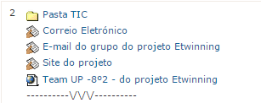

Check list_3 - Glogster Edu (Start an account)
(Please, feel free to choose another multimedia format)
3- Goal: Create an account in Glogster Edu - http://edu.glogster.com/?ref=com
1-Instructions (to create an account): – manual for teachers –http://edu.glogster.com/download/glogster-edu-users-guide.pdf
- Navigate to http://edu.glogster.com/?ref=com
- create an Free account – Educator Free
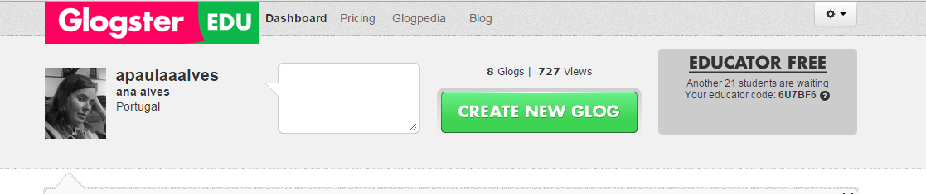
2- Navigate to glogpedia http://edu.glogster.com/glogpedia (You do not need an account to access the glogpedia)
- Select some Glogster related to the Science project. You can show/discuss later with the students
- Remember: The students must build their prototype or final product in audiovisual or multimedia format (Glogster Edu, eBook, Issuu …)
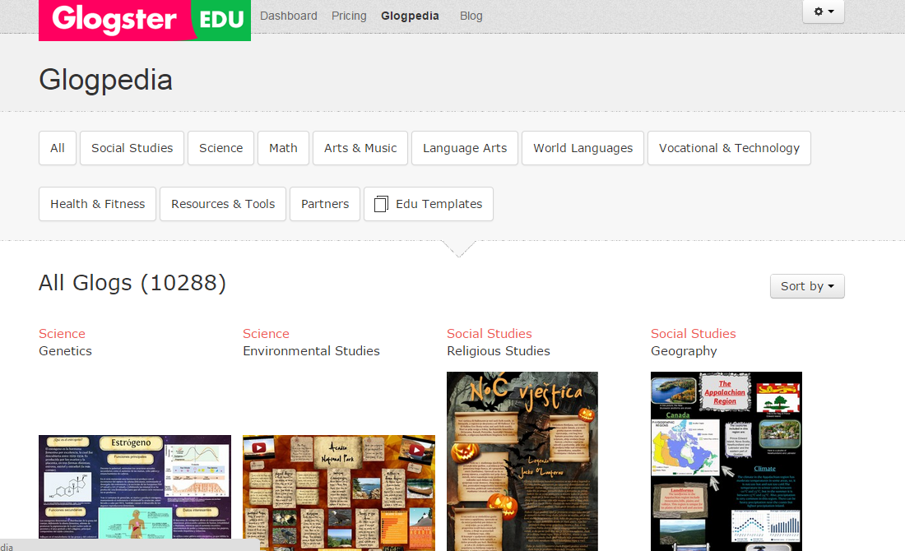
3- Create student’s account (for each team):
- You can create multiple student accounts under your teacher account (your educator code)
Instructions: Give students your educator code and instruct them to register for an account. After they register, they will show up on your Dashboard under your "students" tab.
Students can create accounts in student registration.
January 10, 2015 – Ana Alves, Portugal

