Geography-Italy
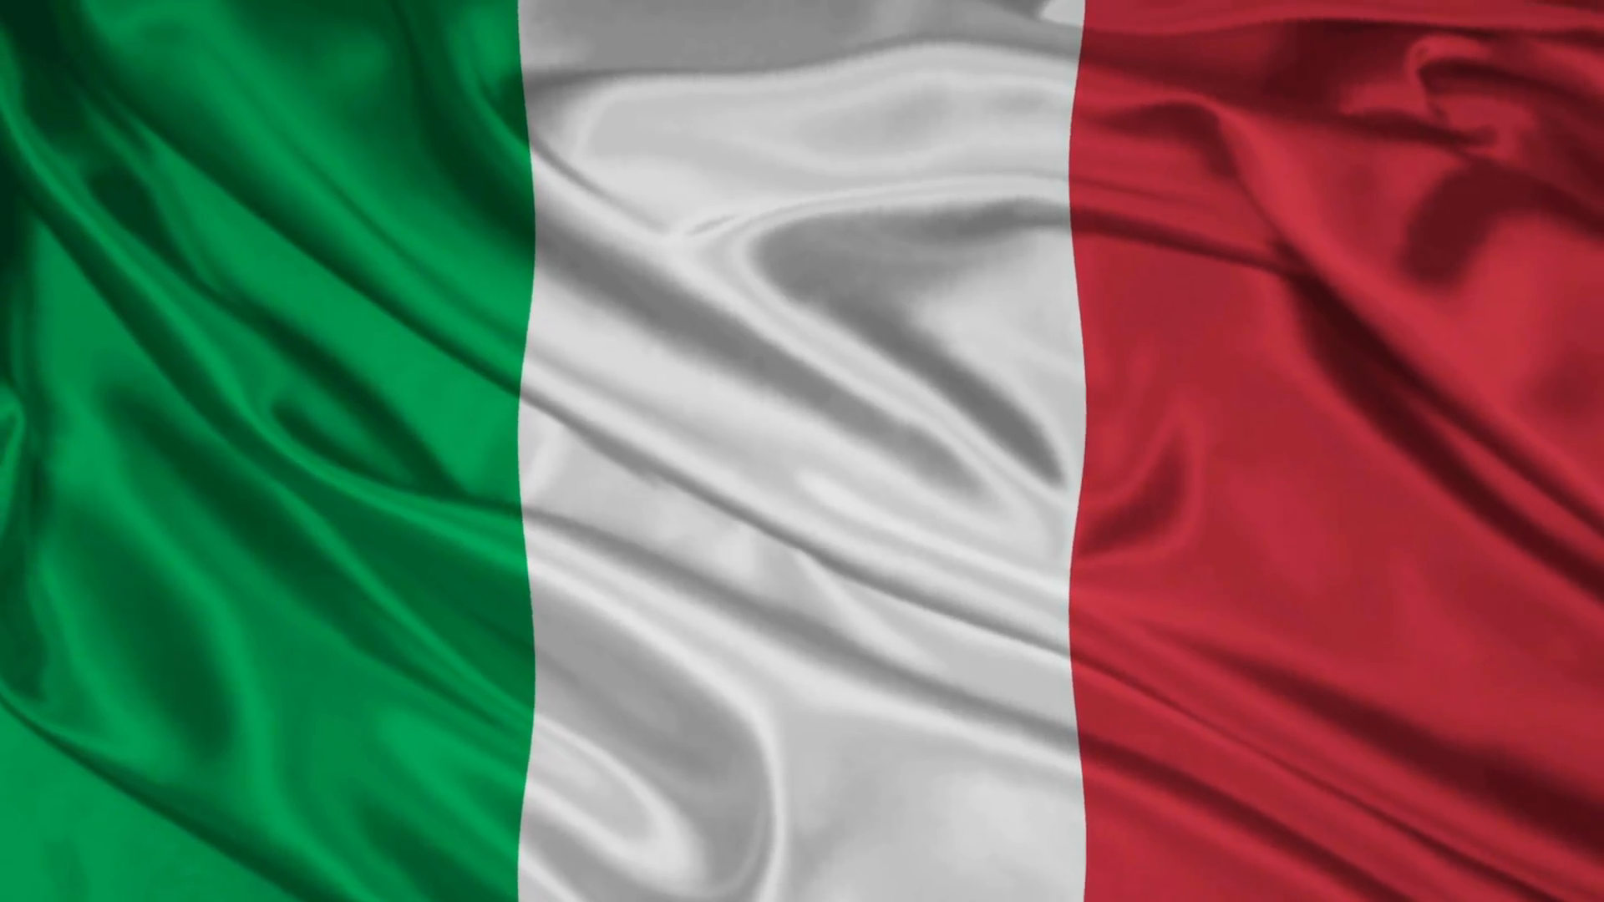

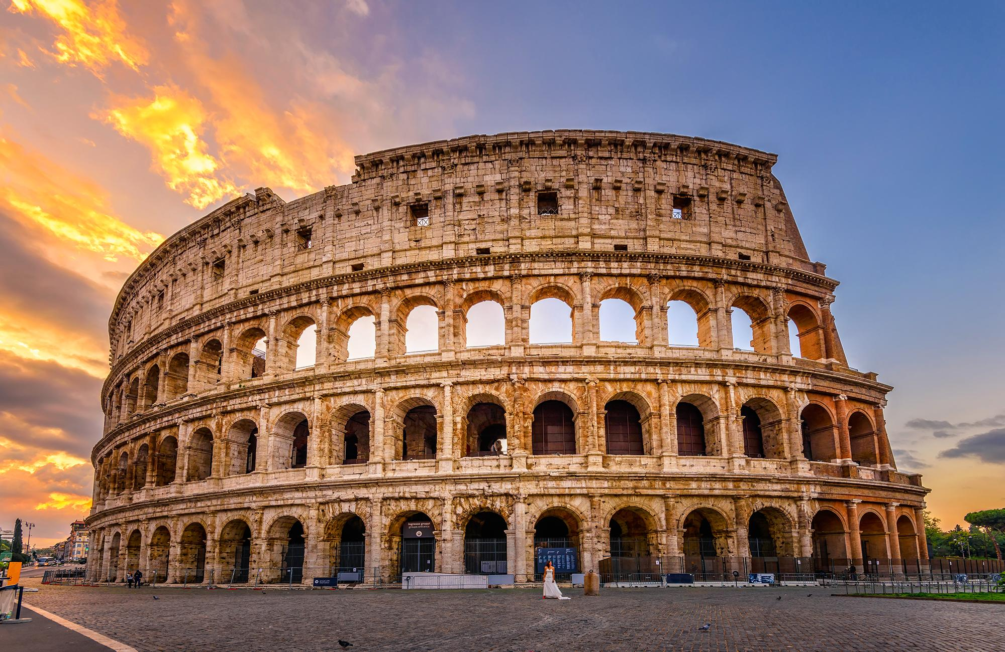

Rome
Italy capital is Rome.Rome area is 1.285 km².Rome population is 2.873 million.Rome has a big and famous colosseum.Gladiators fighted in the this arena.Rome has a big history.A times,Rome was capital of Roman Empire.The most popular Roman Empire king is Julius Caesar. According to the sources we have,Roman Empire created by two brothers,Remuz and Romulus.
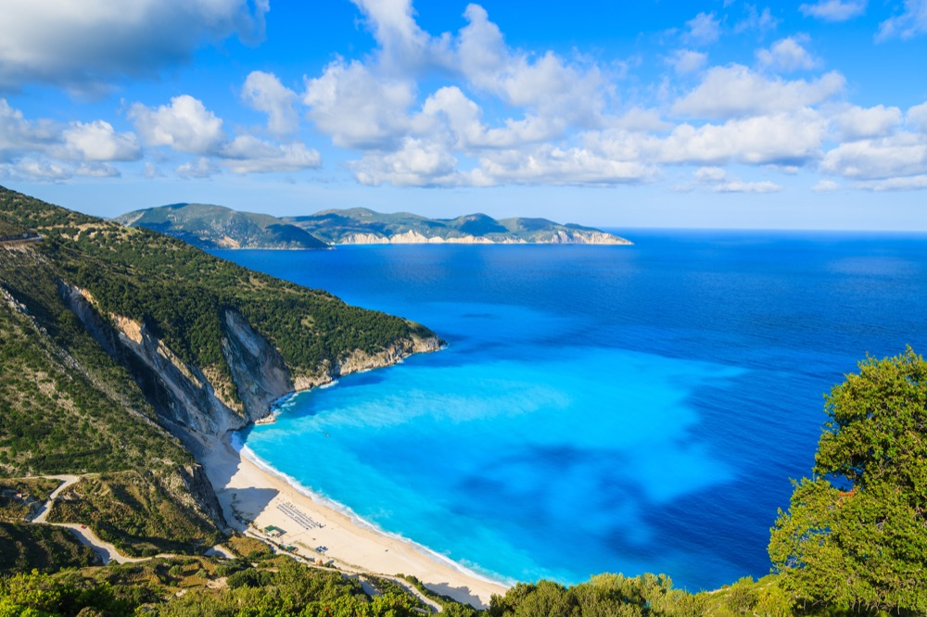
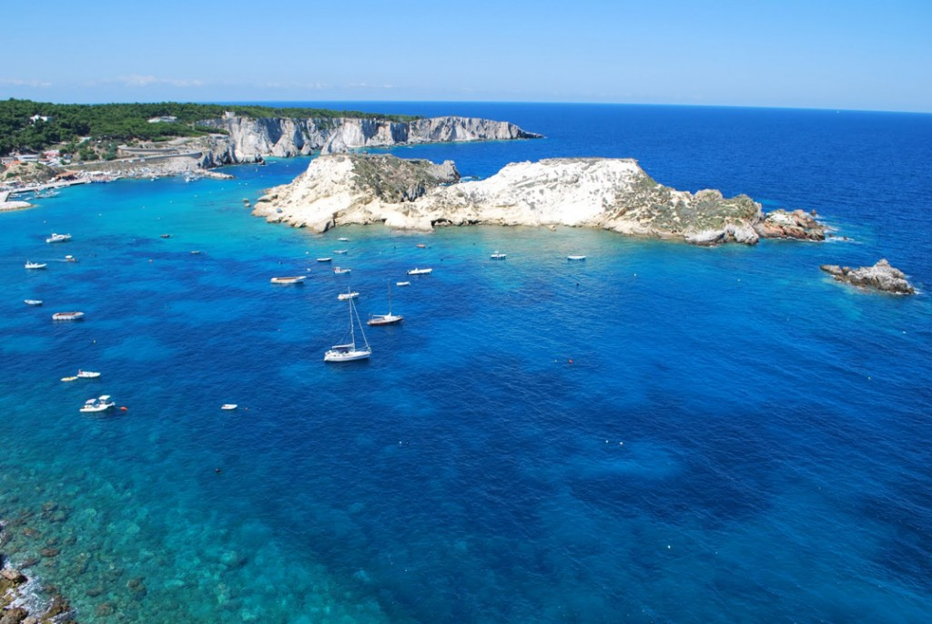

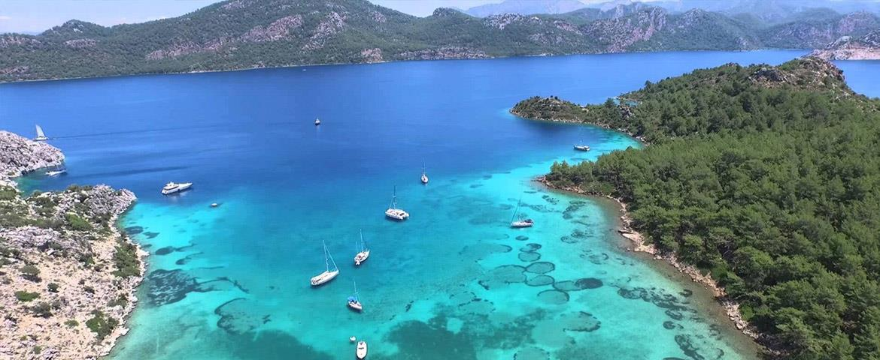

Seas Of Italy
Italy has got five sea.This are Adriatic Sea,Lonely Sea,Mediterreno Sea,Tyrrhenian Sea and Ligure Sea.The most big sea is Mediterreno Sea.
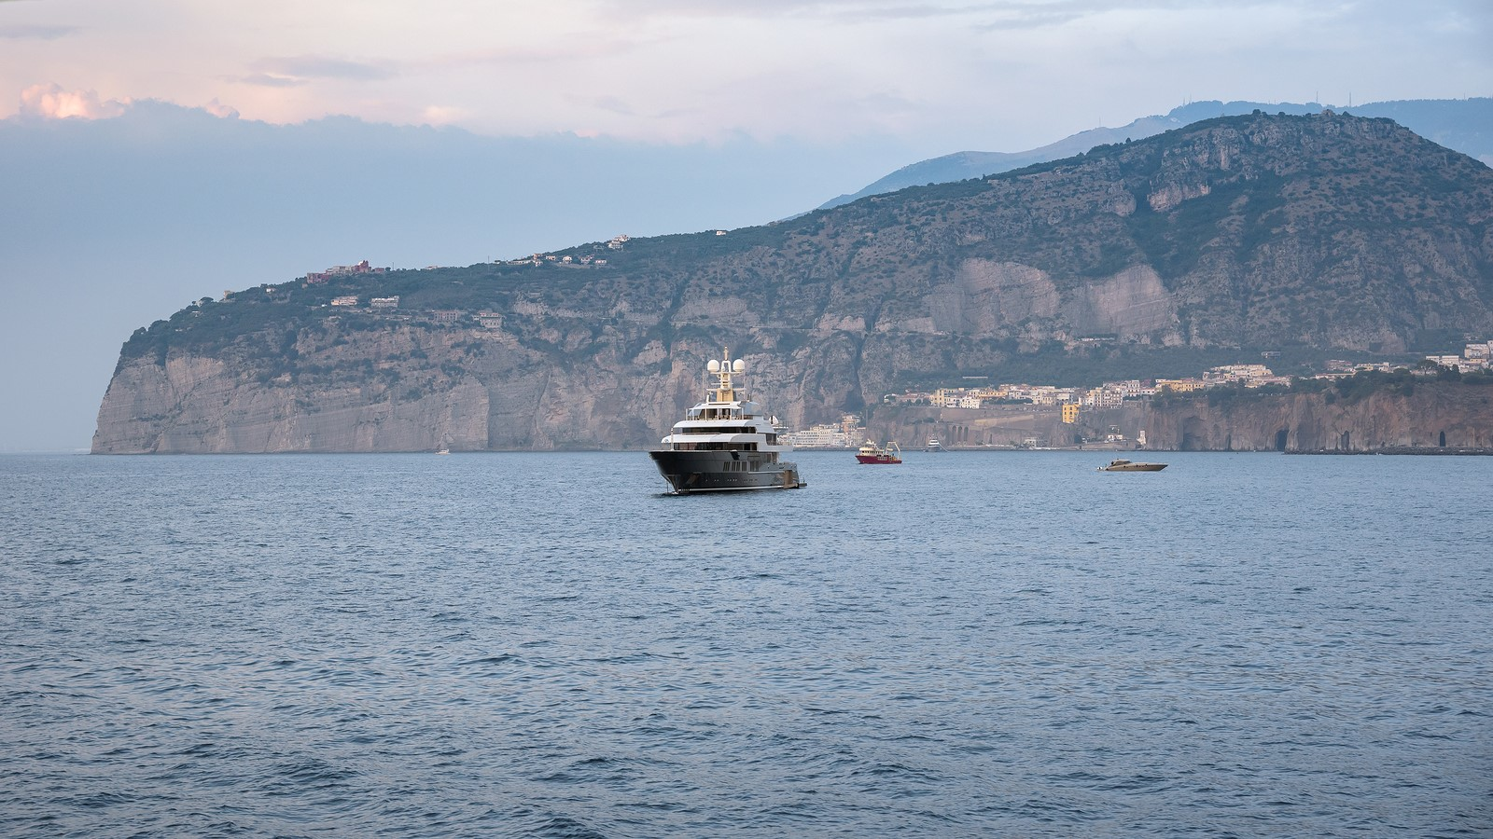
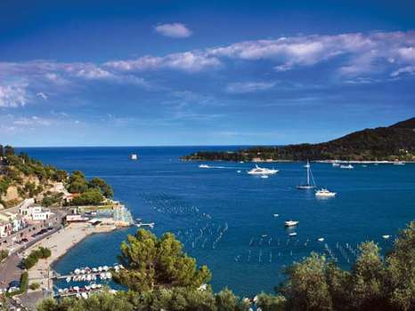

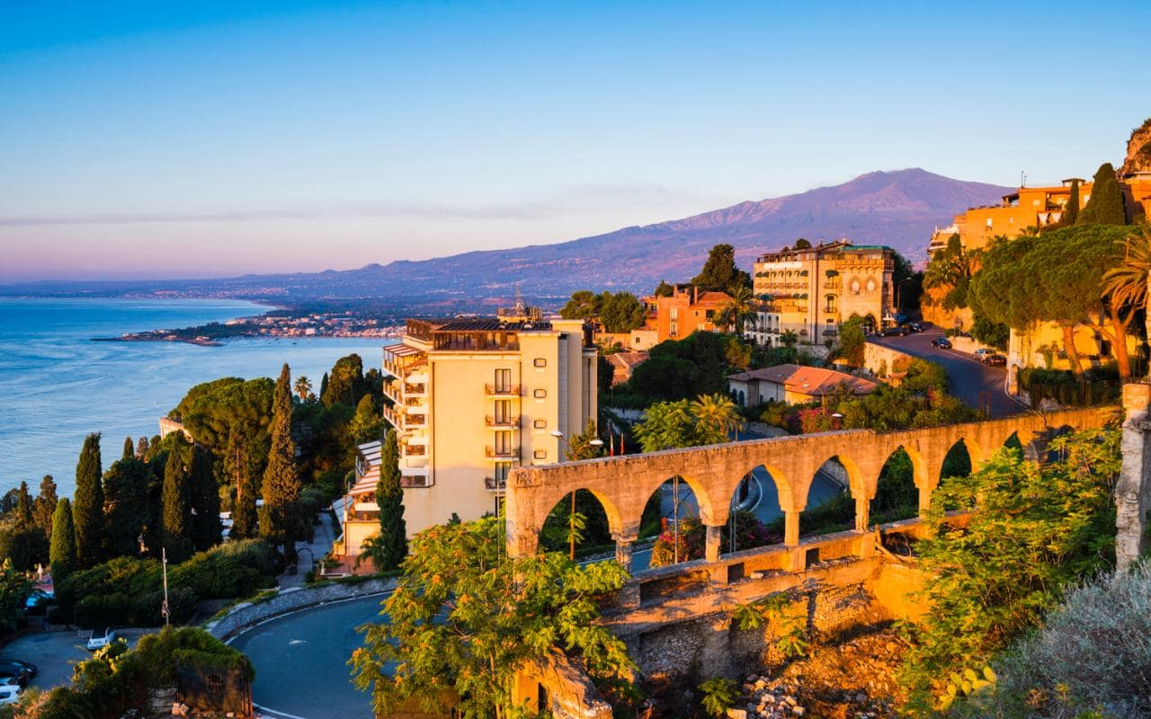
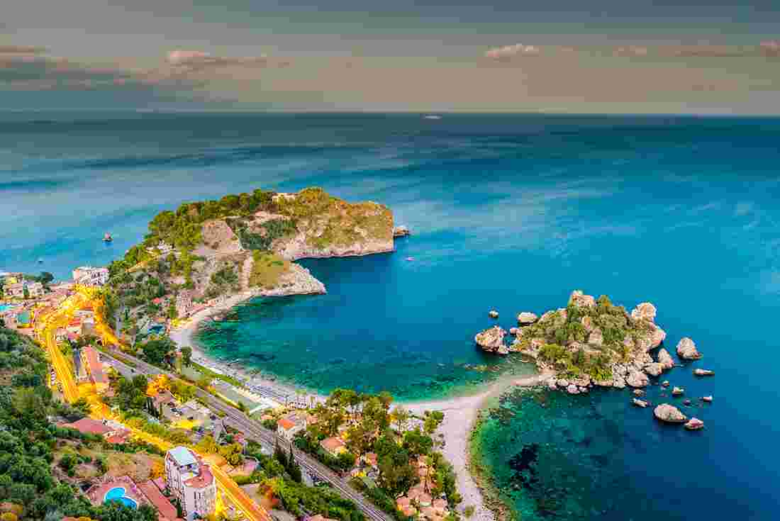
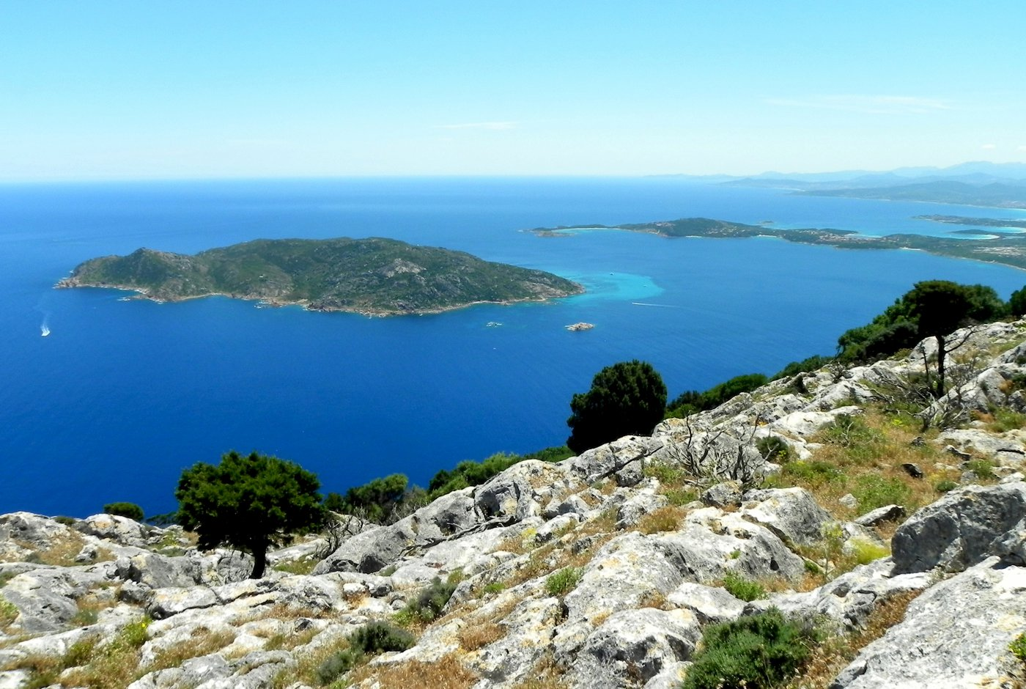
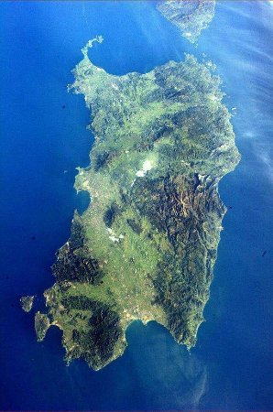

Two Big Island Of Italy
Italy has got two big island.This are Sicily and Sardegna.This are important turism islands.Sicily area is 25.711 km².Sardegna area is 24.090 km².

Top 3 Big Cities Of Italy
Italy has got top three big city.This are Rome,Milano Firenze.Rome area is 1.285 km².Rome population is 2,873 million.Milano area is 181,8 km².Milano population is 1,352 million.Firenze area is 102,4 km².Firenze population is 382.258.
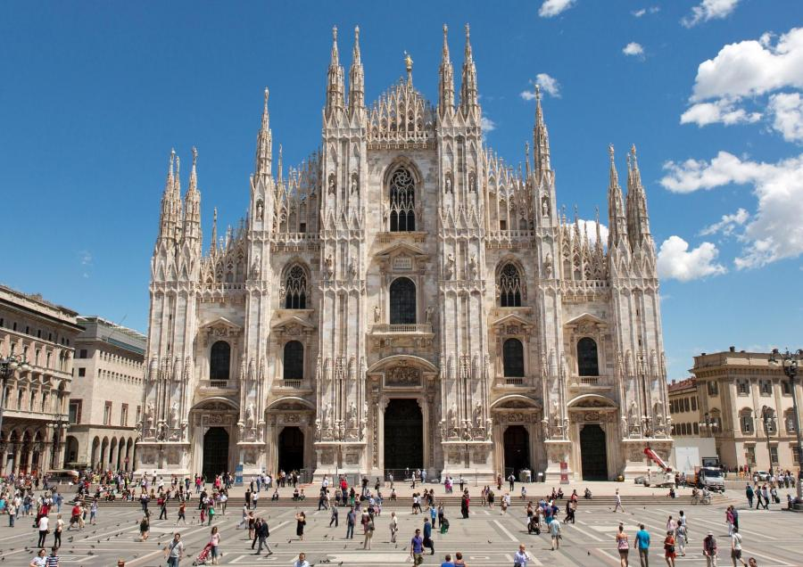
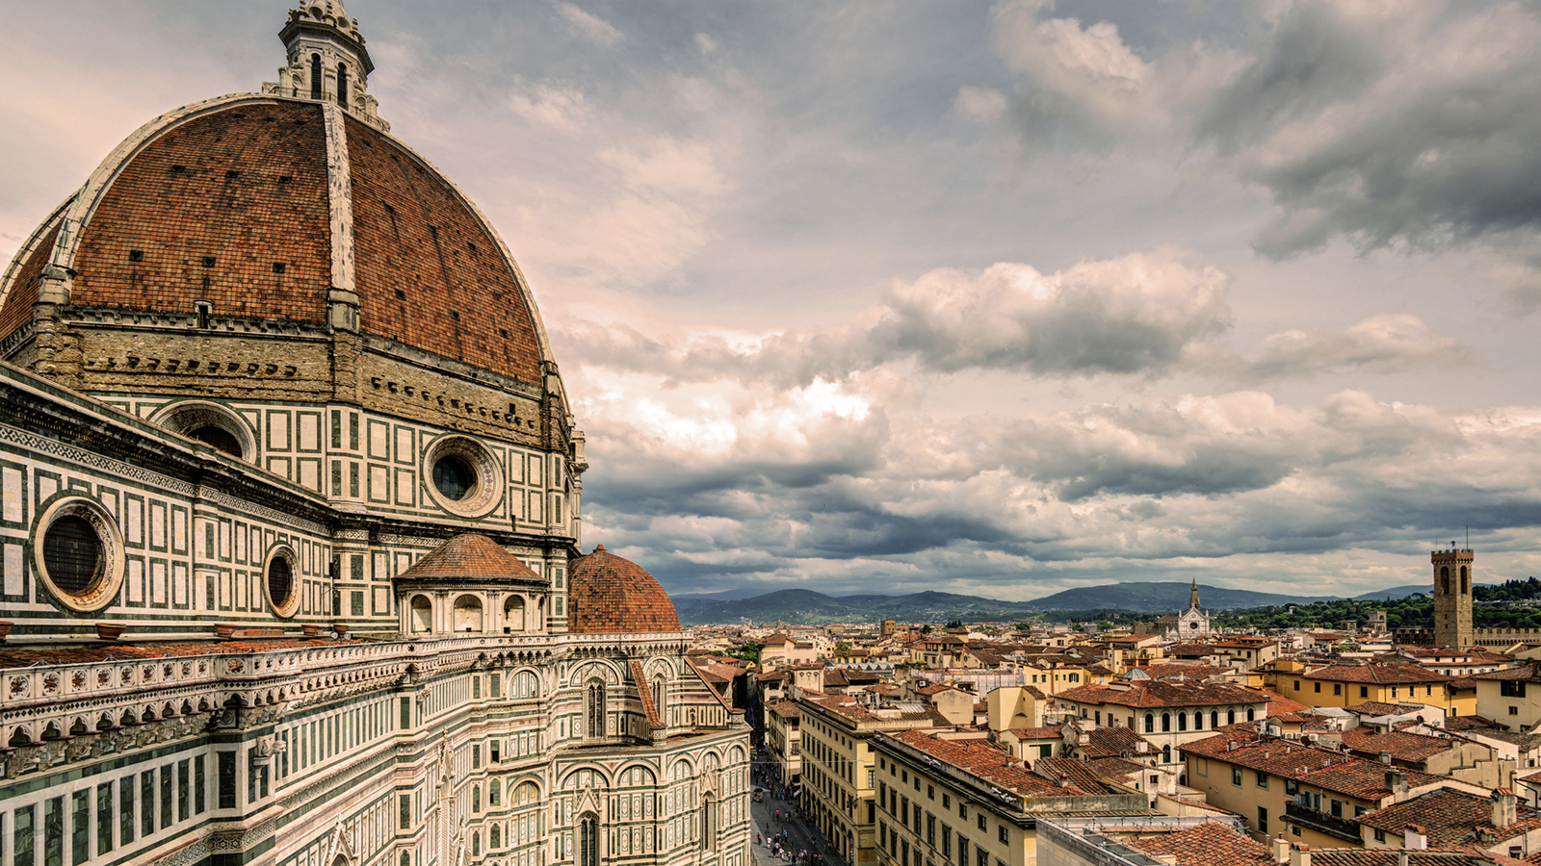

The Highest Mountain Of Italy
The highest mountain is Mountain Bianco in Italy.Mountain Bianco length is 4.810 m.
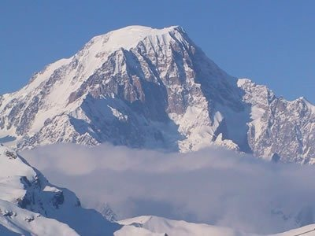
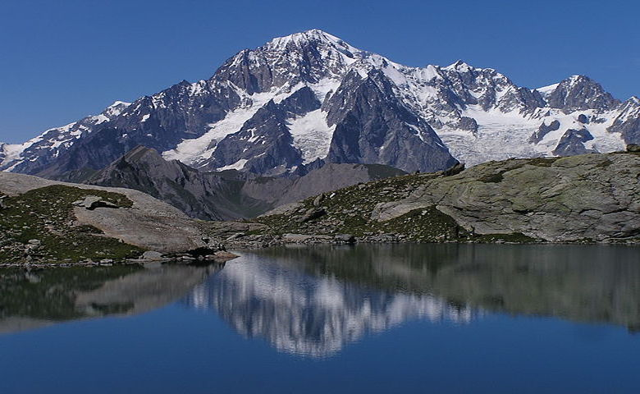

The Biggest Lake Of Italy
The biggest lake is Maggiore lake in Italy.Maggiore lake length is 66 km.
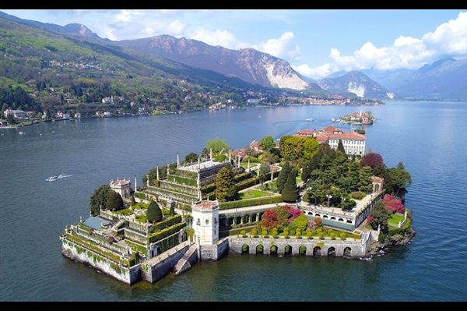
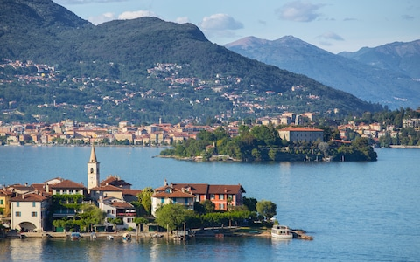

Cities Of Italy
Italy has got 104 city.Top 3 crowded cities in Italy:
Rome: Population is 2,318,895
Milano: Population is 1.236.837
Naples: Population is 959.470
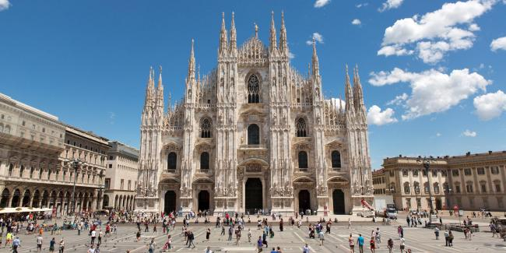
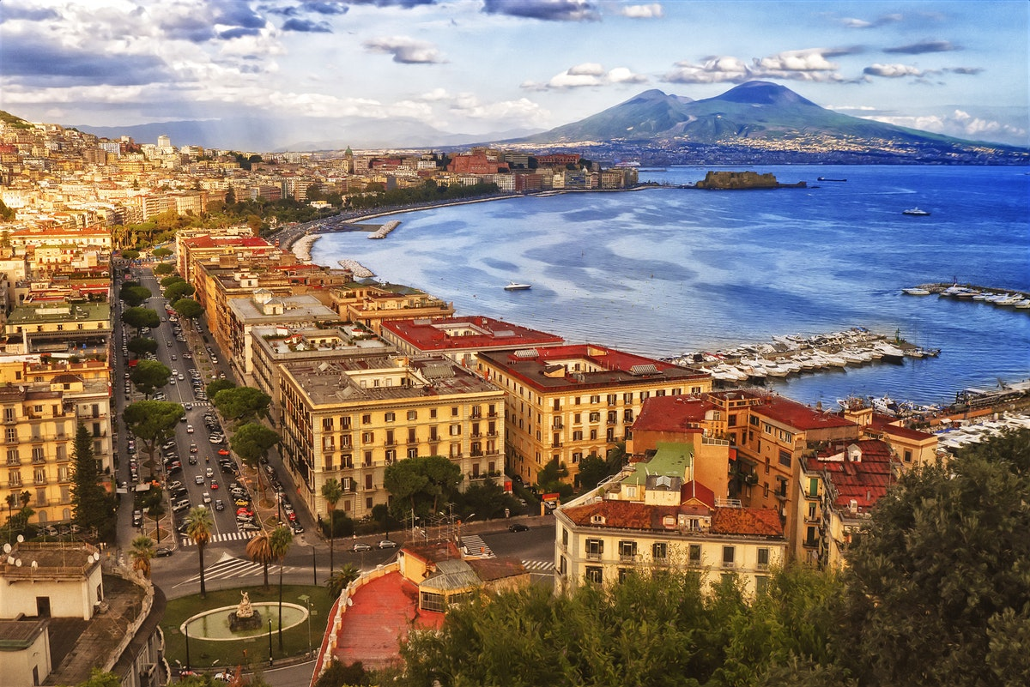

Climate Of Italy
With its hot, dry summers and cool, wet winters, Italy experiences a mediterranean climate. Winters in Italy are cool and humid in the north and the mountainous zone In The summer these Winds can bring very hot, unpleasant weather, sometimes even up to the northern districts of Italy.
Population Of Italy
Italy population is 60 million.The most crowded city is Roma.
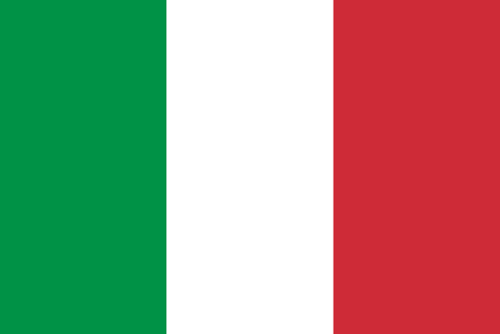

The Longest River Of Italy
The longest river is Po River in Italy.Po River length is 652 km.
