Sports culture in Turkey
Turkish people like and play many kinds of sports. Their most popular sport is football. They have also big traditions in wrestling. Turkey have succeeded in wrestling and football. Turkey`s traditional sport is oil wrestling. In that sport you wrestle in oil.
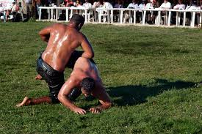

During the summers many Turks like to do some water sports like swimming, surfing and rafting. They also like to play volleyball.
We asked if the Turkish students who are in our Erasmus Project have tried any winter sports. They told that they have tried for example skiing and snowboarding which are popular sports in Finland. They enjoyed doing winter sports.
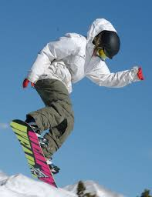
More information: Hakan Sükür

Hakan Sükür is a retired professional Turkish footballer. He has born the first September 1971 and he is now 47 years old. He retired in 2008.

Sükür`s playing position was striker. For example he played for Galatasaray, Torino and Inter Milan Sükür represeted Turkey 112 times. He scored 51 goals for Turkey.
Sükür scored the fastest goal in World Cup history. He scored in eleventh second.

