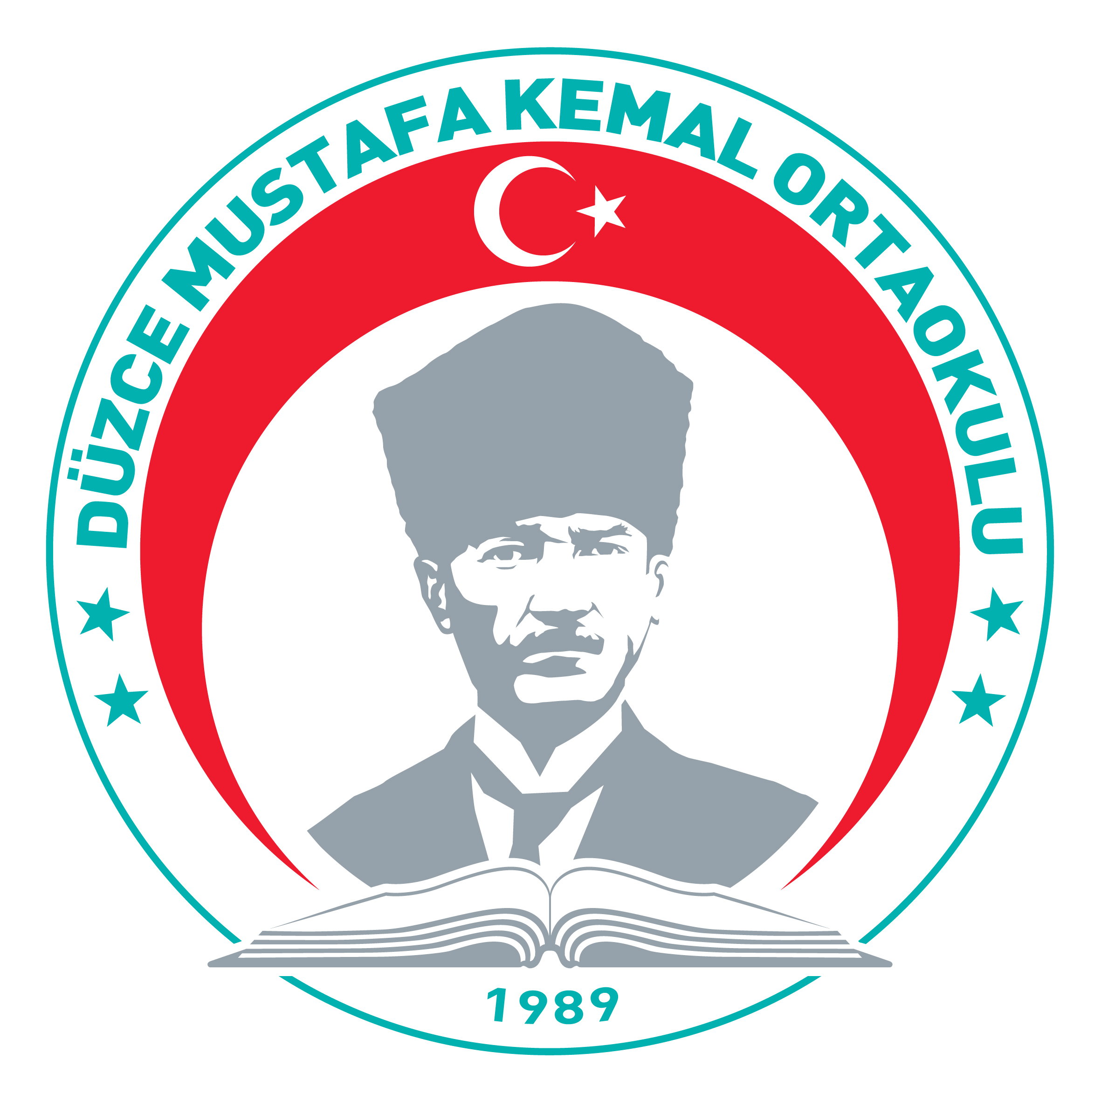


MUSTAFA KEMAL ORTAOKULU
DÜZCE

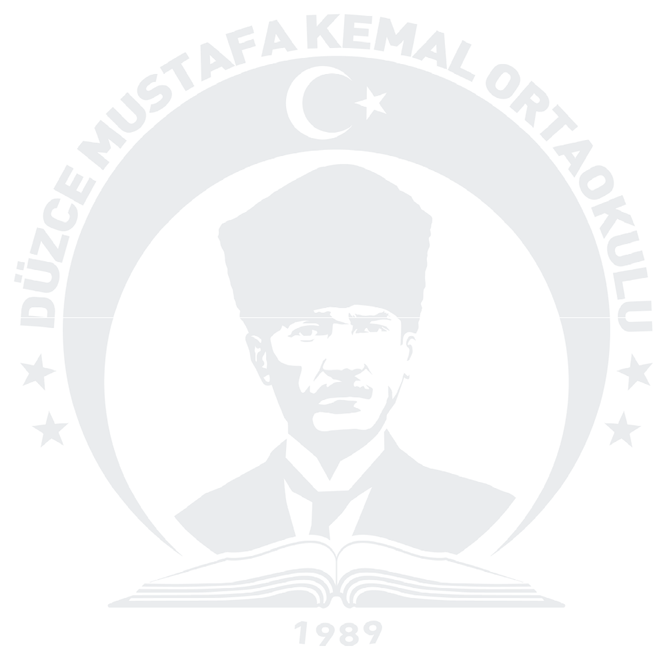
02/05/2019

OFFICIAL INVITATION

This is a formal invitation to each of our partner countries of our School Exchange Partnership

CREACTION 2018-1-FR01-KA229-047999

Dating from June 11st to June 13rd:

- College Elso Triolet, at Varennes-sur Seine, France
- Koivusaaren koulu, at Jarvenpaa, Finland
- L’IES El Yelmo, at Cortijos Nuevos, Spain
- Instituto Comprensivo Statale San Giorgio, at Catania, Italy
- The Observatory School, at Bidston, UK

Muhsin CELEP
Principal


Address: Kültür Mahallesi, Kuyumcuzade Bulvarı N0: 33 Merkez / DÜZCE / TURKEY
Website: http://duzcemustafakemaloo.meb.k12.tr
Tel: (0380) 514 27 38

E-mail: 731897@meb.k12.tr

