İTALY
İtaly is a country in south europe rome,milano,firenze are the top 3 biggest cities, also there are 104 cities in italy.it has many geographical beauties for example bianco mountain,po river,sicilia,sardegna
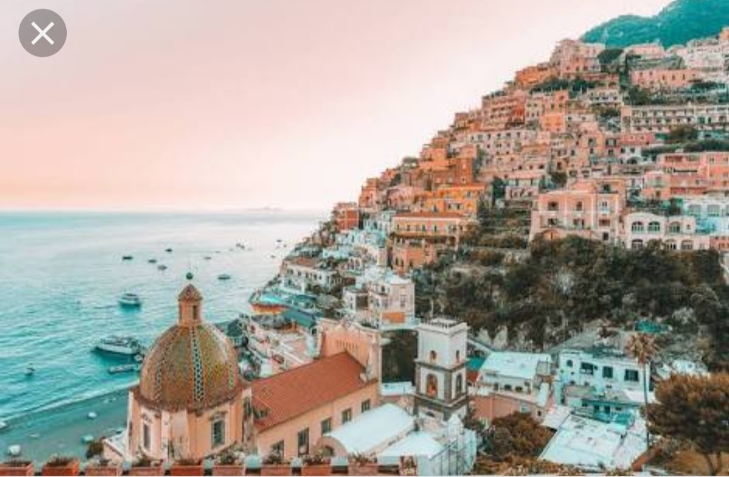
Also İtaly has 60 million people in it

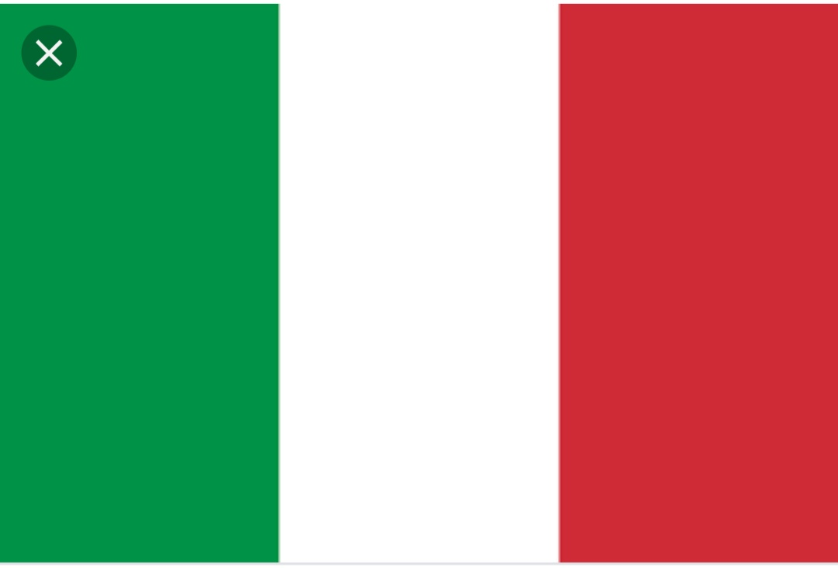

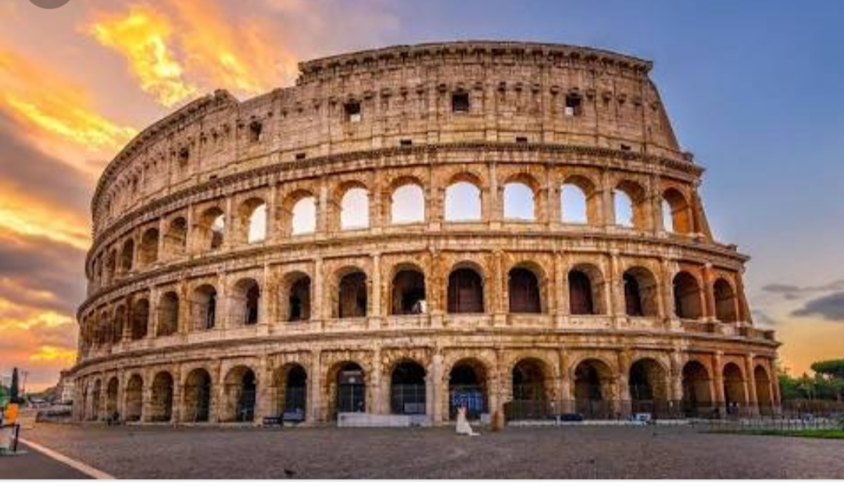
ROME

Rome is the capital of italy it has 200873 population and it has 1285 km area also Rome was established at 21 April 753 B.C.Also the famous fountain,Fountain Of Love is in Rome

BİANCO MOUNTAİN
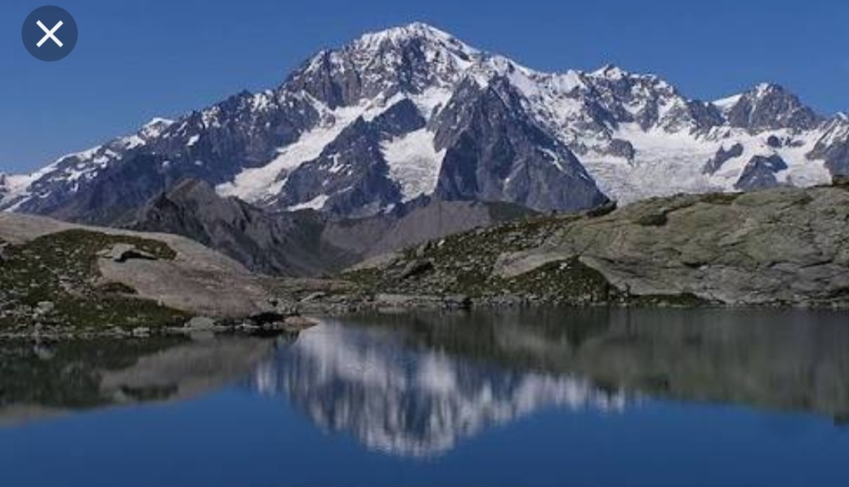

Bianco Mountain is the biggest mountain in Europe.its 4,792 meters tall

MİLANO
Milano is a city at north İtaly.Milanos population is 100.310 and Milanos area is 2370.İt has the Most population in İtaly after Rome.And there is some famous places like Sforza Castle

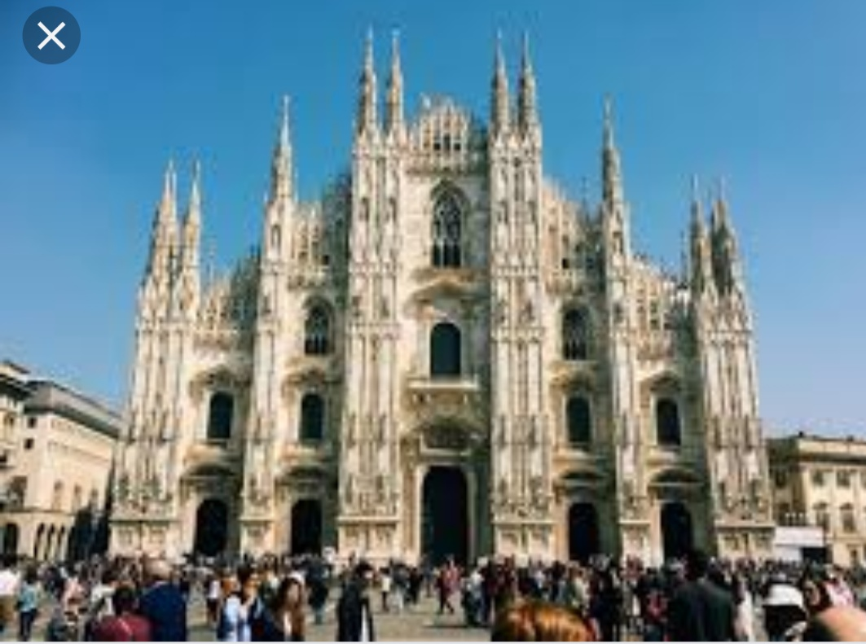

SARDEGNA AND SİCİLİA
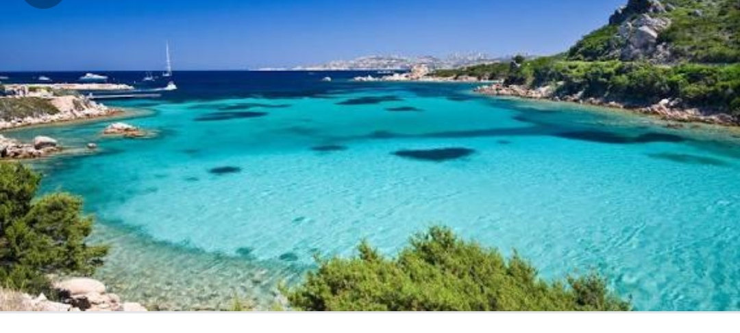
Sardegna is a island at italy its the biggest island in Mediterranean after Sicilia.
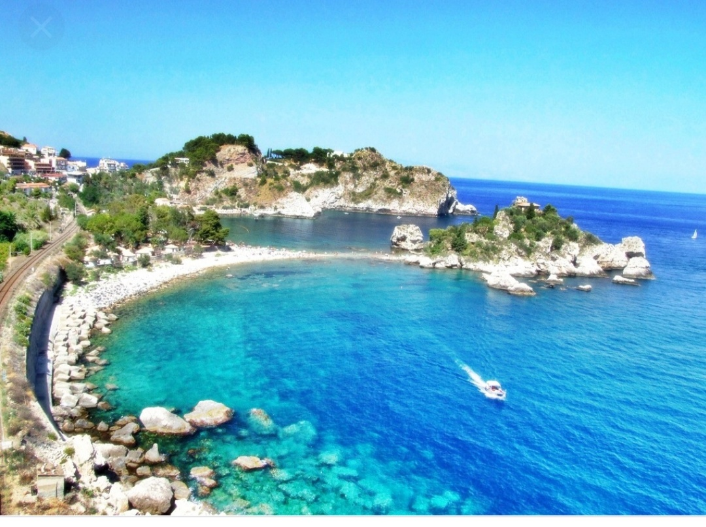
The area is 24.090 Km

Sicilia is the biggest island of Mediterranean.İts at North İtaly.
İts a fascinating island.

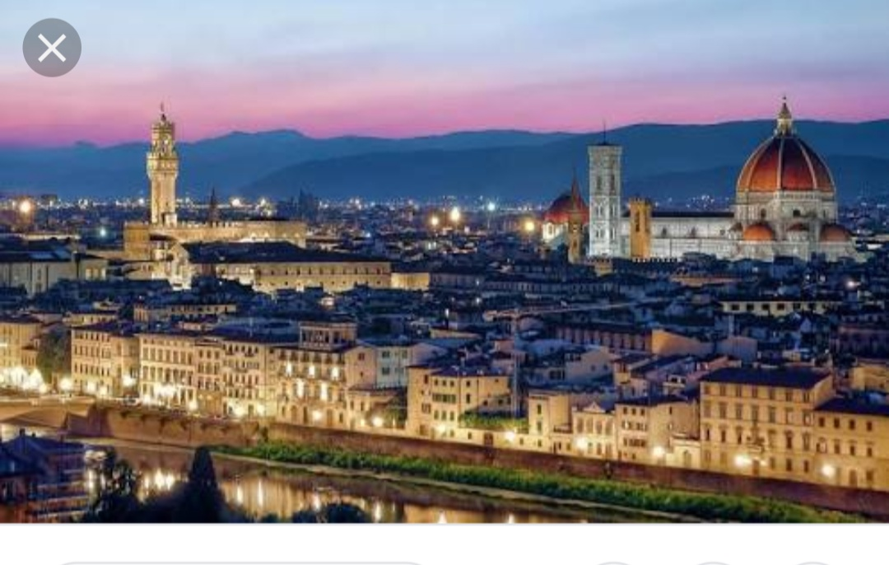

FİRENZE⬆️
Firenze is a big city in italy,in the past it was the capital of İtalia Kingdom
For a short time.also there is famous places for example Palazzo Pitti,Santa Croce Church.

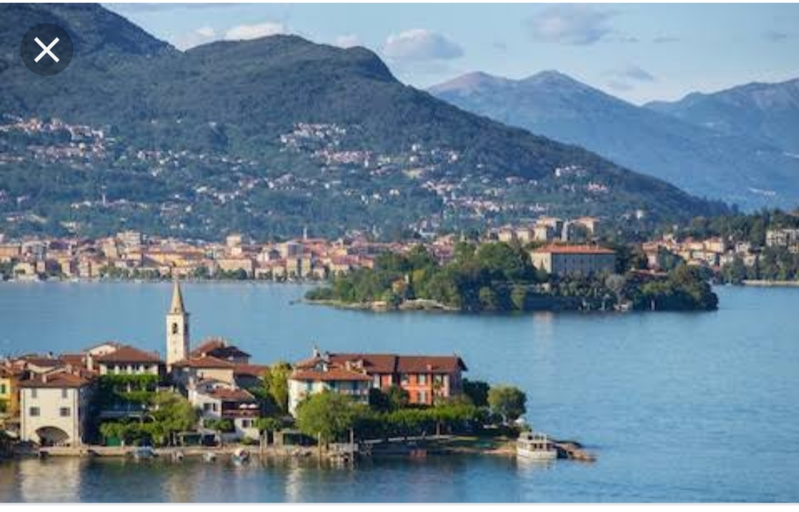
Maggiore is a lake at North İtaly and its near to South Switzerland.

MAGGİORE LAKE⬆️

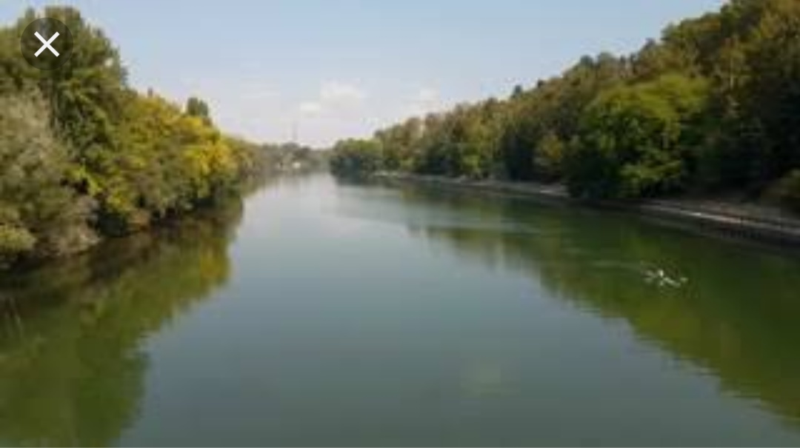

PO RİVER

Po is a river in Europe and its the biggest river in italy.İts 652 kilometers long.
Also some part of Po River is in Switzerland

THANK YOU FOR READİNG MY PRESENTATİON.

KEREM ARABACI

