FINLAND

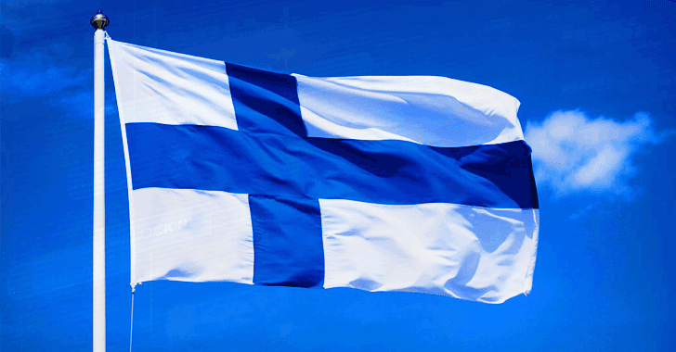  ID ( capital, government, population...) | Finland is a parliamentary democracy with a multiparty political system and a president as the head of state. Finland declared itself independent of the Russian Empire on 6 December 1917.  The prime minister's name is Juha Sipilä  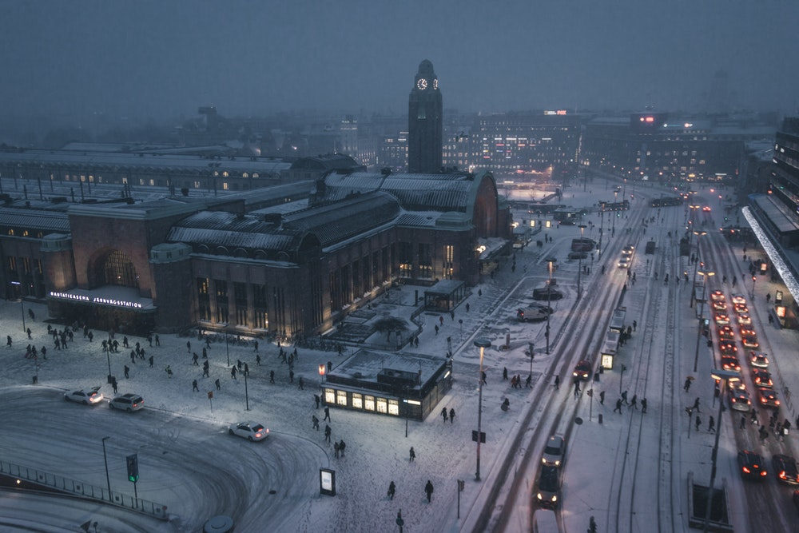  Finland is a small country. The population is 5.5 million.  Finland’s area is 338 424 square kilometers. Finland is not really big country but it´s 64th biggest country in the world. There´s is also many forest´s and lake´s. And we have really cold winter´s and lot of snow!

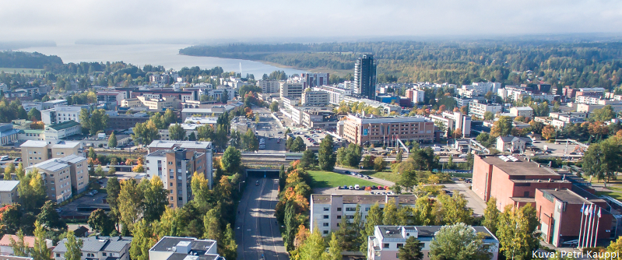  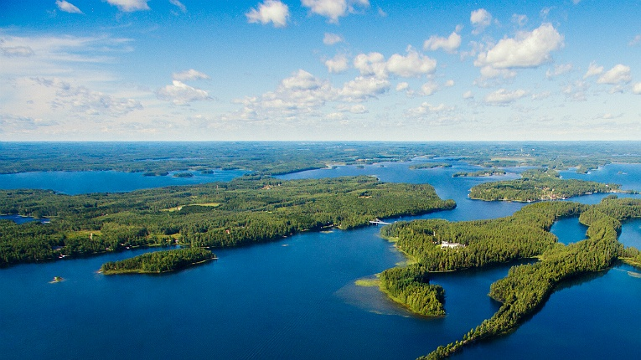 | Jarvenpaa is near of capital city and this is really nice city. I like live in here!  Järvenpää is about 40 kilometers from our capital city Helsinki.  Some of the biggest companies in Finland are Fazer, they make many sweet things to eat. Fazer´s blue chocolate is best chocolate in the world and you have to taste it!  For example there is Kone. It`s a company that makes elevators.  Finnair is an airline company.

