GEOGRAPHY: FRANCE – FONTAINEBLEAU AND VARENNES SUR SEINE

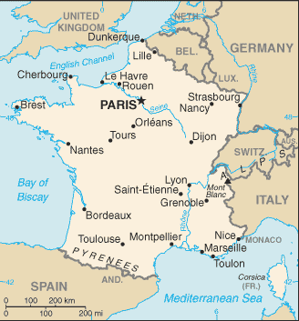
Borders: Belgium, Luxembourg, Germany, Switzerland, Italy, Spain, Andorra, Monaco, maritime border with the United Kingdom, Mediterranean Sea, Atlantic Ocean, English Channel
Total Size: 547,030 square km
Geographical Coordinates: 46 00 N, 2 00 E
General Terrain: mostly flat plains or gently rolling hills in north and west; remainder is mountainous, especially Pyrenees in south, Alps in east.
There is the Auvergne volcanoes.
Geographical Low Point: Rhone River delta -2 m
Geographical High Point: Mont Blanc 4,807 m

Currency: Euro
Climate: generally cool winters and mild summers, but mild winters and hot summers along the Mediterranean; occasional strong, cold, dry, north-to-northwesterly wind known as mistral.
Major Cities: PARIS (capital) 10.41 million; Marseille-Aix-en-Provence 1.457 million; Lyon 1.456 million; Lille 1.028 million; Nice-Cannes 977,000 (2009).
Major Landforms: French Alps, Jura Mountains, Pyrenees, Massif Central plateau, Gorges du Verdon canyon, Loire Valley, Corsica Island
Major Bodies of Water: Seine River, Loire River, Meuse River, Rhone River, Gulf of Lion, Bay of Biscay, English Channel, Strait of Dover, Etang de Berre lagoon, Lac du Bourget, Mediterranean Sea, Atlantic Ocean
Famous Places: Eiffel Tower, The Louvre Museum, Notre Dame Cathedral, Arc de Triomphe, French Riviera, Champs Elysees, Palace of Versailles, Les Invalides, Mont Blanc, Gorge du Verdon, Mont Saint-Michel, St. Tropez, Chateau de Chambord, Dune of Pyla.

FONTAINBLEAU:
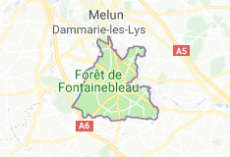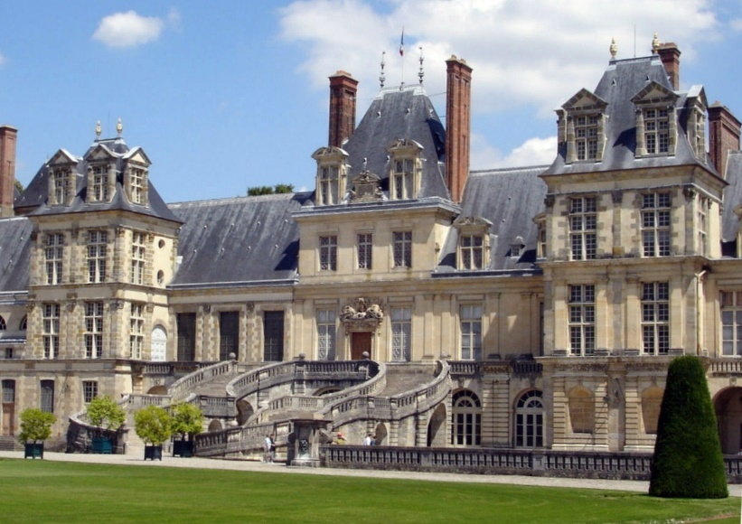
Chateaux de Fontainebleau

VARENNES SUR SEINE:
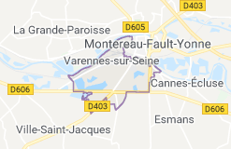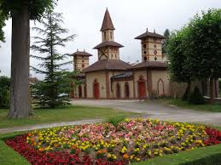
Parc de la Sauvagerie

