Sports in France
Football,rugby,judo,pétanque are popular sports in france.

Famous sport players

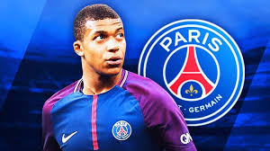
Griezman Tony Parkey Mbappé

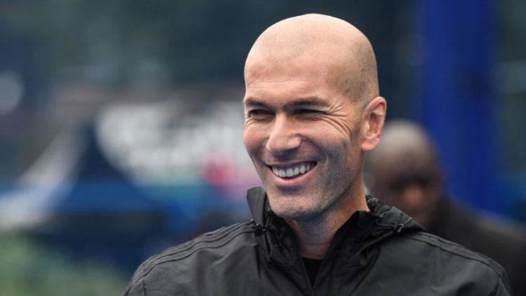
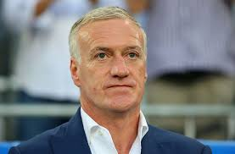
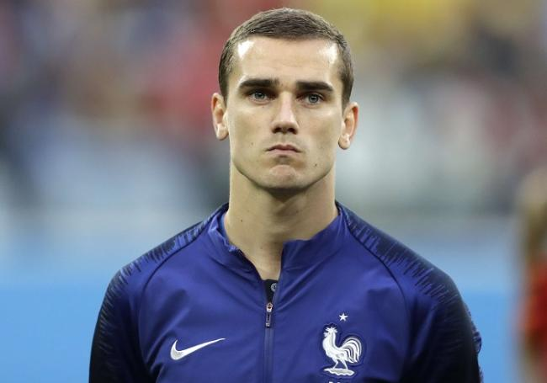
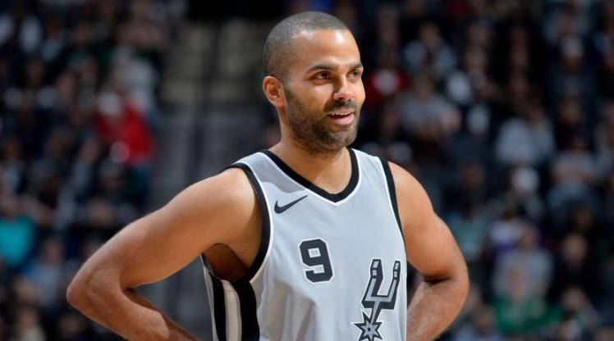
Teddy Riner Zinedine Zidane Didier Deschamps

Yannick Noah Gael Monfils
ff

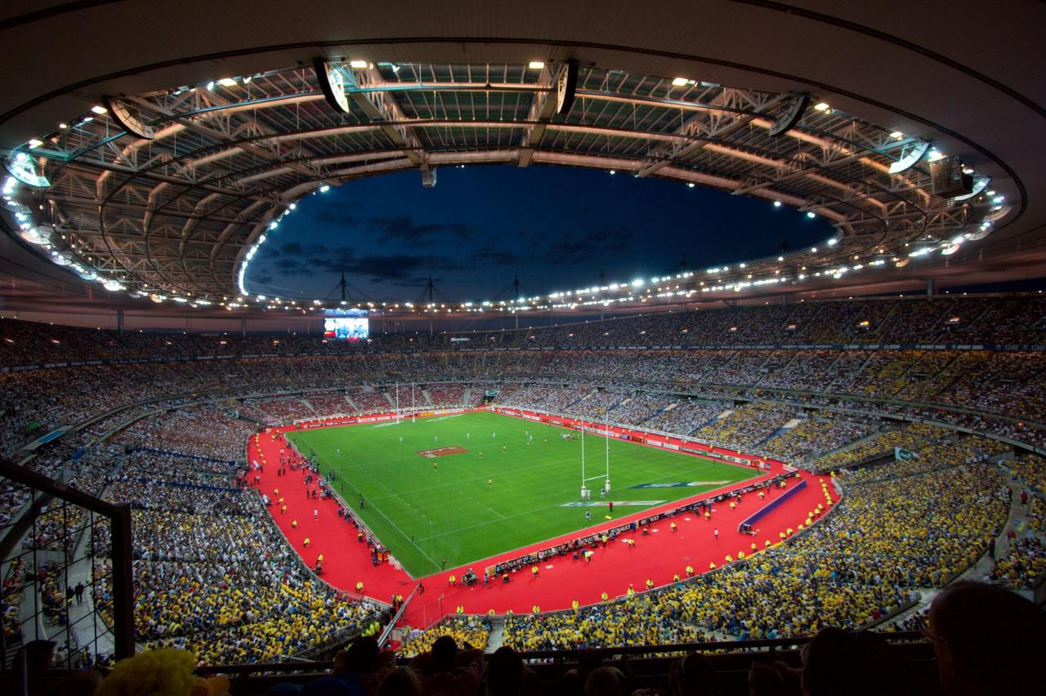
This is the most famous arena in France:Stade de France

These sports are originated in France;

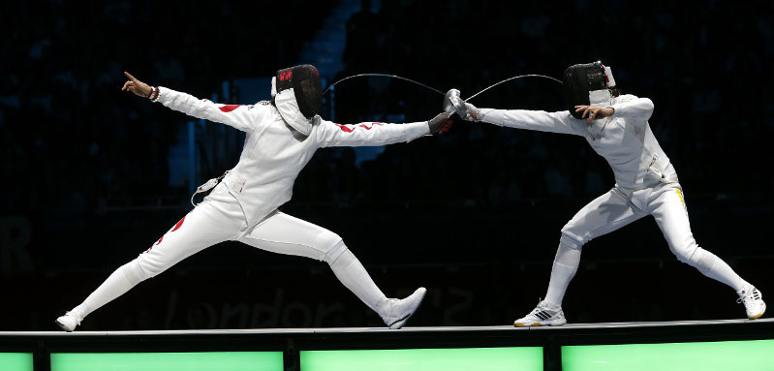
Pétanque Billiards Fencing
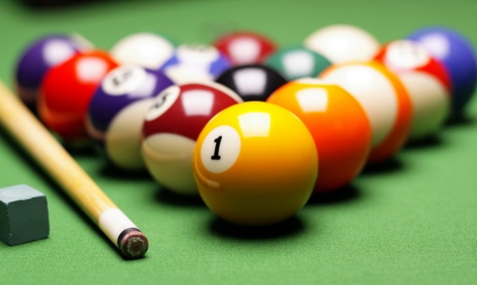
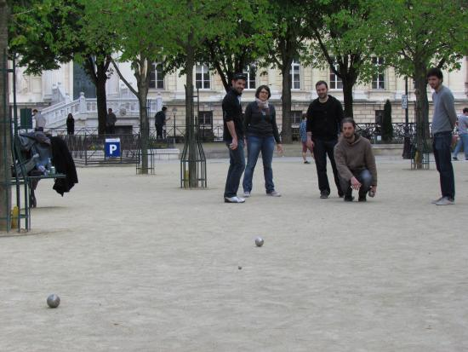
French Boxing
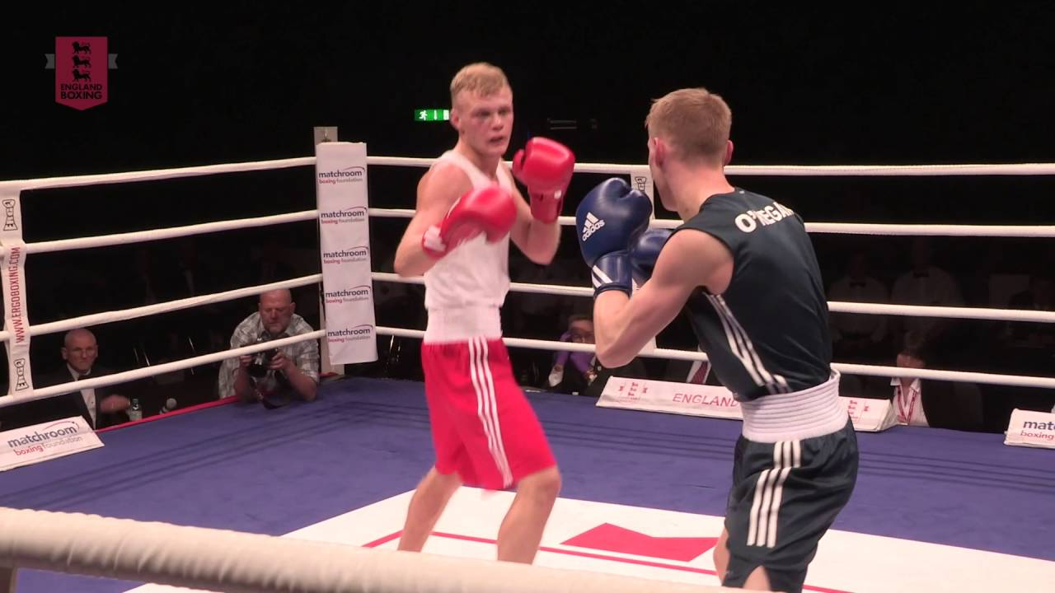
These tournaments are the most popular in France:
- Roland Garros(tenis)
- Tour de France(cycling)
- Pro A(basketball)
- Ligue 1(football)

The best basketball team is It’s Limoges

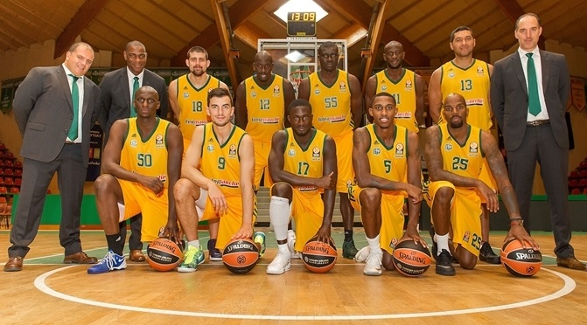

What is the best football team?Somebody thinks Olympique de Marseille,other thinks Paris Saint Germain.

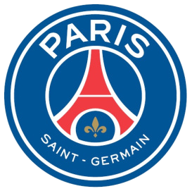
Olympique de Marseille Paris Saint Germain
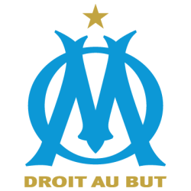

Vs.

France won football world cup twince in 1998 and 2018.

Pétanque:You play with 3 iron balls.You throw a small ball “the cochonnet”.Then you throw your balls and the nearest to the cochonnet wins.

French people eat pasta,chicken,fruit,vegetables and bread when they are on a diet.

France got most medal in judo.

