TURKEY

ID ( capital, government, population...)  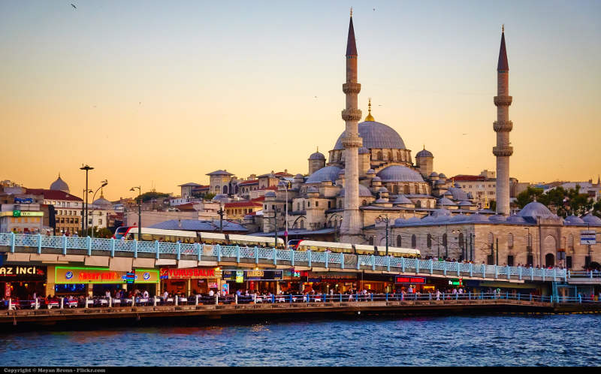  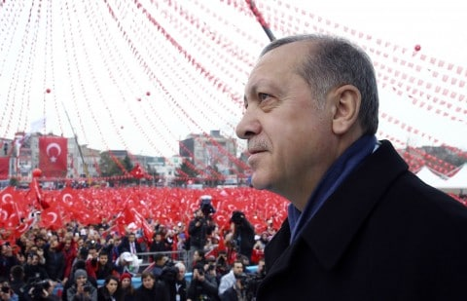  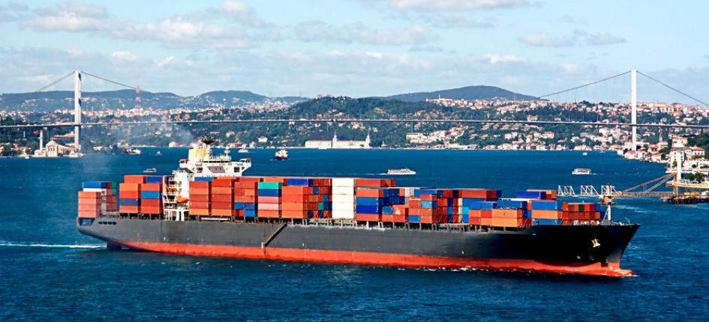 | Turkey is 783.562 km² big, and oppositely to many people thoughts, Ankara is their capital, not Istambul.  The most populated cities in Turkey are İstanbul, İzmir, Ankara.  Düzce's population is not that significative.  The country's regime is a democratic government.  According to general opinions, most of Turkish people feel European rather than Asian mixing a range of ethnic groups as Armenian, Greek or Syrians.  They are distributed among 7 regions in the country. Turkey could be considered a mostly urban country.  The main economic sectors are Agriculture and industry. İn Düzce the sector is agriculture (nuts, corn, tobacco, strawberry) and industry of clothes.

