https://www.youtube.com/watch?v=lTGpjG_T7z8

Process
- Create an HP Reveal account
- Log in to your account
- Start creating Auras(*) in Reveal Studio
- Deliver your Auras to users
- Download the HP Reveal app from the App Store or Google Play to see the AR you created!
(*)Auras: is an heritage of the former name of HP Reveal : Aurasma. An auras is just an experience you create within HP reveal.
1,2,3 Steps you're done.
Use case : Create a dynamic business card. When I give my card to a contact who also has installed HP Reveal (iphone or android), pointing at my card will play a video and when he/she clicks on the video the web browser opens my Linkedin profile page...

Step 1 : Login
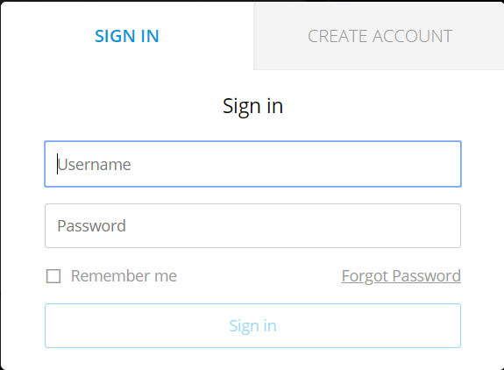

Step 2: Create your aura , upload your trigger
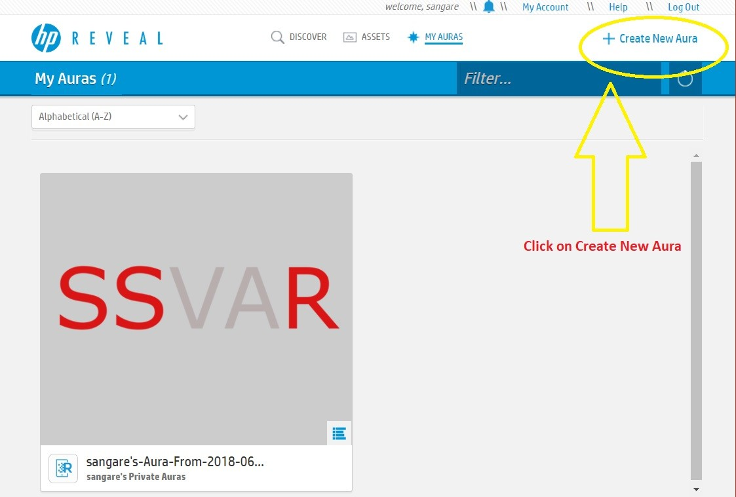
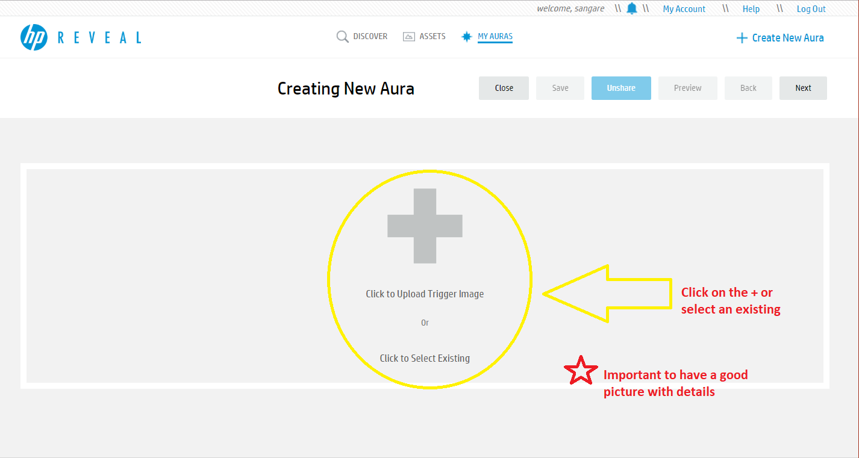
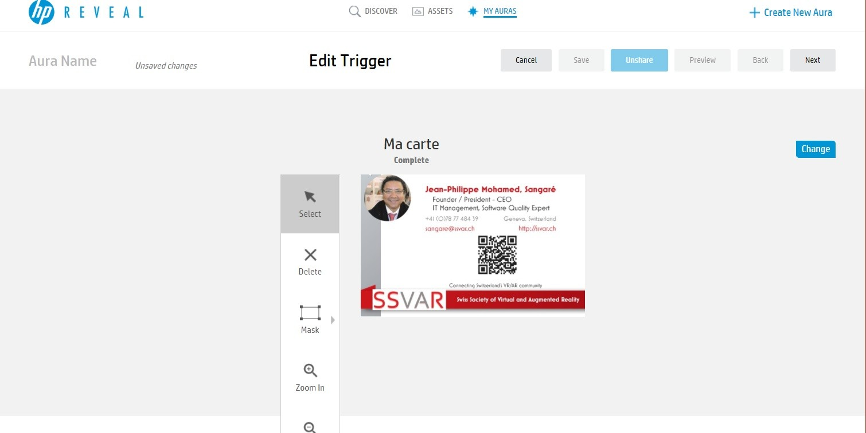
As you can see I've uploaded my Business Card.

Step 3: Upload your overlay
The overlay could be a video, image. I choose a video.
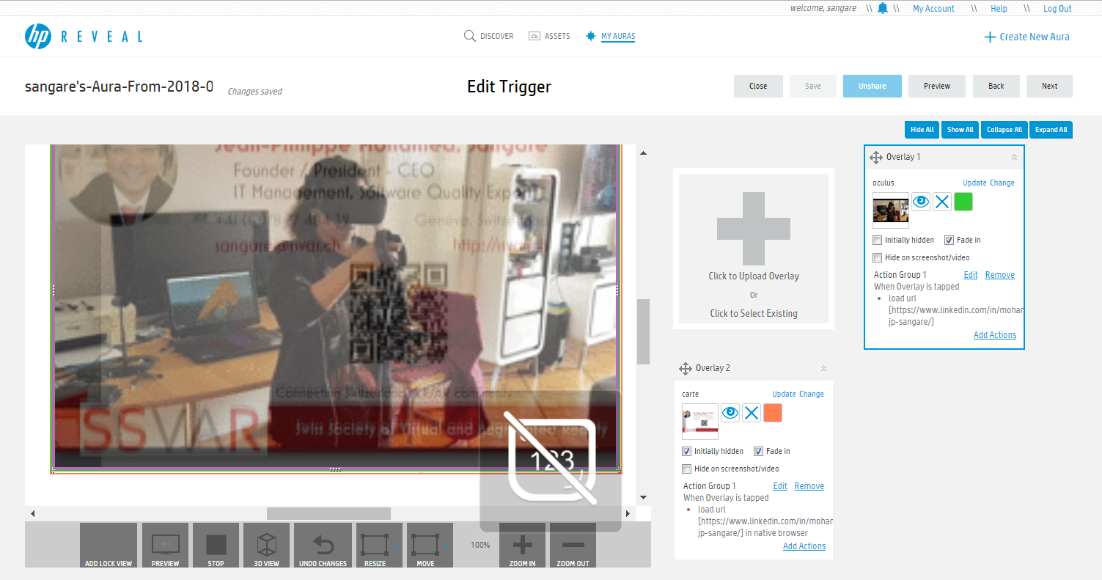
You can preview the aura. And if you're satisfied, you save it. Be careful, the first save of the creation will be public so you have to go into the library to make it private if you don't want to share yet, or never.
At the end:
To launch the Aura:
Open the HP Reveal app on your phone or tablet and log in using the same username and password as your HP Reveal Studio account.
Go to the "Auras" tab within the "Explore" section and drag the page downward to refresh the Auras.
Select the app's view finder and point your device at the Trigger image below to preview your Aura.

