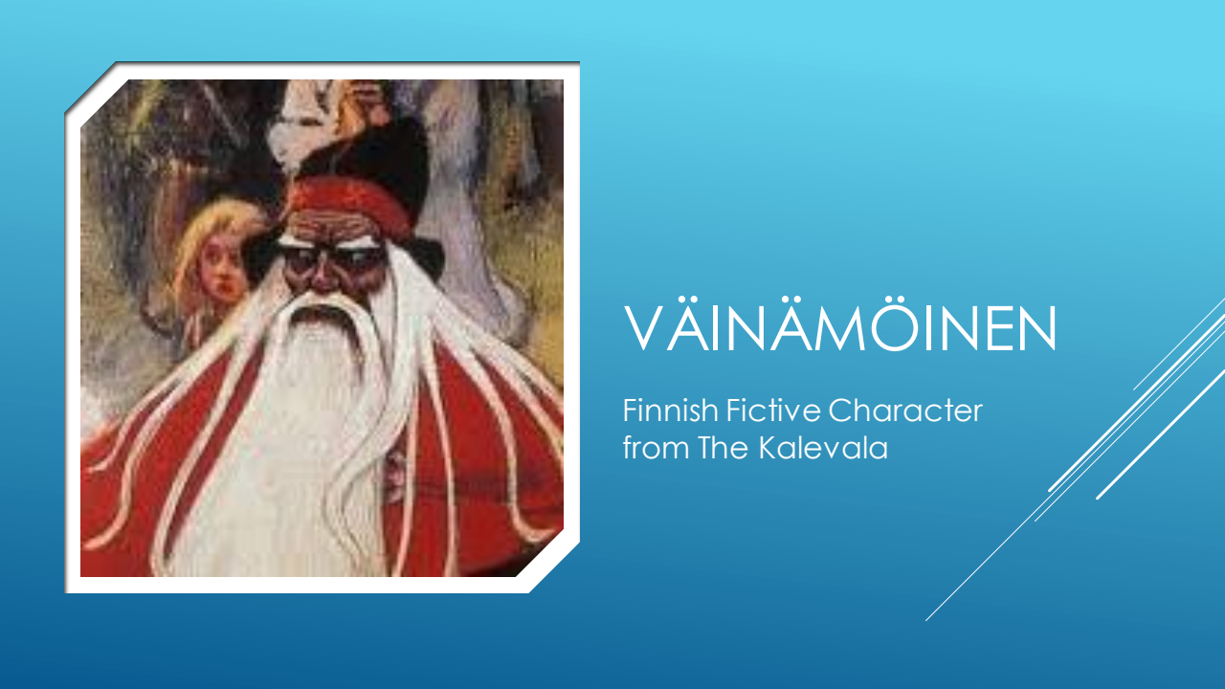
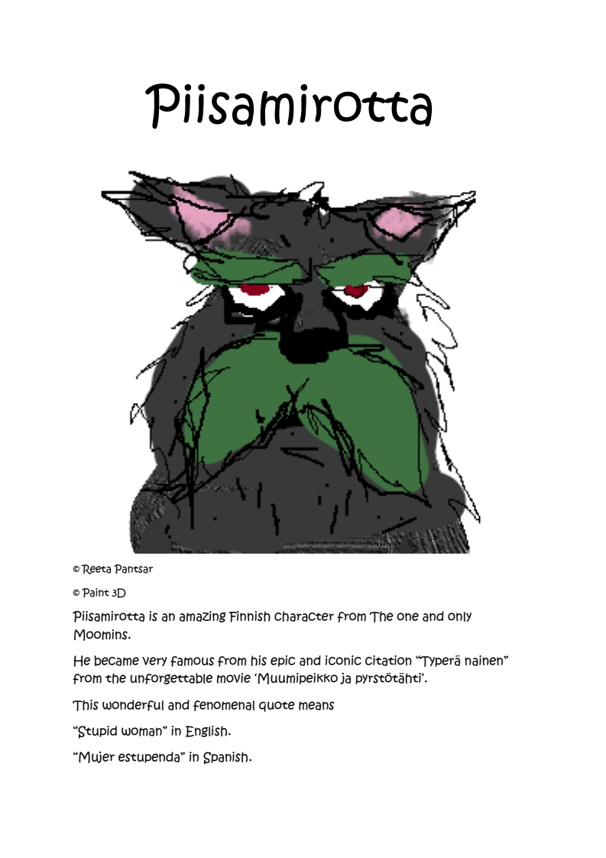

VÄINÄMÖINEN AND THE DOG. PIISAMIROTTA.

VÄINÄMÖINEN :HELLO ! It’s been a long time ! How are you ? YOU ARE SO. PRETTY !

PIISAMIROTTA:OH THANK YOU ,YOU ARE PRETTY TOO. What are the news ?

VÄINÄMÖINEN : IF YOU WANT YOU CAN COME TO MY PLACE. I HAVE COFFEE

PIISAMIROTTA : OK I WILL COME !

VÄINÄMÖINEN AND PIISAMIROTTA : LET’S GO !

THEY REACH THE DESTINATION… IT’S A MESSY PLACE.

VÄINÄMÖINEN : HERE IS MY BEAUTIFUL HOUSE…

PISSAMIROTTA : When is the last time you cleaned it ?

VÄINÄMÖINEN : You know, I’m an artist. I think objects should be free to live their lives

PISSAMIROTTA:THAT’S A SPECIAL HOUSE...

VÄINÄMÖIMEN : YES !THANK YOU ! I knew you were a good friend ! HERE IS A BROOM ! HAVE FUN !

Vainamoimen runs away…

