Spain ID
Spain’s capital is Madrid. Spain is kingdom. The king is Felipe VI. Population of Spain is 46.5 million. Spain’s prime minister is Pedro Sanchez. Currency is euro. The most popular religion in Spain is catholic. Spain has many beautiful places, like Madrid and Barcelona. People in Spain like to live there because it’s very beautiful.

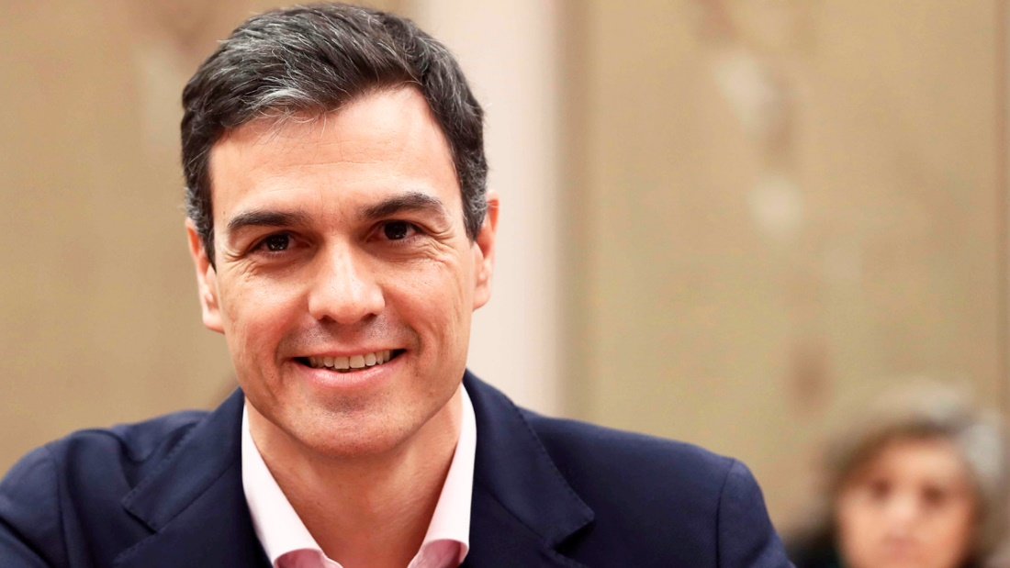
This is Pedro Sanchez.

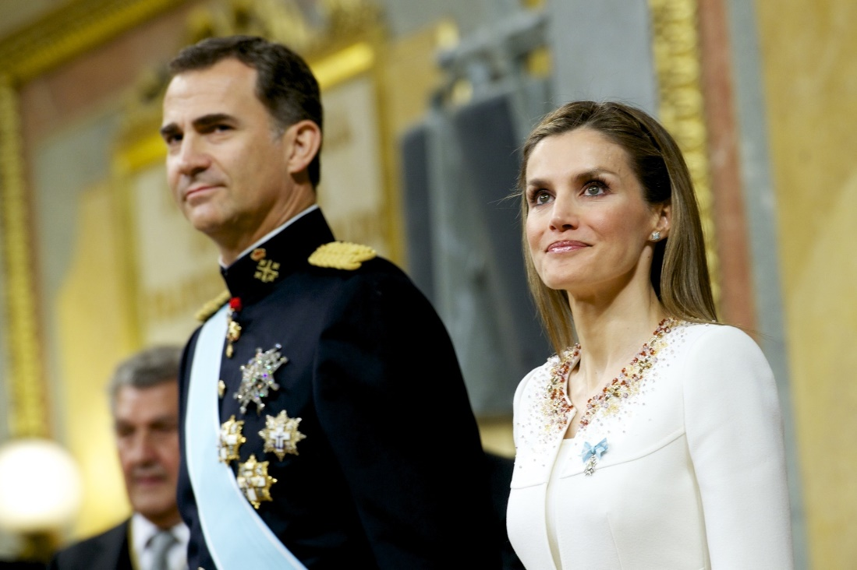
Here are the king and queen, Felipe VI and Letizia.

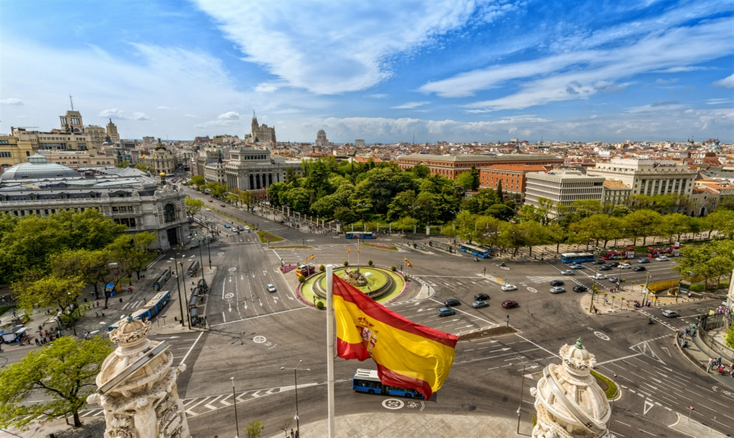
Here you can see the capital of Spain, Madrid.

