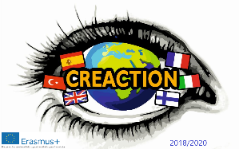
CREACTION
FRANCE- May 6th/ 10th

Day 0 Sunday 5th
- Arrival of the different teams
- Students go to their families. Teachers to hotel.
- Teachers have dinner at restaurant or delivered at home (UK)

Day 1 Monday 6th
- Arrival of students and teachers at 9 at school .Presentation of local and foreign school teams
- Presentation of the week program . Delivery of material.
- Welcome lunch at the canteen
- Ice breaking activities: Drama Workshop and PE classes for students
- 5 pm :Students go back to families/ Teachers hotel

Day 2 Tuesday 7th
- Arrival of students and teachers at 9 at school
- Morning: Conference / Activities about Europe institutions and Elections.
- Lunch at school.
- Afternoon : Cultural Heritage Workshop.Visit of the Medieval City of Provins (UNESCO protected site). Back to families and hotel at 5 pm.

Day 3 Wednesday 8th

- Morning : Article Writing Metholodgy for students.
- Afternoon : Cultural Heritage Visits in Paris.
- Dinners in families/ out for teachers

Day 4 Thursday 9th
- Arrival of students and teachers at 9 at school
- Europe Day : Languages Workshops by Students
- Lunch at school
- Cultural Heritage Workshop.Visit of the Castle of Fontainebleau.
- Back to families and hotel at 5 pm.
- Goodbye party. You can cook traditional recipes at host home and bring them.

Day 5 Friday 10th

- Morning: Exchanges and conversations about the Week. Students work on a final presentation
- Lunch at school.
- Afternoon: . Students work on a final presentation (the end)
Evaluation time, certification

