Little my
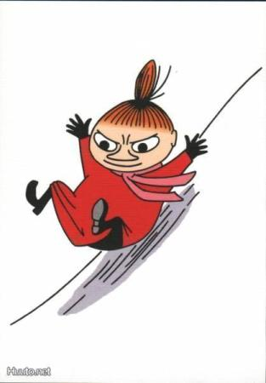

Little my lives with the moomins in the moomin house, even though she isin’t related to them.
She is brave and fearless. She is also fiery and irritable but also happy and friendly she also wants to decide things for her self. Little my likes to find out people’s secrets but she never reveals them to others
She was born on a midsummer night. Moomin family took her in when she was still very young. Little My wears her bright copper-red hear in an onion shaped bun on top of her head and usually wears a red dress.

