GEOGRAPHY – TURKEY

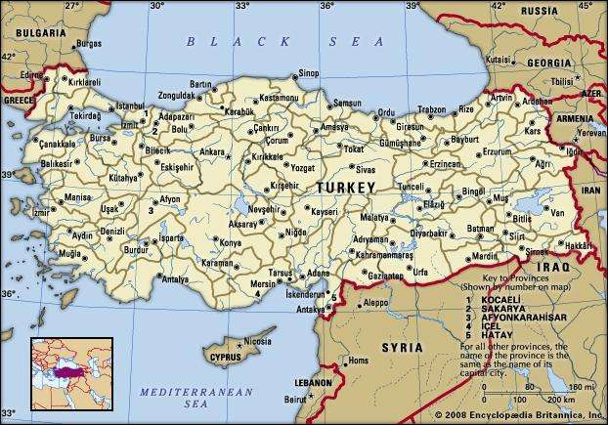

Turkey occupies a unique geographic position, lying partly in Asia and partly in Europe. Throughout its history it has acted as both a barrier and a bridge between the two continents.
Turkey is situated at the crossroads of the Balkans, Caucasus, Middle East, and eastern Mediterranean.
Borders: Turkey is bounded on the north by the Black Sea, on the northeast by Georgia and Armenia, on the east by Azerbaijan and Iran, on the southeast by Iraq and Syria, on the southwest and west by the Mediterranean Sea and the Aegean Sea, and on the northwest by Greeceand Bulgaria.
Turkish straits: the Bosporus, the Sea of Marmara, and the Dardanelles. They link the Black and Aegean seas.
Capital: The capital is Ankara, and its largest city and seaport is Istanbul.
Form of government: parliamentary democracy.
Mountains: Turkey’s highest mountain is Mount Ararat (5,165 metres); in the southeast there is the Uludoruk Peak (4,744 metres); in the west, the Demirkazık Peak (3,755 metres) and Mount Aydos (3,479 metres).

Rivers: Aras River (400 km), Euphrates (1,250 km) and Tigris rivers (530 km).

Lakes: Turkey has about 50 lakes; saline lakes: Lake Van, Tuz; freshwater lakes: Lakes Akşehir, Eğridir, Beyşehir and Lake İznik.
Climate: The coastal areas of Turkey have a temperate Mediterranean climate, with hot, dry summers and cool, wet winters.
The coastal areas of Turkey have a temperate Oceanic climate with warm, wet summers and cold, wet winters.
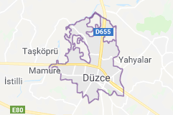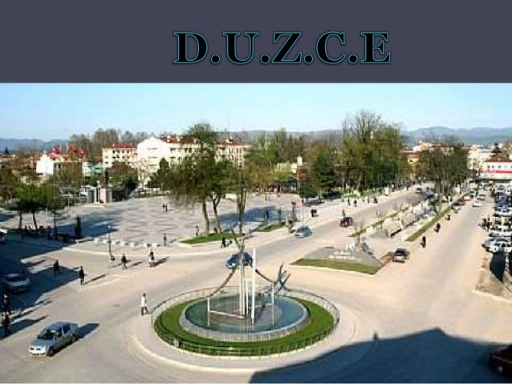

Duzce is the city of our Turkish friends.

