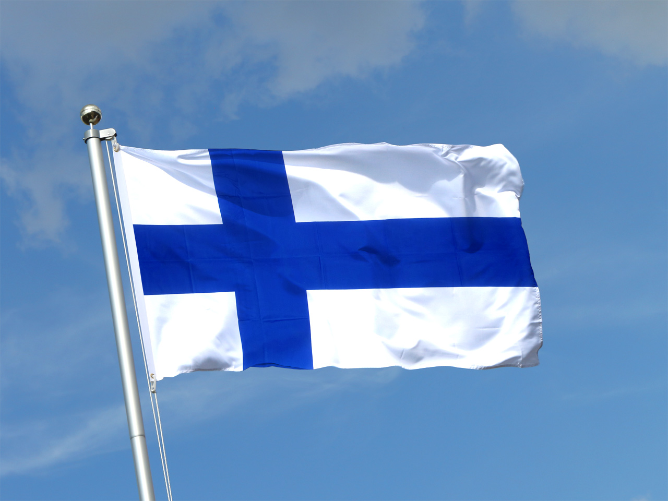
Music in Finland

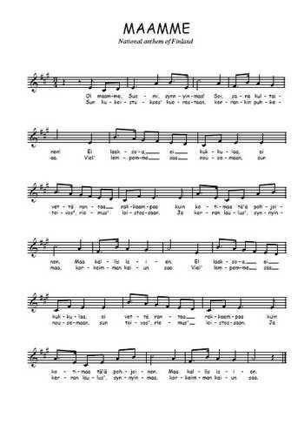
In Finland the National anthem’s name is “Maamme” this anthem was written in 1848 and adopted in 1868. His writer is Johan Ludvig Runeberg and the music is from Fredrik Pacius.


The international singer in Finland is Robin Packalen (born August 24, 1998), better known by his stage name Robin. He is a Finnish singer and teen pop artist. Over the course of his career, Robin's albums and certified singles have sold more than 370,000 copies, making him one of the top 70 best-selling artists in his country.
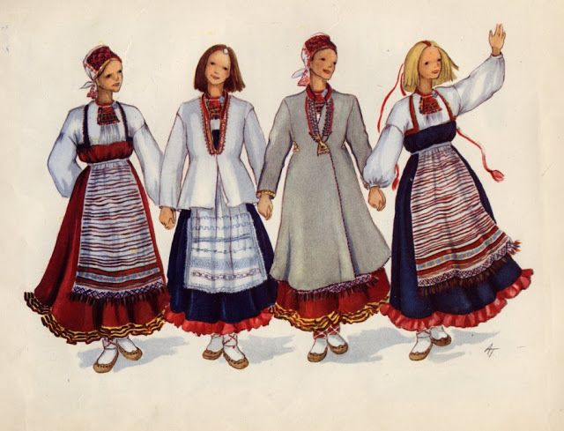
The traditional music in Finland it’s the karelian. It’s a traditional Karelian music as expressed by Kalevala and considered the purest expression of Finnish myths and beliefs. This Finnish traditional music has been experiencing a revival in recent decades, and has become a branch of popular music.

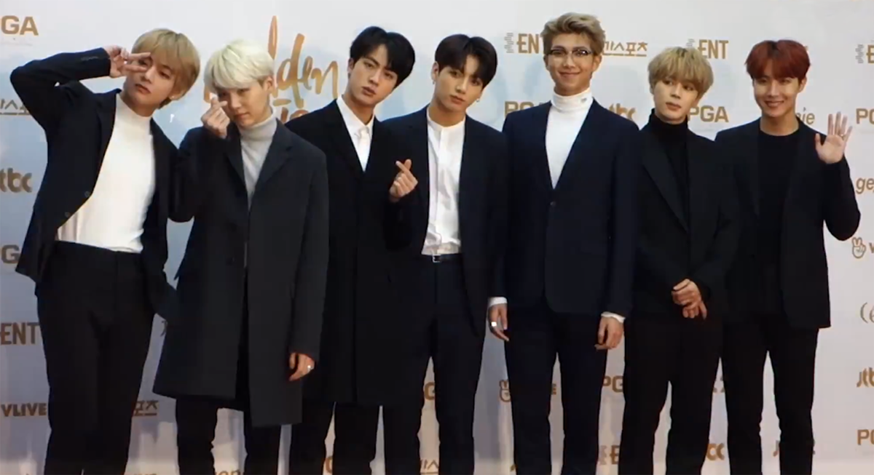
Students’ favorites

Their favorite band is BTS their musical style is the K pop is a South Korean boy band from Seoul. It is formed in 2013 by Big Hit Entertainment and consists of seven members: Jin, Suga, JHope, RM, Jimin, V and Jungkook.

They listen to normal pop. K-POP. This musical trend invented after the war to help the financial crisis that crossed South Korea, in 1992, saw its popularization be launched through the group Seo Taiji & Boys, whose fusion between several musical styles (and mainly hip-hop) was a great success, revolutionizing the music industry in South Korea3. As a result, the addition of elements from foreign music becomes a commonplace practice in the K-pop4 industry.

The most popular singer is Ville Hermanni Valo, born on November 22, 1976 in Vallila, a suburb of Helsinki, Finland. He is a Finnish singer-songwriter known as the singer of the band HIM

The singers that the teenager listen to in Finland are :TPITZ Hurriganes, uure Boelius, Eino ja Aapeli, Isac Elliot, Robin,Trisha paytas ,Jeffree Star, Britney Spears, Christina Aguilera, Demi Lovato, Ariana Grande, BTS, BIGBANG,NCT, BLACKPINK RED VELVET, GOT7, EXO, TWICE, SEVENTEEN, iKON, UNB, Jackson Wang ERIKSEEN, and others ACDC, Iron

