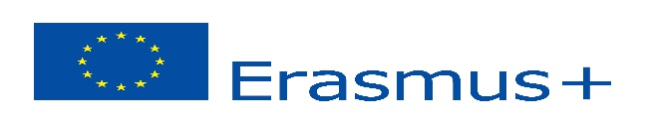
“SCIENCE THROUGH EXPERIMENT IN EUROPE”
Turkey,Poland,Spain,Slovenia,Greece,Romania

Key Action 2: Cooperation for innovation and the exchange of good practices
STUDENTS: INITIAL QUESTIONNAIRE 2018
(To be distributed at the beginning of the project, explaining each item to the students)
 |  |  |  | 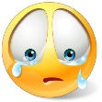
I HAVE HAD THE OPPORTUNITY TO GET TO KNOW PEOPLE FROM FOREIGN COUNTRIES | 41 | 5 | 1 | 1
I KNOW WHERE THE COUNTRIES IN THIS PROJECT ARE LOCATED | 37 | 7 | 3 | 1
I KNOW FEATURES OF DIFFERENT EUROPEAN COUNTRIES | 16 | 25 | 6 | 1
THE GAMES I PLAY AND THE THINGS I PLAY WITH ARE THE SAME AS THAT OF OTHER EUROPEAN CHILDREN | 10 | 22 | 14 | 2
MY SCHOOL IS SIMILAR TO SCHOOLS IN OTHER EUROPEAN COUNTRIES | 26 | 20 | 1 | 1
I THINK I WILL BE ABLE TO COMMUNICATE EASILY WITH OTHER EUROPEAN CHILDREN | 37 | 9 | 2 | 0
I WILL HAVE FUN DURING THE PROJECT ACTIVITIES | 31 | 15 | 2 | 0
I WILL WORK TO IMPROVE MY KNOWLEDGE OF EUROPE (people, culture, territory, habits…) | 16 | 23 | 7 | 2

THE MEETINGS WILL BE THE OPPORTUNITY TO: | Please, mark 4 preferences
- GET TO KNOW OTHER CHILDREN - 35
- VISIT NEW PLACES - 30
- TASTE LOCAL DISHES - 20
- SPEAK A FOREIGN LANGUAGE - 22
- TAKE A JOURNEY WITHOUT MY PARENTS - 9
- BE RESPONSIBLE - 9
- HAVE FUN - 37
- FIND OUT ABOUT DIFFERENT WAYS OF LIFE - 16
- TRAVEL BY PLANE - 14
- HAVE 5 DAYS HOLIDAY - 15

DURING THE MEETINGS, I WILL LEARN TO: | Please, mark 4 preferences
- LIVE WITH CHILDREN FROM OTHER COUNTRIES -17
- APPRECIATE DIFFERENT CULTURES –25
- BE A EUROPEAN CITIZEN -18
- DISCOVER NEW PLACES - 28
- TEACH OTHERS ABOUT MY OWN COUNTRY -18
- IMPROVE MY ENGLISH -27
- COMMUNICATE IN SEVERAL WAYS -20
- BE MORE RESPONSIBLE AND INDEPENDENT -14
- EXPRESS MY CREATIVITY -20
- COLLABORATE WITH CHILDREN WHO SPEAK DIFFERENT LANGUAGES -20

