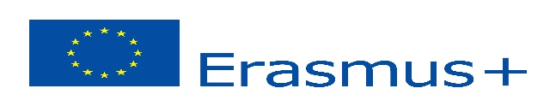
“SCIENCE THROUGH EXPERIMENT IN EUROPE”
Turkey,Poland,Spain,Slovenia,Greece,Romania

Key Action 2: Cooperation for innovation and the exchange of good practices
STUDENTS: INITIAL QUESTIONNAIRE 2016
(To be distributed at the beginning of the project, explaining each item to the students)
 |  |  |  | 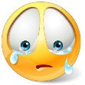
I HAVE HAD THE OPPORTUNITY TO GET TO KNOW PEOPLE FROM FOREIGN COUNTRIES | 194 | 57 | 24 | 48
I KNOW WHERE THE COUNTRIES IN THIS PROJECT ARE LOCATED | 108 | 91 | 76
I KNOW FEATURES OF DIFFERENT EUROPEAN COUNTRIES | 87 | 91 | 50 | 105
THE GAMES I PLAY AND THE THINGS I PLAY WITH ARE THE SAME AS THAT OF OTHER EUROPEAN CHILDREN | 118 | 113 | 44 | 48
MY SCHOOL IS SIMILAR TO SCHOOLS IN OTHER EUROPEAN COUNTRIES | 100 | 86 | 69 | 68
I THINK I WILL BE ABLE TO COMMUNICATE EASILY WITH OTHER EUROPEAN CHILDREN | 138 | 83 | 60 | 42
I WILL HAVE FUN DURING THE PROJECT ACTIVITIES | 210 | 53 | 19 | 14
I WILL WORK TO IMPROVE MY KNOWLEDGE OF EUROPE (people, culture, territory, habits…) | 200 | 94 | 17 | 12

THE MEETINGS WILL BE THE OPPORTUNITY TO: | Please, mark 4 preferences
- GET TO KNOW OTHER CHILDREN - 247
- VISIT NEW PLACES - 204
- TASTE LOCAL DISHES - 150
- SPEAK A FOREIGN LANGUAGE - 103
- TAKE A JOURNEY WITHOUT MY PARENTS - 83
- BE RESPONSIBLE - 130
- HAVE FUN - 157
- FIND OUT ABOUT DIFFERENT WAYS OF LIFE - 106
- TRAVEL BY PLANE - 114
- HAVE 5 DAYS HOLIDAY - 119

DURING THE MEETINGS, I WILL LEARN TO: | Please, mark 4 preferences
- LIVE WITH CHILDREN FROM OTHER COUNTRIES -161
- APPRECIATE DIFFERENT CULTURES –149
- BE A EUROPEAN CITIZEN -100
- DISCOVER NEW PLACES - 208
- TEACH OTHERS ABOUT MY OWN COUNTRY -170
- IMPROVE MY ENGLISH -175
- COMMUNICATE IN SEVERAL WAYS -85
- BE MORE RESPONSIBLE AND INDEPENDENT -200
- EXPRESS MY CREATIVITY -192
- COLLABORATE WITH CHILDREN WHO SPEAK DIFFERENT LANGUAGES -135

