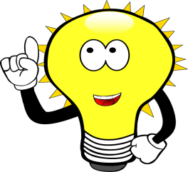
Hi! My name is The Little Light Bulb. I am the children's friend and I want to teach you some things about me and my girlfriend, The Electricity.
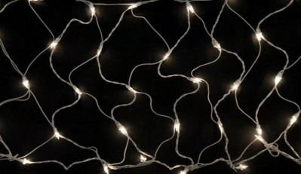
But where did we meet?
- 1. ... in public and household lighting .........................
- 2. ................... in transport and industry .....................
- 3. .......................... in trade, traffic lights ..................

Why do you think I can light?
- You can light because the electrical current generated by the electricity passes through your filament.
- If the Electricity did not exist I, The Little Light Bulb , would not exist either. That is why it is very important to present it.
Recognize the sources of electricity generation.

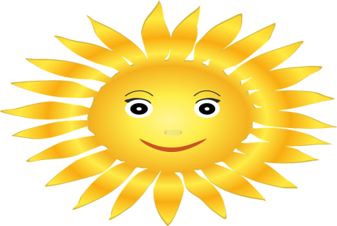
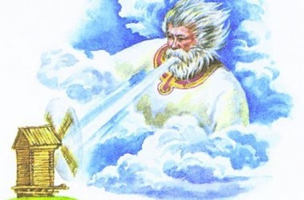
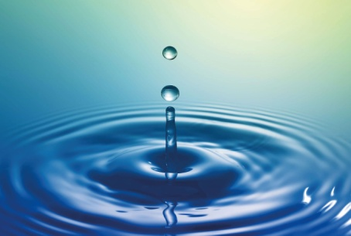

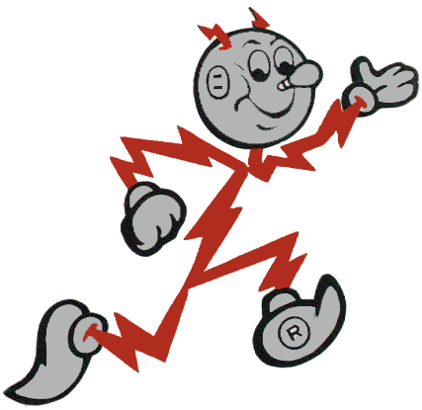
List the three energy sources.
................................

..........................

..................

The water has been used to produce energy since ancient times.
Enumerați tipurile de energie produsă utilizând apa.
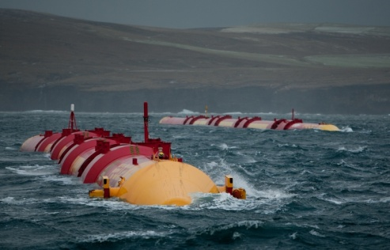
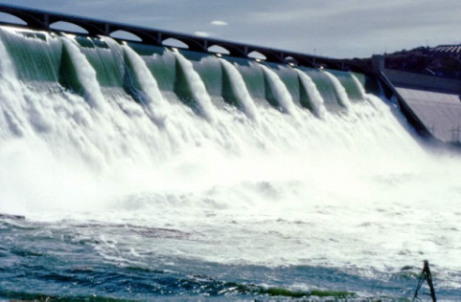

...............................

.............................................
-

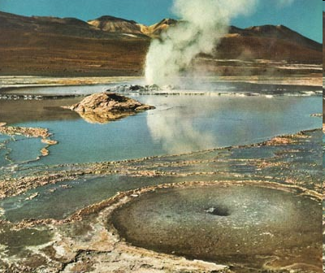
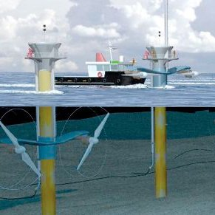

...............................
........................................

The wind is a source of energy for the production of electricity.
Specify the type of energy produced by the wind.
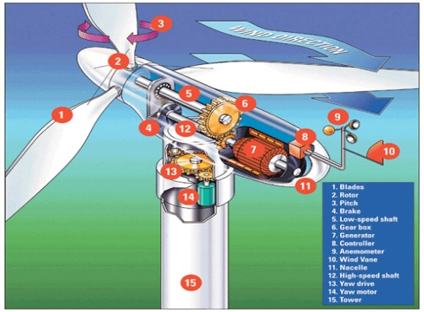
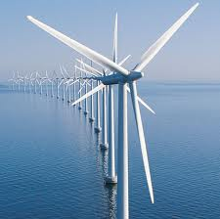

.......................................

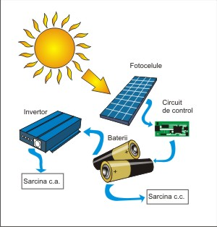
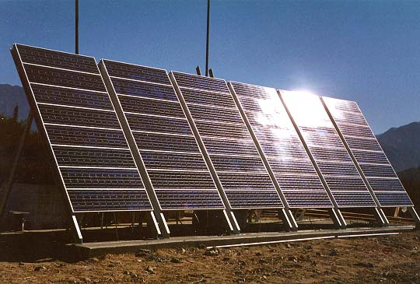
The sun is a source of energy for power/electricity generation.

………………………….

What other type of energy is used in power generation?
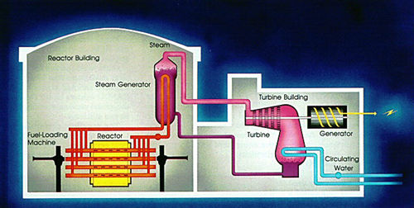
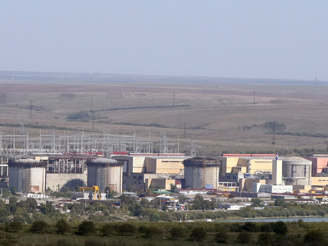

...........................

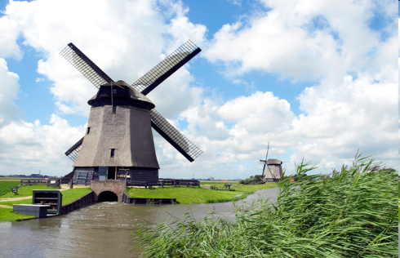
How was the energy produced by water and wind used long time ago?
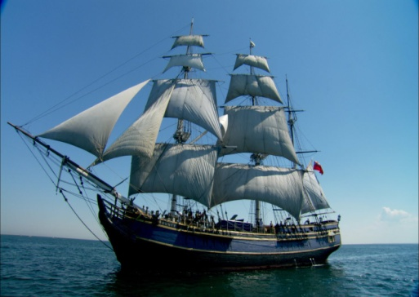
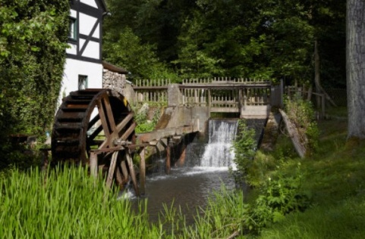

.
The water mill and the windmill transform the energy of water and wind into mechanical energy for grinding cereals.
Sailing ship for navigation at sea.
We presented to you the resources and types of energy. But how does electricity come into/enter in people's houses?
Electricity is produced in power plants and transported by high or underground power lines by low, medium or high voltage lines, then distributed to consumers.
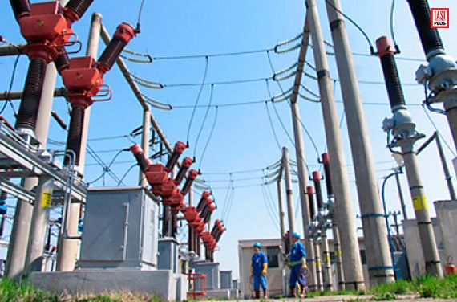
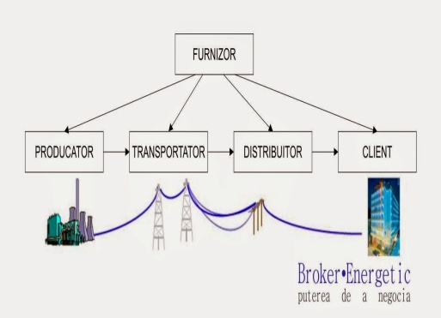

Provider, Producer, Carrier, Distributor, Customer
Electricity, my friend has other friends in the people's houses? Present them, please.
1. Appliances ................................
2. Electronic devices .............................................. ...............................
3. Lamps ...............................
4. Batteries................................
In what materials from home appliances do I find my girlfriend, Electricity?
Metallic materials are good materials conducting electricity.
But why do household appliances have plastics, rubber or cotton in their composition?
Because they are insulating materials and protect people against electric shock.

What are the exhaustible and inexhaustible sources of electricity generation?
Exhaustible resources | Inexhaustible resources
-(chemical energy of fuels)/ Oil | -( -wave energy
- natural gas | - tidal energy
- coal | -wind energy
-wood | -solar energy
 | -geothermal energy
Practical Application:Build a simple electrical circuit.

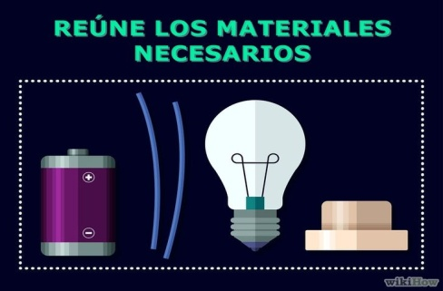
Materials required:
• Battery
• Two metal wires (conductors)
• A light bulb
• A switch
Remarks:
The electrical current comes out of the battery via the terminal marked +, passes through the circuit breaker that turns off the electrical circuit, the bulb illuminates and reaches the battery again via the terminal marked with -.
Conclusions:
• The power source is the battery.
• The electricity consumer is the bulb.
The electric current flows through the metal wires and therefore the light is lit.
• The switch closes or opens the power circuit

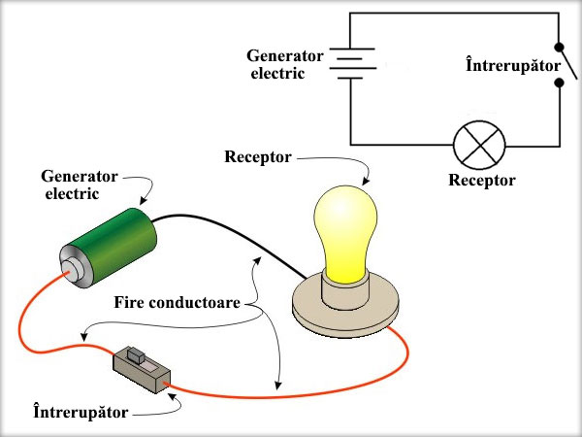

- power generator
- switch
- receiver
- conductive wires
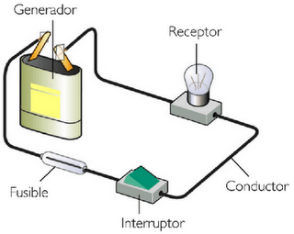

The sun and the wind can save the planet.

Renewable energies, based on wind, water and especially on the sun head to sustainable development, even if this thing does not solve all the problems.
Electricity cannot be stored, so it needs to be consumed. I, The Little Light bulb turn it / transformit into light energy

