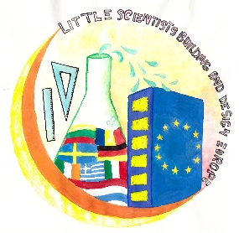
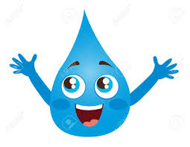Hello, my name is Water. I am your best friend. You love me so much that you live only for ……… days without me.
But, where do I come from? 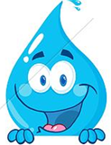
1. ……………………………………………………..
2. ……………………………………………………..
3. ……………………………………………………..
4. ……………………………………………………..
5. ………………………………………………………

Do I ever finish? 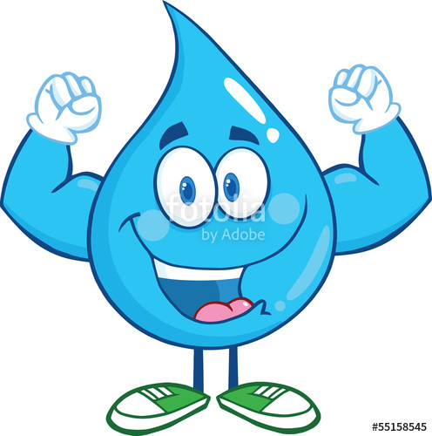
……………………………………………………………………………………………………………….
……………………………………………………………………………………………………………….
……………………………………………………………………………………………………………….

Where do you get me when you are thirsty?
……………………………………………………………………………………………………………….
…………………………………………………………………………………………………………………
…………………………………………………………………………………………………………………
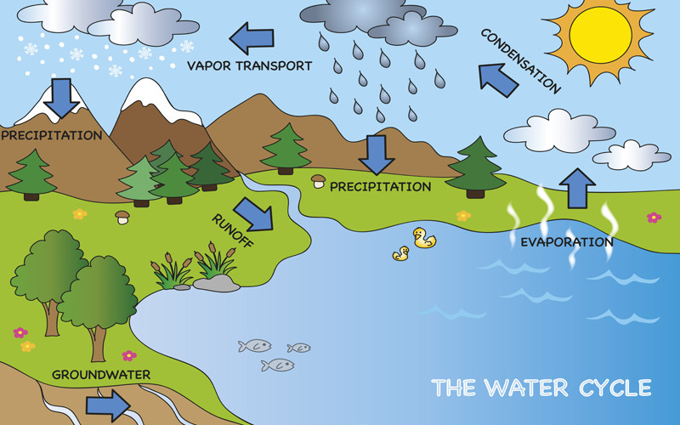
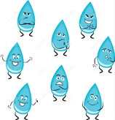
You see here how my family, The Drops and I, go round and round, from the beginning of the Earth some million years ago.

Aha! This means;
You use the same water as dinosaurs did!
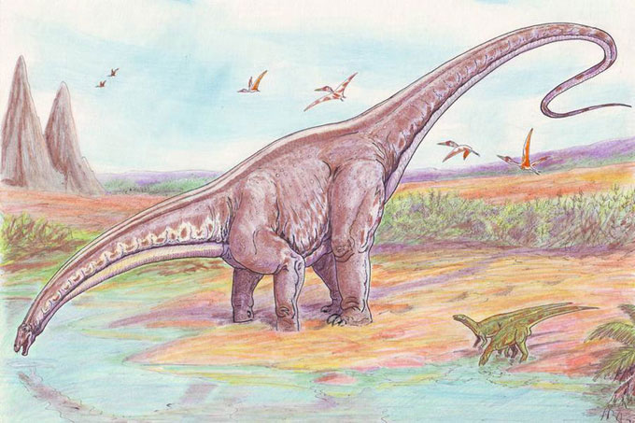

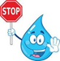
There is plenty of water. 71% of the Earth is covered with water! Isn’t it?
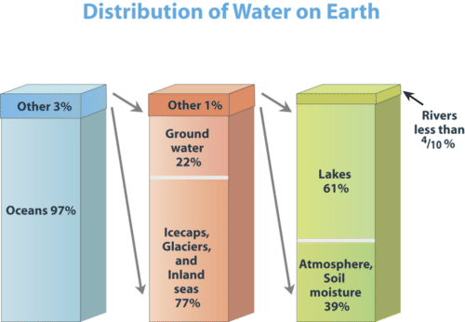This means! 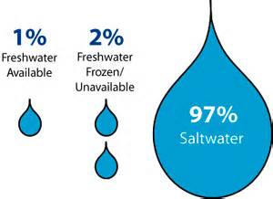

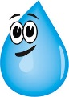
What happens if we pollute the water?
………………………………………………………………………………………………………………………….
………………………………………………………………………………………………………………………….
…………………………………………………………………………………………………………………………. Could you decribe how the water cycle works in a city?

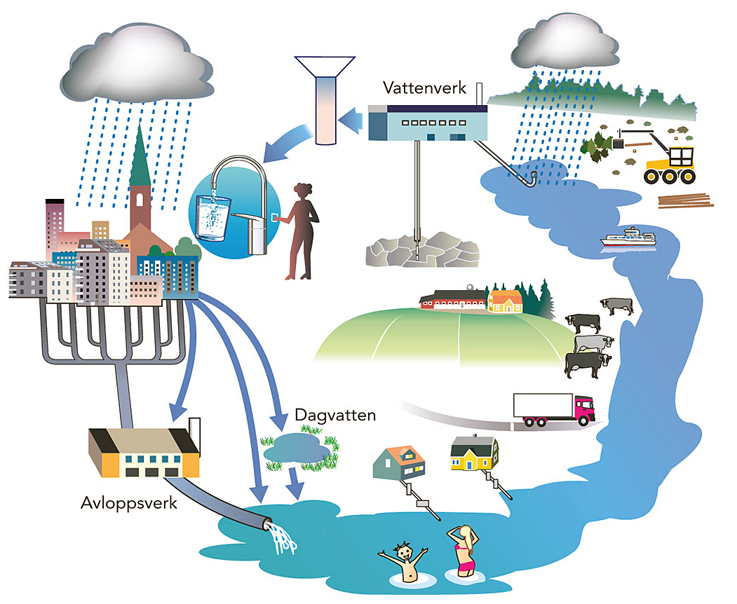
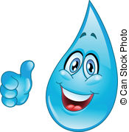
Please study the picture of the city!
Then, find out how The Drops Family get to your home?

