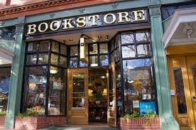

How to open a store?
Make your dreams come true

The idea to open their own shop comes up in the minds of many people when they think about their future plans. Therefore, we invented a step-by-step plan to help you make your dreams come true. We will show you the plan referring to the example of two brothers who opened a bookstore.

Step 1:
To open a shop it is very helpful to study economics.

Step 2:
Make up your mind about what kind of store you want to open.
Which store is most efficient?

Step 3:
Then you can create a business plan. It should include the money you have, the money you need and the money you will earn. Furthermore, it should have a timetable for all the work that needs to be done before opening the store.

Step 4:
Find the perfect place for your store. It should be affordable and located where it is needed. (For example, a bookstore close to another one is not very effective.)

Step 5:
If you need support in terms of money, you can get it from the bank. There are many possibilities for young contractors to get financial help.

Marie, ...

Step 6:
Depending on what kind of shop you want to open, you can make special contracts, for example you may only have to pay what you sell.

Step 7:
Open your store as soon as possible, because you pay taxes no matter if your shop is open or closed.

To open your own store is not that easy, but if you work hard and follow the listed tips, as the two brothers did, you can make your dreams come true.

We wish you a successful start creating your own shop...


