Youth Unemployment Rate in Germany

The number of 15-24-year-olds in Germany who are neither working nor in training is the lowest in the EU, official data for 2014 show. In 2014, there were 330,000 people aged 15 to 24 out of work, according to figures released by Germany's statistics office, Destatis, on Tuesday. The office puts the rate of youth unemployment in Germany at 7.7 percent, the lowest in the EU.
Youth Unemployment Rate in Germany decreased to 7 percent in September from 7.10 percent in August of 2015. Youth Unemployment Rate in Germany averaged 9.65 percent from 1991 until 2015, reaching an all time high of 15.60 percent in May of 2005 and a record low of 5.70 percent in February of 1991. Youth Unemployment Rate in Germany is reported by the Eurostat.
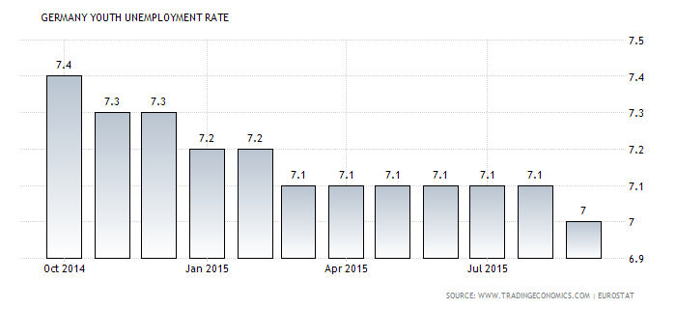

Actual | Previous | Highest | Lowest | Dates | Unit | Frequency
7.00 | 7.10 | 15.60 | 5.70 | 1991 - 2015 | percent | Monthly

This page provides the latest reported value for - Germany Youth Unemployment Rate - plus previous releases, historical high and low, short-term forecast and long-term prediction, economic calendar, survey consensus and news. Content for - Germany Youth Unemployment Rate - was last refreshed on Monday, November 2, 2015.

