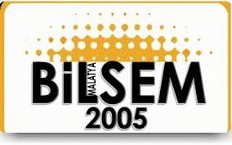

Toli Zordumis School
Boro Prcan 38, Kumanovo,Skopje Macedonia
Telephone Number: +389 31 412 311

MALATYA BİLİM VE SANAT MERKEZİ

Karakavak Mah. Turgut Özal Bulvarı No117/7 MAŞTİ Karşısı
Yeşilyurt/ Malatya
Telephone +90422 238 03 33- Fax +904222384141 - e-mail:
756527@meb.k12.tr
I N V I T A T I O N
With in the frame of Erasmus+ programme , Key Action 2,Strategic Partnerships ,we are pleased to invite the delegation of consisting of: Toli Zordumis-Macedonia

1. Natalija Spasovski
2. Olivera Saltirovska

to the Transnational Project Meeting of the partnership „Communication Through Art and Music Integrated With ICT, project’s number 2017-1-TR01-KA219-046529”
In Malatya,Turkey, during 29 of April 2019 - 03 of June 2019

The aims of the meeting are
• to share good practices of art, music and ICT in our schools
• to share experiences and local natural and cultural values
• to fulfill the goals of the transnational project meeting
• to work on project final report

I you have any question regarding this meeting, please send an email to ayikzuhal@gmail.com (contact person) or 756527@meb.k12.tr (school).
We look forward to meeting you soon in our country.

Malatya, 28/03/2019
Yours sincerely,

Umit Arslan
the head master

