From Globe to Erasmus
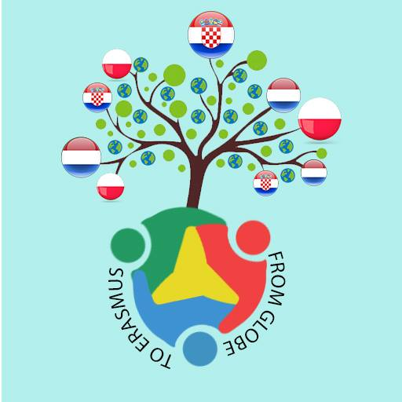

Written by: Paulina, Jazz, Lucia, Tijn, Magda, Ivo and Floor

The project ‘From Globe to Erasmus’ is all about learning to work alongside with people from other countries. The exchange started in Poland where we were introduced to Erasmus and his ideas. We were told that we would form groups of people from Croatia, Poland and the Netherlands. For each research group, teams would be formed consisting of 2 students from each country specializing in one topic. The topics that we could choose from are all geography related; land, water and air. We as the students had almost complete freedom in choosing our topic as long as it fitted within these criteria. Some of the Concerning subject you can think of are: flooding, pollution and of air water or land... We will also have to do at least one series of measurements according to Globe protocols and upload the to the database of Globe.
Besides the research, there would be four exchanges during which pupils would get to know, and learn from, each other. In every exchange there would be 6 people from each country.

As mentioned before, we all had to make projects. For the project we chose one of the 4 spheres; lithosphere (land), hydrosphere (water), biosphere (living things), and the atmosphere (air). For the project two people of each country teamed up and later they were matched with the other countries. After that we made a research question and the hypothesis in that groups. Then we did some measurements and as well as some researches and we compared them with results from other countries. When the data was collected, the Dutch people created an essay and we published everything on our padlet which we did in a group of Polish and Croatian people.
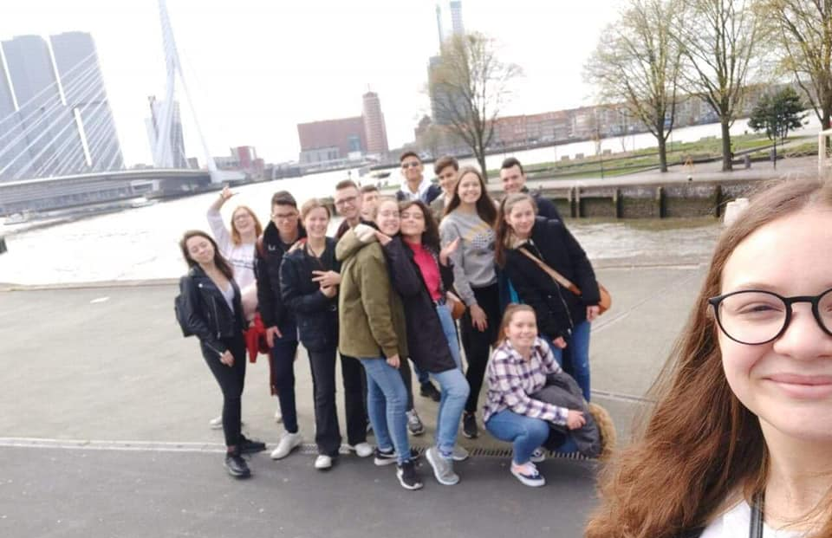
In the Netherlands we choose the top 3 projects (top 3 essays and top 3 padlets). We considered summary, if they had GLOBE protocols, the quality of research question, investigation plan, research methods, GLOBE data, if they used tables or some graphics of data, conclusion and teamwork.

During the last meeting in the Netherlands three projects were chosen to be ‘the best’. Two of the projects were about the hydrosphere and the other one about the atmosphere. The best of all was the project of Nasreddine, Nicole, Deniz, Marcin, Kinga, Anna, Anamarija and Vito. Their research question was ‘what is the correlation between the size of the city and the pH level of the rivers’. The reason for their project being the best is because of the good communication between the different groups, it had a clear structure and their research was very relevant to this project and it showed new insight. This did not go well in every project as for group 27 the communication did not go very well. In their evaluation they made clear that they did not receive the results from Croatia and therefore the accuracy of the research was decreased. This could be improved in the next trial by adding stricter rules or consequences to the communication. Next to that we can do weekly check ups on what we did and what results we collected to that point. However group 27 did do very good on the role distribution and they showed a very detailed investigation plan on how factories influence the water parameters. The third best group, group 29, looked at the atmosphere with the research question; ‘What effect do gas emissions have on pH value and how does it change in different surroundings?’ They showed good research and gave more insight on the problem of polluted air and they showed that there were no struggles in the communication. Other projects did not seem to reach all the criteria as there were still a lot of confusion. This could be prevented if the groups were made of the more engaged people and if they were to have the same age. Some projects also seemed to lack a good research question, therefore we suggest that the teachers also take a look at that before the research starts. Overall the project did teach us how to work together with other countries. Even though it had not always been easy and a lot still needs improvements, we do think it offered an interesting experience.

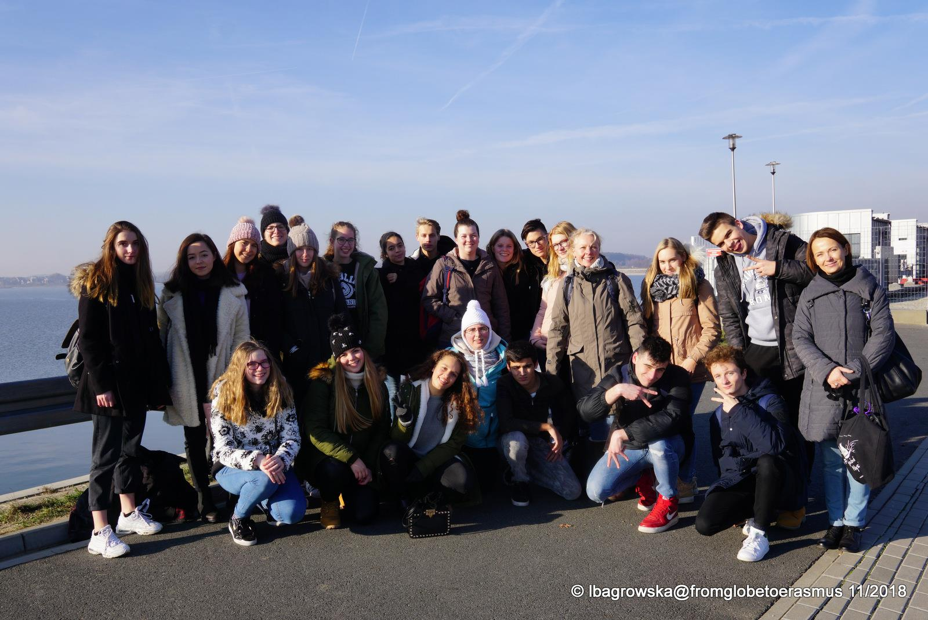
The first time we met was in Poland. We went to Poland with 6 Dutch and 6 Croatian students. To officially start ‘from Globe to Erasmus’. In Poland, the student got to know each other better and we received more information on what the goal of the project was. During that week we also did several other activities as we went bowling, did some experiments on the water in the reservoir in Nysa. After that week, we got matched up and did the projects as explained before. The second exchange was in the Netherlands, this is where we evaluated what we did and what could be improved. The Croatian group that went to the Netherlands was a totally different group, while the Dutch and Polish group already had met up. However this did not stop us from forming new friendships. All the foreign groups stayed at host families during the exchanges. This also allowed the students to experience the different cultures in the houses as well. It was very interesting to see this differences, especially for the different foods. For example, we got to eat Pierogi, which are a sort of Polish dumplings, and stroopwafels, which are Dutch waffles with syrup. Overall the meetings gave us more insight on the project and allowed us to think of improvements for next year’s exchanges.

Interview:
We interviewed one student from Poland who participated in this project - Magda Maroszek. She participated in the first exchange week in Poland and the second exchange week in the Netherlands. Here are some interesting answers.

How did you like the project?
It was an amazing opportunity to meet people from other countries, it was really fun.

Who were you in the project with?
In this project I was with Lotte Harmsen, Amber Balesar, Ema Bauer, Karla Jakac and Paulina Salega.

What was the most inspirational thing about this project?
The most inspirational thing in this project was meeting with my friends from other countries.

What don’t you like about this project?
Sometimes it was hard to understand each other in a group.
Tijn: What I really did not like was that the project felt so experimental

What makes your heart sing?
Traveling makes my heart sing.

What was the hardest thing to do in this project?
The hardest thing in this project was to communicate with people who I didn’t know.

Was the research interesting to you?
Yes, it was very interesting, it was funny to do the measurements with Paulina (my group partner).

What did you research?
We researched the quality of tap water in every country in different parts of the city - suburbs and centrum of the city.

Do you like the food in the Netherlands?
I really like the food in the Netherlands. My Dutch mom makes the best food ♥.

What was the most interesting thing about the first week of exchange in Poland?
I made new friendships for my entire life. I’m grateful that I can see them again.

Would you like to be in the project next year? Why?
Yes, I would really like to see the same people again.

Do you prefer the theoretical or practical part of the project?
I prefer the practical part of this project. The results of the measurements were really surprising for us. We were wrong with our hypothesis.
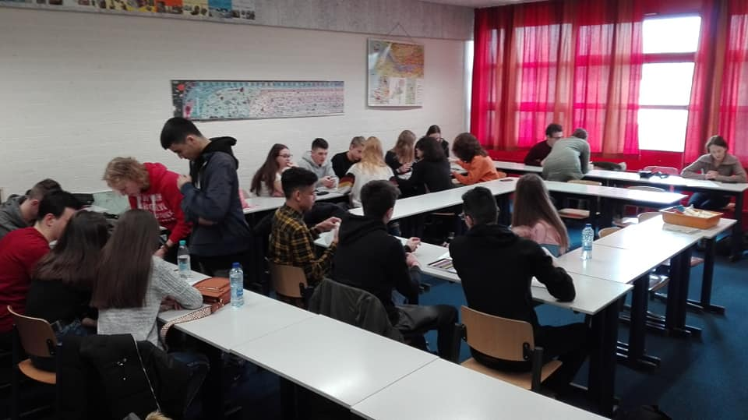

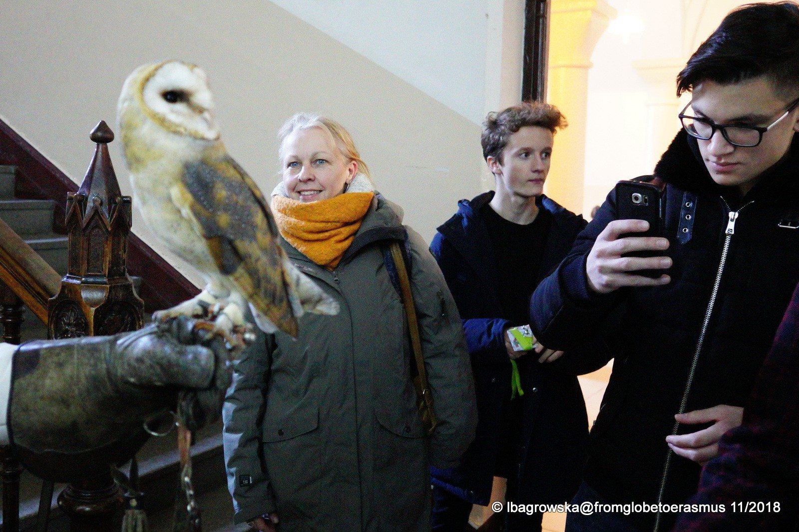
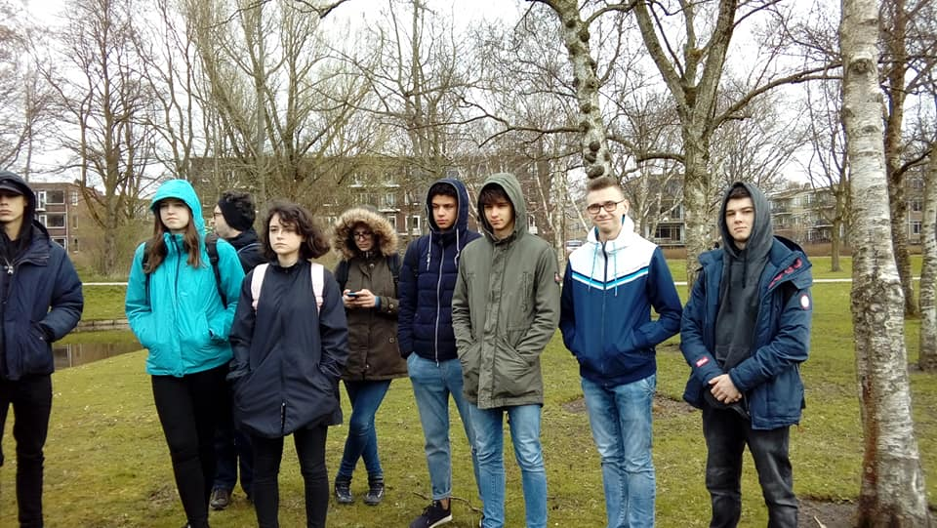
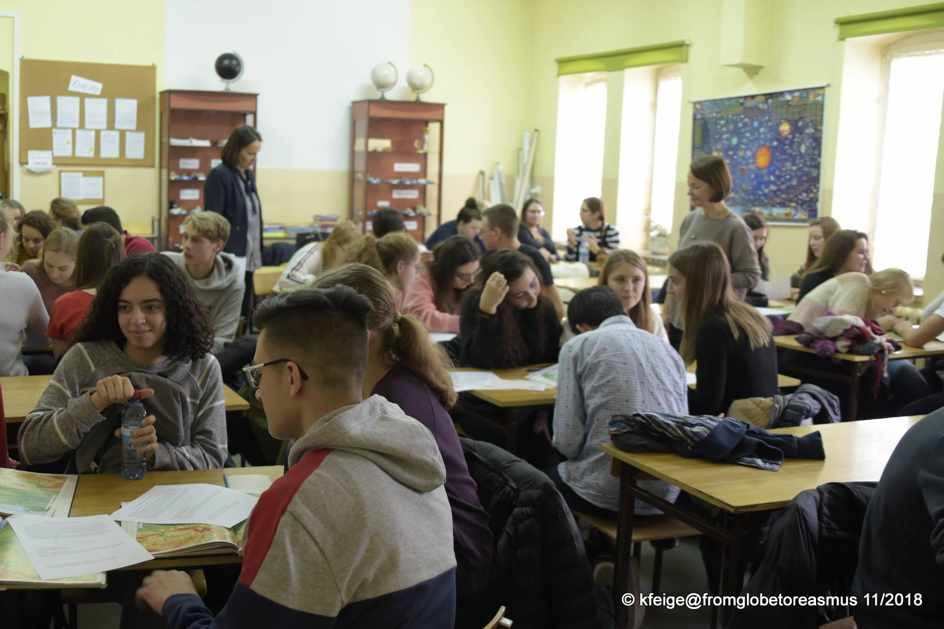

Project by Kenan, Bente, Jakub, Paulina, Vjekoslav, and Toni
Project by Erva, Erin, Emilia, Dominika, Jana, and Leona

