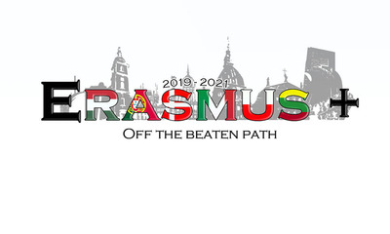
Erasmus + Off the Beaten Path Quiz
Society of the Tisztviselotelep and
Ganz Colony

Part 1 – Tisztviselotelep
Question 1
Who had their first church built in Tisztviselotelep ?
- Luterans
- Catolics
- The reformed congregation
Question 2
Wich one of this schools was opened first ?
- School in Vajda Péter Street
- The Royal Széchenyi István Secondary School of the Hungarian State
- School in Elnök Street
Question 3
Who came up with an diea of building Tisztviselotelep aglomeration ?
- Government
- Workers associaton
- Officials
Question 4
What thoes the term „ Officials’’ ment in XXth century houngary ?
- Politician
- Celebrity
- Someone with a degree
Question 5
Who was the coordinator of building Tisztviselotelep
- Ferenc Gaál
- Vajda Péter
Part 2- Ganz Colony
Question 6
Who lived in Ganz Colony ( choose two answers)
- Factory Workers
- Officers
- Factory menagment
- Criminals
Question 7
What kind of flat was avilable for the factory menagers
- 1 room flat
- 2-3 room flats
- Basement flats
Question 8
Who designed house esthablishment in Ganz colony
- Petr Vajda
- Pal Liptak
- Könyves Kálmán
Question 9
How many tubs were in the bathhouse
- 3
- 14
- 10
Question 10
How many children could the kindergarten accomodate
- 50
- 60
Check your answers :
- Catolics
- School in Vajda Péter Street
- Officials
- Someone with a degree
- Feren Gaal
- Factory workers and managment
- 2-3 room flats
- Dr. Pal Liptak
- 14
- 60

