ACTIVITY  FIRST TECHNICAL SCHOOL  KRAGUJEVAC, SERBIA | QR KOD
JANUARY
1-Geometry of flags
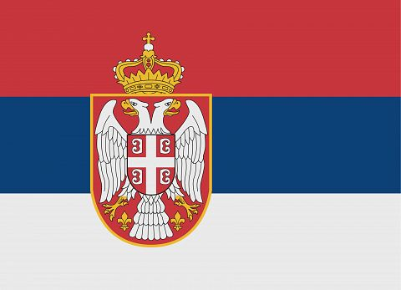
JANUARY
1.1-Geometry of flags
JANUARY
2-The Story of theFlag
FEBRUARY
1-Geometry of HistoricalBuildings
FEBRUARY
2-Geometry of DecorationArts in Architecture
MARCH
1- Geometry in TraditionalClothing
MARCH
2- T-shırtdesıgnusınggeometrıcfıgures
APRİL
1- House StuffGeometry
MAY
2- Famous mathematicians

