ACTIVITY | QR KOD
JANUARY
1-Geometry of flags
JANUARY
2-The Story of theFlag

FEBRUARY
1-Geometry of HistoricalBuildings

FEBRUARY
2-Geometry of DecorationArts in Architecture
MARCH
1- Geometry in TraditionalClothing
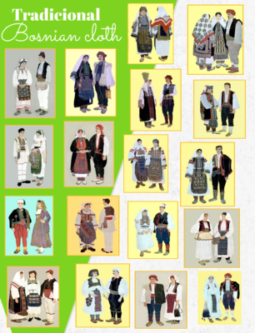
APRİL
- House StuffGeometry
MAY
- Famous mathematicians

