ACTIVITY | QR KOD
JANUARY
1-Geometry of flags

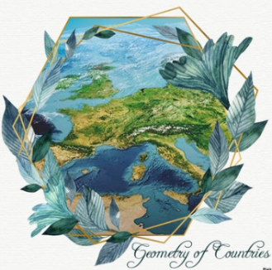
JANUARY
2-The Story of the Flag

FEBRUARY
1-Geometry of Historical Buildings

FEBRUARY
2-Geometry of Decoration Arts in Architecture

MARCH
1- Geometry in Traditional Clothing

MARCH
2- T-shırt desıgn usıng geometrıc fıgures

APRİL
1- House Stuff Geometry

APRİL
2- Language of Geometry in Traditional Household Goods

