OUR EUROPEAN BOOKShELF

TURKEY

Classical writer:
Mevlana Celaddiin-i Rumi i
In addition to his best-known book of verse, Masnawi, he also wrote Divan-i Kebir; Fih-i Ma-Fi, Mecalis- i Seb’a and Mektubat.
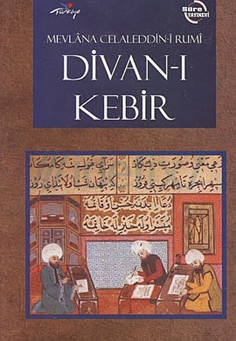
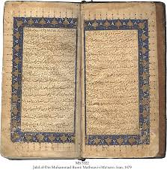

extract:
THE SOLOMON AND HOOPOE
Gathering together all the birds came to the presence of the Prophet Solomon. They began to show their talents and abilities to be close to him. The turn came for the hoopoe and he said " O Sultan, I will declare only one talent, wich is an infernior one; at the time when I am at zenith, I gaze from the zenith with the eye of certainty and I see the water at the bottom of the earth. So that (I know) where it is and what is its depth; what its colour is. I see them all.
Then said Solomon, "O you may be a good companion in waterless deserts !"
When the crow heard this, from envy he came and said to Solomon,"If he had always had this keen sight, how would not he have seen the snare beneath a handful of earth?" He disclaimed the talent of the hoopoe.
Then the Prophet condemned the hoopoe.
The hoopoe replied, "O Sultan, I see every trap in the air if the destiny does not muffle the eye of my intelligence. however, when the destiny comes, wisdom goes to sleep..."
Know that it is by the destiny that the infidel disbelieves in the destiny.

Contemporary writer:
Orhan Pamuk
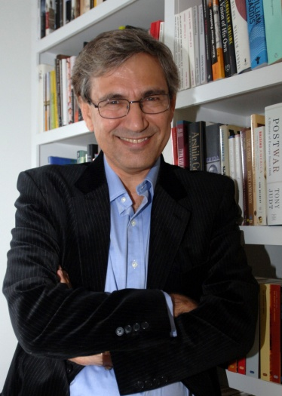
THE RED-HAIRED WOMAN  Orhan Pamuk’s tenth novel, The Red-Haired Woman is the story of a well-digger and his apprentice looking for water on barren land. It is also a novel of ideas in the tradition of the French conte philosophique. |  | ILLUSTRATED ISTANBUL  Illustrated Istanbul is a magnificent volume of 450 black and white photographs of the city curated by Orhan Pamuk, an enriched edition of his memoir Istanbul: Memories and the City. |  | BLACK BOOK - 25th ANNIVERSARY SPECIAL EDITION  First published in Turkish in 1990, The Black Book came to be a milestone not only in the career of Orhan Pamuk but also in the last forty years of Turkish literature.
Extract:

The Museum Of Innocence
It was the happiest moments of my life, though I didn’t know it. Had I known, had I cherishead this gift, would everythhing have turned out differently? Yes, if I had recognized this instant of perfect happiness, I would have held it fast and never let it slip away. It took a few seconds, perhaps, fort hat juminous state to enfold me, suffusing me with the depest peace, butit seemed tol ast hours, even years. In that moment, on the afternoon of Monday, May 26,1975, at about a quarter to three, just as we felt ourselves to be beyond sin and guilt so too did the World seem to have been released from gravity and time. Kissing Füsun’s shoulder, already moist from the heat of our lovemaking, I gently entered her from behind, and as I softly bit her ear , her earring must have come free and, for all we knew, hovered in midair before falling of its own Accord. Our bliss was so profound that we went on kissing, heedless of the fall of the earring, whose shape I had not even noticed.
Outside the sky was shimmering as it does only in Istanbul in the spring. In the streets people still in their winter clothes were perspiring, but inside shops and buildings, and under thelinden and chestnut trees, it was still cool . we felt the same coolness rising from the musty mattress on which we wre making love, the way children play, happily forgetting everything else. A breeze wafted in thtough the balcony window, tinged with the sea and linden leaves; it lifted the trulle curtains, and they billowed down again in slow motion,chilling our naked bodies.From the bed of the back bedroom of the second-floor apartment, we could see a group of boys playing football inthe garden below,swearing foriously in the May heat,and as it dawned on us that we were enacting,word forword,exactly those indecencies,we stopped making love to look into each other’s eyes and smile.But so great was our elation that the joke life had sent us from the back garden was forgetten as quickly as the earring,
When we met the next day,Füsun told me she had lostone of earrings.Actually,not long after she had left the preceding afternoon,I’d spotted it nestled in the blue sheets,her initial dangling at its tip and ı was about to put it aside when,by a strange compulsion, I slipped it into my pocket. So now I said,”I have it here,darling”as I reached into the right-hand pocket of my jacket hanging on the bad omen,a hint of maling fate,but then I remembered that I’d put on a different jacket that morning, because of the warm weather. “ıt must be in the pocket of my other jacket”
“Please bring it tomorrow. Don’t forget” Füsun said,her eyes widening. “It is very dear to me.”
“All right.”
Füsun was eihteen,a poor distant relation,and before running into her a month ago,I had all but forgotten she existed. I was thirty and about to become engaged to Sibel,who, according to everyone, was the perfect match.

ITALY

CLASSICAL WRITER:
Alessandro Manzoni (1785-1873)
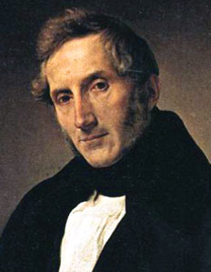
MAIN WORKS
There are 5 important poetical compositions that celebrate all the Church's recurrings: La Resurrezione, Il Nome di Maria, Il Natale e La Passione have been published between 1812 and 1815, while La Pentecoste was completed in 1822.
‘I promessi Sposi’ is a historical novel by Alessandro Manzoni, first published in 1827, in three volumes. It has been called the most famous and widely read novel of the Italian language.
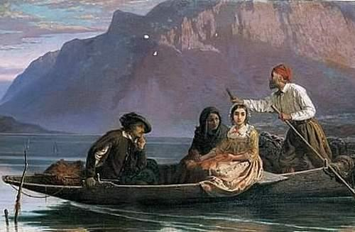

Extract:
THE BETHROTED (I promessi sposi) – by Alessandro Manzoni

‘They then passed through a lower room to the parlour of the convent; and before entering, the guardian, pointing to the door, said to the women in an undertone, ‘She is there;’ as if to remind them of the lessons he had been giving. Lucia, who had never before seen a monastery, looked round the room, on entering, for the Signora to whom she was to make obeisance, and perceiving no one, she stood perplexed; but seeing the Father advance, and Agnese following, she looked in that direction, and observed an almost square aperture, like a half-window, grated with two large thick iron bars, distant from each other about a span, and behind this a nun was standing. Her countenance, which showed her to be about twenty-five years old, gave the impression, at a first glance, of beauty, but of beauty worn, faded, and, one might almost say, spoiled. A black veil, stiffened and stretched quite flat upon her head, fell on each side and stood out a little way from her face; under the veil, a very white linen band half covered a forehead of different but not inferior whiteness; a second band, in folds, down each side of the face, crossed under the chin, encircled the neck, and was spread a little over the breast to conceal the opening of a black dress. But this forehead was wrinkled every now and then, as if by some painful emotion, accompanied by the rapid movement of two jet-black eyebrows. Sometimes she would fix two very dark eyes on another’s face with a piercing look of haughty investigation, and then again would hastily lower them, as if seeking a hiding-place.’

CONTEMPORARY WRITER:
Niccolò Ammaniti (1966-)
He was born in Rome in 1966, and he studied Biologic Sciences without ever getting a degree.
He published his first novel, ‘Branchie’, in 1994.
Some famous novels written by Ammaniti are: ‘Ti prendo e ti porto via’, ‘Io non ho paura’ and ‘Come Dio comanda’.
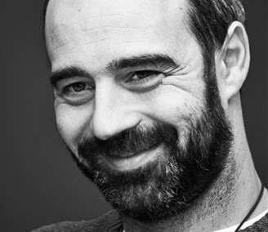
I’M NOT SCARED (Io non ho paura) –
translated by Ercole Guidi
Characters:
Michele: He is the protagonist of the novel, he decides to help Filippo, although he knows the risks that he is going through.
Filippo: At the beginning of the novel, he distrusts Michele, but after that he learns the boy wants to help him, and he begins to trust in the new friend.
His dad: He Is a gangster, and he has kidnapped Filippo.
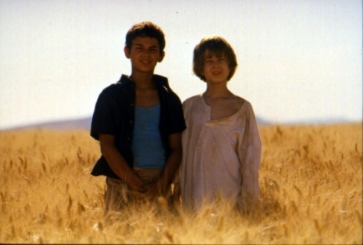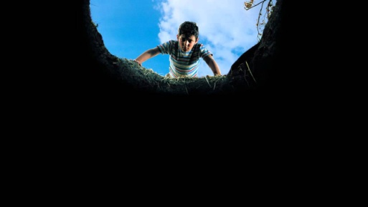
Extract: ‘I was about to pass Salvatore when I heard my sister scream. I turned and saw her disappear, swallowed by the wheat that covered the hill.I shouldn't have brought her along; mama would be really mad at me now.
I paused. I was sweaty. I recovered my breath and called to her. "Maria? Maria?"
A wee, doleful voice replied. "Michele!"
"Are you hurt?"
"Yes, come."
"Where did you hurt yourself?"
"On the leg."
She was feigning; she was tired. I'll keep going, I said to myself. But what if she really was hurt?
Where were the others?
I saw their tracks in the wheat. They were climbing slowly, in parallel lines, like the fingers of a hand, toward the hilltop, leaving behind a trail of trampled stalks.
That year the wheat was tall. It had been a wet late-spring, and by mid-June the stalks were more luxuriant than ever. They came up thick, loaded with ears, ready to be harvested.
Everything was buried in wheat. The hills, low, rolled sequentially like the swells of a golden ocean. Wheat, sky, crickets, sun, heat, as far as the eye could see.
I had no idea how hot it was; a nine-year-old doesn't know much of degrees centigrade, yet I knew it wasn't normal.
That cursed summer of 1978 went on record as one of the hottest of the century. The heat got into the stones, crumbled the earth, scorched the plants and killed the beasts, turned the houses into ovens.
When you picked the tomatoes in the garden, they had no juice and the zucchini were small and hard. The sun took away your breath, your strength, your desire to play, everything. And at night it wasn't any better.
At Acqua Traverse the adults never left the house before six p.m.. They shut themselves up indoors, with the shutters closed. We were the only ones venturing out in the sweltering and deserted countryside.
My sister Maria was five years old and followed me with the obstinacy of a little mongrel delivered from a dog-pound. «I wanna do what you do,» she always said. Mama sided with her.
«Are you or are you not her big brother?» And there was no saying; I had to take her along.
No one had stopped to help her.
But then of course, it was a race.’

spain

classical writer:

Miguel de Cervantes Saavedra (1547-1616):
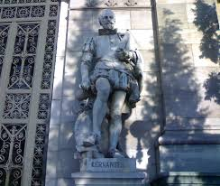
the greatest novelist of the Spanish language. His masterpiece, "Don Quixote," is one of the most important and influential books in the history of the novel.
In January 1605 Don Quixote was published in Madrid; it was an immediate success, receiving the dubious honor of having three pirated editions appear in Lisbon in that same year. In the words of the German philosopher F. W. J. von Schelling, Don Quixote is "the most universal, the most profound and the most picturesque portrait of life itself."
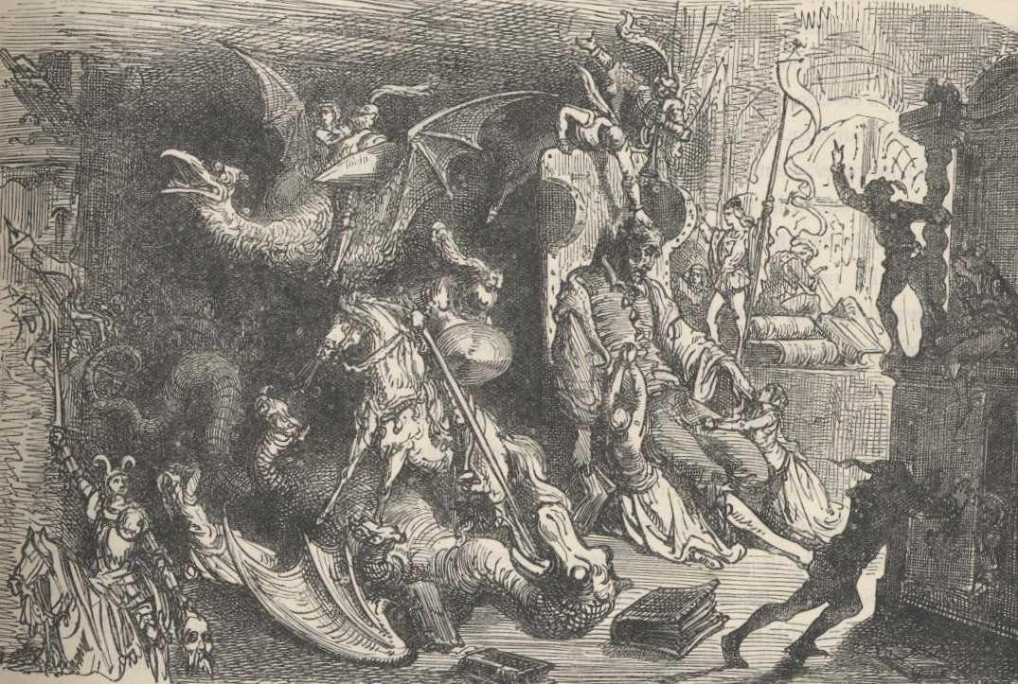
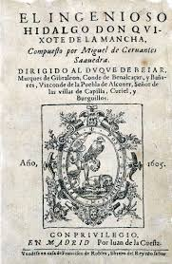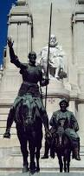

Extract:
‘In a village of La Mancha, the name of which I have no desire to call to mind, there lived not long since one of those gentlemen that keep a lance in the lance-rack, an old buckler, a lean hack, and a greyhound for coursing. An olla of rather more beef than mutton, a salad on most nights, scraps on Saturdays, lentils on Fridays, and a pigeon or so extra on Sundays, made away with three-quarters of his income. The rest of it went in a doublet of fine cloth and velvet breeches and shoes to match for holidays, while on week-days he made a brave figure in his best homespun. He had in his house a housekeeper past forty, a niece under twenty, and a lad for the field and market-place, who used to saddle the hack as well as handle the bill-hook. The age of this gentleman of ours was bordering on fifty; he was of a hardy habit, spare, gaunt-featured, a very early riser and a great sportsman. They will have it his surname was Quixada or Quesada (for here there is some difference of opinion among the authors who write on the subject), although from reasonable conjectures it seems plain that he was called Quexana. This, however, is of but little importance to our tale; it will be enough not to stray a hair's breadth from the truth in the telling of it.’

contemporary writer:

Torres Grueso, Juan (1912-1982)

A Spanish poet who was born in Tomelloso.

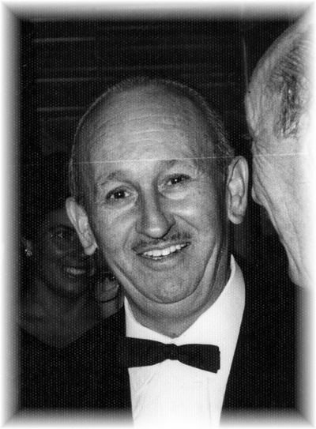

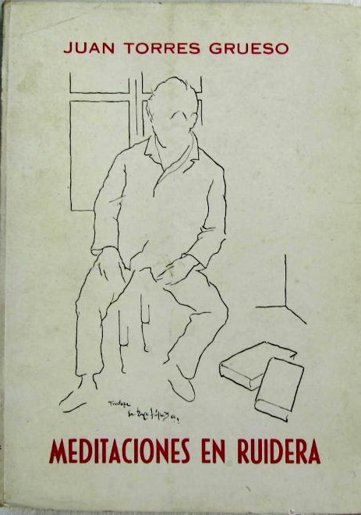

Some of his works:
- Ahora que estoy aquí by Juan Torres Grueso
- Tierra seca by Juan Torres Grueso
- Estampas de mi tiempo by Juan Torres Grueso
- Meditaciones en Ruidera by Juan Torres Grueso

Los campesinos
Juan Torres Grueso

Ellos saben que vienen de la tierra.
A ella están pegados y, sumisos, constantemente giran
gritándole a las madres sus sentires redondos.
En un abrazo fuerte le ofrecen su pesar,
y el aire corre y vuela la carne de sus lágrimas
y el sueño que, perdido, se quedó sin labrar.

Aceptan el camino sin mirar su retorno.
Tienen el ruido sordo de las playas y el mar.
Hacen frente a la vida ignorando su suerte,
y reclaman espacios de vitales cosntancias
sin que nadie, a la puerta, les salga a esperar.

Y son felices ellos porque ignoran qué es eso.
Ellos son fieros nobles con almas repetidas.
Y no tienen noticia de tales atributos
hasta que se reencuentren con su sombre hecha vida,
y el viaje alcanzando en su claro nocturno
con la planta amarilla de sus pies sin andar.

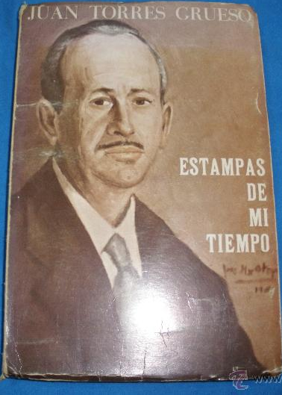

lithuania

classical writer:
Balys Sruoga (1896 - 1947)
Lithuanian poet, playwright, critic, and literary theorist. 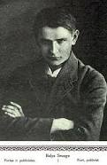

Sruoga's best known work is the novel “The Forest of the Gods” (“Dievų miškas’), based on his own life experiences as a prisoner in Nazi concentration camps, where he was sent in March 1943 together with forty-seven other Lithuanian intellectuals, after the Nazis started a campaign against possible anti-Nazi agitation in occupied Lithuania.
In the book, Sruoga revealed life in a concentration camp through the eyes of a man whose only way to save his life and maintain his dignity was to view everything through a veil of irony and humor, where torturers and their victims are exposed as imperfect human beings, being far removed from the false ideals of their political leaders.
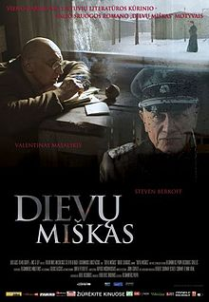
extract:
‘Moors, hummocks, hills. On the white sands, sifted into hills though the hands of a superior force — tall and spindly pines in the guises of yeshiva students. On the hillsides — birch trees, so sickly, so impoverished, as if the sun herself forgot about these orphans, her foundlings. On the slopes and slants — huckleberries, blueberries, lingo berries braided, wove themselves into a succulent green carpet dotted with multicolored berries. In the furrows, pits, and cross-wings — clumps of bog grasses, sedges, and cowslips.
Once, a long, long time ago, this was the bottom of the sea. It was as if during a storm the waves unexpectedly froze, unexpectedly hardened, and the north winds sprinkled their crests with white sands.
This little place nestled itself on the shores of the Baltic Sea, forty five kilometers east from the city of Danzig. Until 1939 very few knew of this isolated corner. Next to it stagnated a, small moribund town, almost a village, Stutthof, the kind which Germany had thousands of. This little town was connected to Danzig by an asphalt highway and an obsolete railway. And herein dwelt the most boring people in Europe — Prussian Germans, submerged in everyday spiritual poverty, venerating the policeman and the kitchen, superficial order and ale; they could go without their daily bread for an entire week......’

contemporary writer:
Romualdas Granauskas
(18 May 1939 – 28 October 2014 ) a Lithuanian prose writer, playwright, essayist, archaic and modern artist. His prose is sometimes called magic realism.
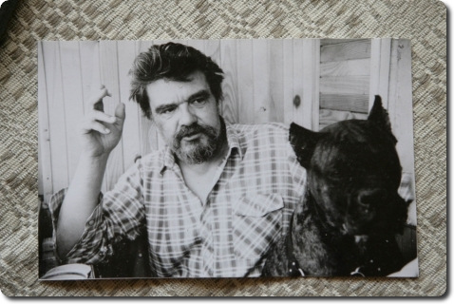
One of the most famous works of R. Granauskas is the story “Life under the Maple tree “(1988). It has become a symbol of rebirth Lithuanian prose; in 1988 was created the television film based on story.
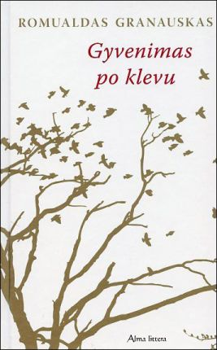“Life under the Maple tree “
The writer tells the story of an old woman, who stayed alone in the meliorated village, while everyone moved to the new village. Each line of this work is full of regret, understanding and compassion. But "Life under the Maple Tree” is not a preachy piece in which the author would like to tell heartless children and grandchildren that they could not forget their old parents. At that time, you couldn’t find another so open and direct story about the most important things in our land, destroyed by the Soviet authorities and collective farms as well as physically and mentally exhausted rural people.
Giedra Radvilavičiūtė (born 1960) is a Lithuanian writer.[1] She was born in Panevėžys in northern Lithuania, and studied in Vilnius University, graduating in 1983 with a degree in Lithuanian language and literature.
extract:
Those Whom I Would Like to Meet Again
CANDY
‘The first time you arrive to work in an American's house is a bit scary. It's particularly difficult to domesticate objects in English. People are much easier. Objects remain mute until you develop relationships with them. As Nabokov wrote about one character's rented apartment, there was, in the study, a half-empty writing table with an unknown past and an unknown future. Modern people live their entire lives without ever speaking to their objects. They're never scratched by an angry chair, they don't drown in trenches of soft furniture, they aren't seduced by slippery blankets, and old mirrors don't challenge them to night time duels.’

Croatia

classical writer:
MARIN DRŽIĆ (1508-1567)
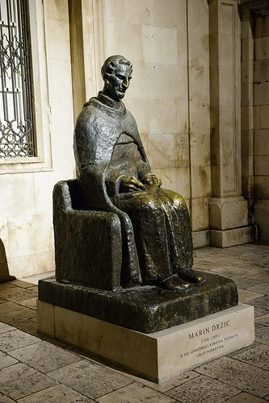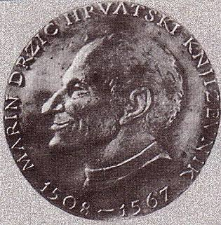
He was nicknamed Vidra(otter) because he spent a lot of time in Rijeka dubrovačka (a small place close to Dubrovnik situated on the banks of the river).
Dundo Maroje is Držić's most popular and most performed work. The comedy demonstrates his Renaissance views presented in the character of the servant Pomet and his negative attitude towards the local authorities. It was written as an extension of his comedy Pomet which got lost. It wasn't published in his lifetime and the original manuscript was never found. The only work that was saved is incomplete transcript dating from the second part of the 16th century. The comedy was first performed in Dubrovnik in 1551. It contains two prologues and five acts.
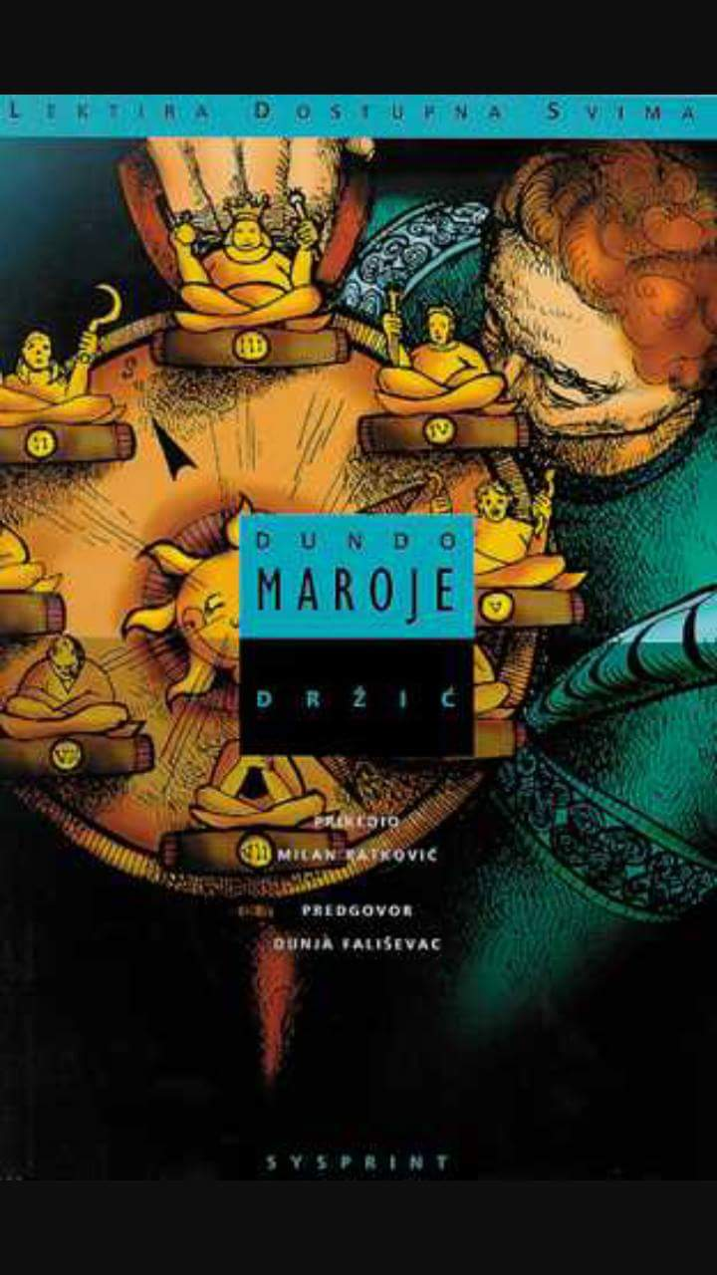
extract:

contemporary writer:
JANKO POLIĆ KAMOV (1886 –1910)
Croatian poet, narrator and playwright.
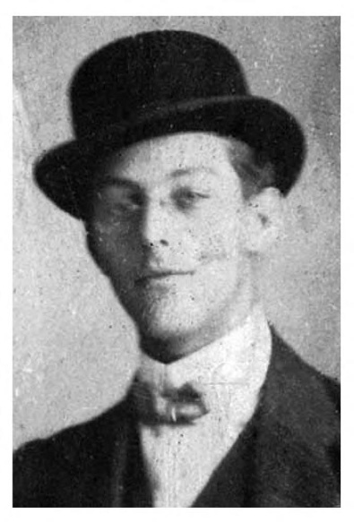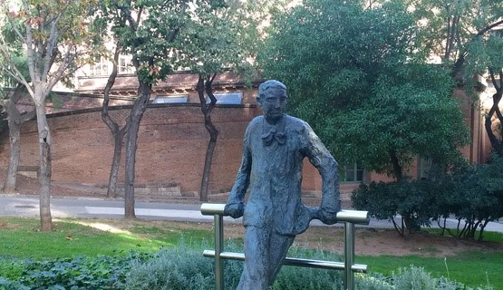
Janko Polić Kamov is a Croatian writer who belongs to the period of Croatian Modernism (through the 19th and 20th century). Modernism includes stylistic features of impressionism, art nouveau, decadentism, symbolism, realism, naturalism and neoromanticism. Writers are focused on their inner self and want to express the unfathomable, subconscious and unexplored. Common features are resistance for tradition, inclusion in middle-european cultural and literal circles, critical mind and freedom of artistic creating.
The Beard (Brada)
The novel starts with the fact that the writer shaved his beard. Everybody considered him older than he actually was, serious and old looking and that he must be a painter or a professor. Girls did not pay much attention to him . He travelled widely, spoke very little and read always. He never joked.
After he shaved his beard, he was relieved. He decided to turn to his studies. In a train he met a girl whom he immediately liked. After a while, they separated. He found a flat and fell in love with the owner’s four daughters. Shortly after he ran out of money and was abandoned by everyone. He considered that his identity depended on a shaved or unshaved beard.
The beard was the essence of his life.
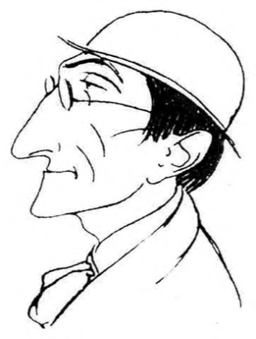
extract:
“ I shaved my beard. You see, I used to have this thick, pointed, reddish beard. Why did I have it? That is a question of great importance and interest! The human soul is most touched by those trivial things that play an important role only in their lives of the great and make them more interesting than their work. Our soul is not economy and science. It is literature , for it is very elastic, random, eccentric, original. Someone might have lived quietly , honestly and decently for years and years; suddenly he looses his temper and kills; or looses his temper and rapes; or looses his temper and robs.
Nowhere are miracles, coincidences and religion as obvious as in crime ; nowhere is the invisible spirit as visible as in murder, drunkenness and sexual excess. To wit, the divine and spiritual always enter where our soul wants to protest against modern society or to express its intimate , insentient, animal instincts. Ignorant apostles learned several languages overnight, the legend says; our young talent committed suicide overnight states the chronicle. One single holy ghost entered all those souls and brought the closer to the deity that evokes all who cannot find their way and settle down in our social order. The faith in a moral being that is above humans- that faith is the same in believers and in anarchists. Moreover, Christ spoke of a God above us and within us and vindicates the anarchy of the past and of the future. A student spoke perfect German when he got drunk, and he had gotten drunk out of despair and sadness for getting an F – in German. “

hungary

classical writer:
Karinthy Frigyes (1887 - 1938)
Hungarian author, playwright, poet, journalist, and translator, one of the most popular Hungarian writers.

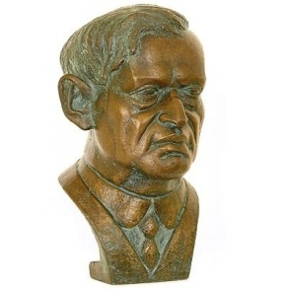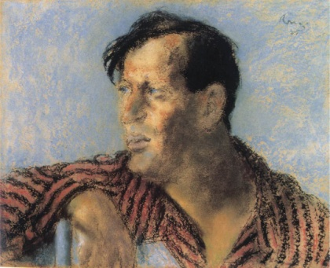
In 1912, his articles also appeared in the Nyugat (the most famous Hungarian literary periodical); he entered the world of cabaret in Endre Nagy's show. He started his writing career as a journalist and remained a writer of short, humorous blurbs until his death. He rose to instant fame in 1912 with the publication of his literary parodies called That's How YOU Write (Így írtok ti).
Some of his works in English translation:
- Drama:A Farce-Satire in One Act (1925)
- A Journey Round My Skull (1939)
- Voyage to Faremido & Capillaria (1966).
- Please Sir! (1968) Translated by István Farkas.

Please Sir! (1916)
Some of Karinthy's notebooks were found after his death. In these he jotted down his first ideas, whenever he used one, he crossed it out at once. One such jotting reads: "Humour is the whole truth."
Please Sir! is a collection of short stories and sketches written at the beginning of his career, a recollection of school day memories.

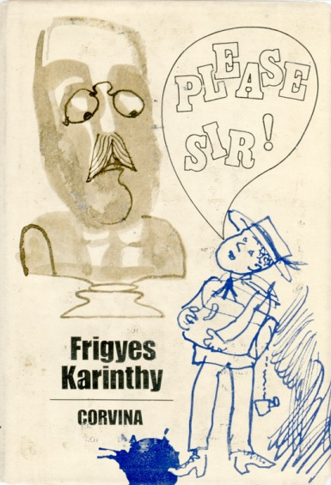
extract:

„I sneak in through the yard. It is shortly after half past ten in the morning, and all the corridors are empty. I can hear people talking whenever I pass a closed door and every time I hear this noise my heart wrenches. I open the door carefully, turn my head toward the teacher’s desk, and I retreat to my seat with silent tread. There is an empty seat in the last row by the heater. The teacher did not look at me; he just dismissed me with a wave of his hand. He thought I was the boy who left five minutes ago. I sit down. There is a reddish-blond, freckled boy sitting next to me and I almost shout out with joy in my surprise: “Well, this is Büchner!” I have not seen him in ages. Where have I been? Goodness, I’ve been having some horrible dreams. It is so good to be home, back here in good old reality, in my real life which I hated leaving. I am home; this is me, Frigyes Karinthy from sixth grade. Oh, it was all just a bad, stupid dream. All of a sudden all the smells are familiar, I’m shaking as I reach into the desk and pull out a notebook. For a moment I cannot believe my own eyes but there it is, written in precise letters on the cover: my name, sixth grade, literature compositions.”

contemporary writer:
Magda Szabó (1917 –2007)
Magda Szabó (October 5, 1917 – November 19, 2007) was a major Hungarian novelist. She also wrote dramas, essays, studies, memories and poetry.

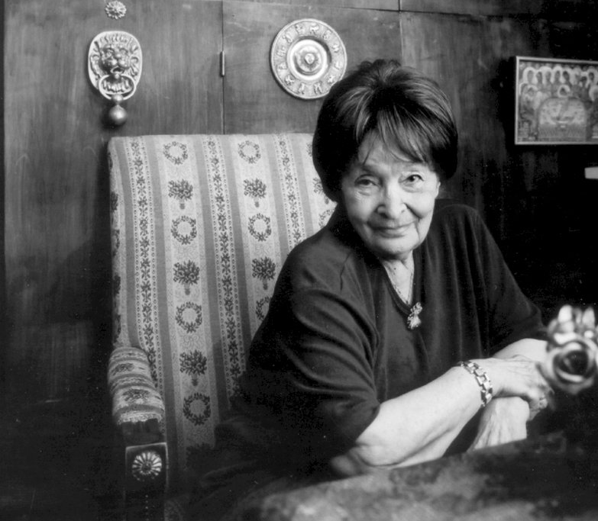
She began her writing career as a poet, publishing her first book Bárány ("Lamb") in 1947, which was followed by Vissza az emberig ("Back to the Human") in 1949.

She wrote novels, short stories, children's and juvenile literature, plays, film scripts and essays; translates from English and Spanish. She has completed more than forty works and was translated into thirty languages.
Some works in English: The Door , The FawnThe Night of the Pig-Killing or Night of the Pigkilling , Tell Sally, An Old-fashioned Story , Iza's Ballad

The Door (1987)
“The Door” appeared in Hungary in 1987, it was initially translated by Stefan Draughon and brought out here by an academic publisher in 1995. Subsequently translated into French, the book won the Prix Femina Étranger in 2003 and was beautifully retranslated by Len Rix for British publication in 2005. In 2006 its second English translation was short-listed for the Independent newspaper’s Foreign Fiction Prize in the UK. It has been selected among the “The 10 Best Books of 2015” by New York Times.
extract:
„I rarely dream. But when I do, I wake up bathed in sweat. Then I lie back down again and wait till my heart quiets down, and I brood over the invincible, magical power of night. As a child or in my youth, I had neither good dreams nor bad; but time after time my old age lines up compressed balls of pain for me from its stockpile, which are so disquieting because they're more dense, more tragic than anything I could ever have lived through; in fact, not once has anything happened to me like what wakes me, screaming in the night.
My dreams are recurrent visions, identical to a hair; I always dream exactly the same thing. I'm standing in our entryway at the bottom of the stairwell, on the inner side of the street door's ironrimmed, wire-reinforced, unbreakable glass window, and I try to unlock the door. Outside on the street there's an ambulance; the silhouette of the medical corps shimmers through the glass as if their unnaturally large, swollen faces have halos, just like the moon. The key turns, but I struggle in vain; I can't open the door, although I'm the one who must let in the medical crew, otherwise it'll be too late for my patient. The lock won't budge at all; the door is stuck as if it had been welded into its iron frame. I yell for help, but not one of the residents of the threestory building pays any attention to me; nor can they because, I now realize, I'm only gasping vacuously like a fish; the horror of my dream culminates in awareness that not only can't I open the door to get help, but I've become mute. At these times, my own scream awakens me; I turn on the light; I try to get over the breathlessness that always grabs hold of me after the dream. ”

