Reading in English for Amusement and Dialogue in Europe
Erasmus+ project
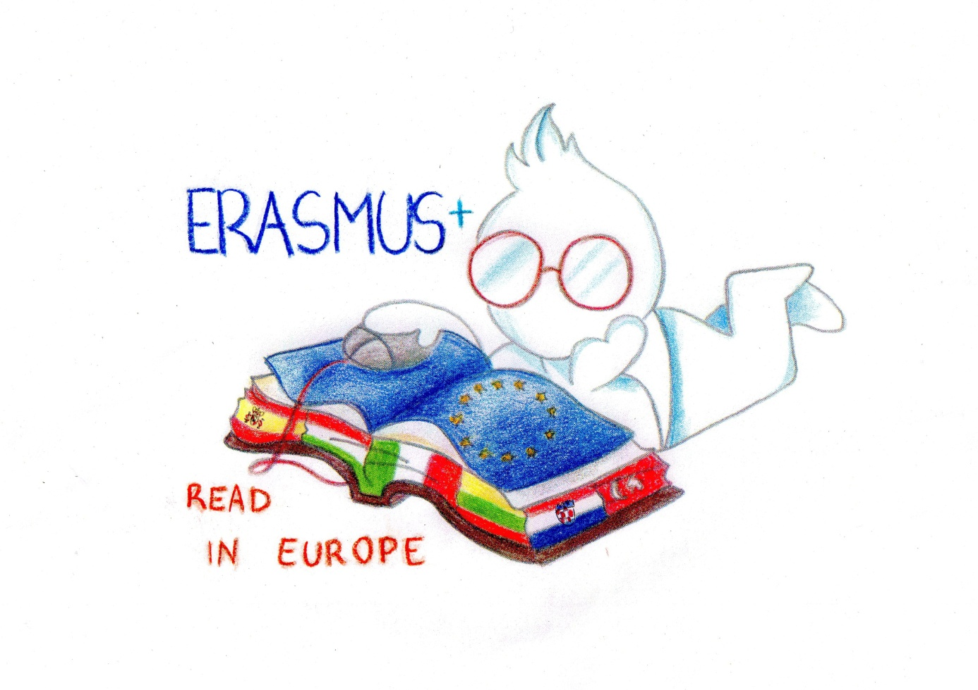

Teacher training event
14-18 March 2016, Lithuania

Common teaching experience

Before our joint teacher training event we had selected a common text that we would work with during the training session. The participating countries paired up and each pair created a lesson plan for a reading lesson based on our chosen text. During the sessions we observed each other and shared good practices for teaching reading skills and vocabulary.
Our chosen text:
Aesop's Fables by Planet PDF
http://history-world.org/Aesops_Fables_NT.pdf

Androcles
A slave named Androcles once escaped from his master and fled to the forest. As he was wandering about there he came upon a Lion lying down moaning and groaning. At first he turned to flee, but finding that the Lion did not pursue him, he turned back and went up to him. As he came near, the Lion put out his paw, which was all swollen and bleeding, and Androcles found that a huge thorn had got into it, and was causing all the pain. He pulled out the thorn and bound up the paw of the Lion, who was soon able to rise and lick the hand of Androcles like a dog. Then the Lion took Androcles to his cave, and every day used to bring him meat from which to live. But shortly afterwards both Androcles and the Lion were captured, and the slave was sentenced to be thrown to the Lion, after the latter had been kept without food for several days. The Emperor and all his Court came to see the spectacle, and Androcles was led out into the middle of the arena. Soon the Lion was let loose from his den, and rushed bounding and roaring towards his victim. But as soon as he came near to Androcles he recognised his friend, and fawned upon him, and licked his hands like a friendly dog. The Emperor, surprised at this, summoned Androcles to him, who told him the whole story. Whereupon the slave was pardoned and freed, and the Lion let loose to his native forest.
Gratitude is the sign of noble souls.

Lesson plan - Croatia and Hungary
Context
Topic: Aesop: Androcles
Total learning time: 45
Number of students: 16
Description: Assumptions: The level of the group is A2-B1. Ss have heard about Aesop and may know the kinds of fables he wrote. Ss have already read the fable. So they understand the main meaning but there are several new words and expressions in the text.
Aims
To improve vocabulary. To engage Ss in reading a piece of authentic literature.
Outcomes
Knowledge(Knowledge): Ss will learn two meanings of 13 words.
Comprehension(Comprehension): Ss will understand the literary meaning and the moral of the text.
Application(Application): Ss will learn to define meaning according to the context.
Analysis(Analysis): Ss will compare the use of words with more than one meaning with their mother tongue.

Teaching-Learning activities
Warm-up Pre-reading activities Drama
Produce 5 minutes students Tutor is available
Volunteering Ss draw cards with verbs on them in turn and they act the verbs out. Other Ss find out the verb. T writes the verbs on the board.

Discuss 2 minutes students Tutor is available
Ss divide the verbs into two groups (underline & circle on the board) according to the characters who do the activities: the slave or the lion. There is no correction at this point if Ss' suggestions are false.

The activity may take more time. If the time is limited, fewer cards can be drawn and the activity finishes when the time is up. If it is more important to revise the verbs, more time can be allocated for the activity.
While reading activities Vocabulary and Comprehension
Collaborate 3 minutes 2 students Tutor is not available
The fable is cut into 8 parts (as many as many pairs there are in the group) and Ss have to put the parts they are given in order. The beginning of the fable is indicated with the title.
Appendix 1

Read Watch Listen 3 minutes students Tutor is available
The pairs read out one part each to check the solution. Alternatively: T reads out the story, Ss listen and check. If it is assumed that Ss have difficulties with pronounciation this may be the better solution.

Practice 3 minutes students Tutor is available
Ss cover the text and listen to the teacher reading the summary of the story. T makes mistakes in the summary and Ss have to shout in when they recognize one. If they know the correct wording they can correct the mistake.
Appendix 2
Investigate 3 minutes 4 students Tutor is not available
Ss are given cards (one for each member of the group) with simplified dictionary entries of highlighted and numbered words in the text. There are two meanings of the words on the cards. Ss have to decide which meaning applies to the word in the text.
Appendix 3
Read Watch Listen 3 minutes students Tutor is available
Ss read out the words one by one with the meaning they chose.

Practice 3+ minutes students Tutor is not available
Ss mingle. Each S has one of the vocabulary cards. Ss find a partner with whom they read out their words to each other then swap the cards. With the new cards Ss find a new partner and repeat the activity until T stops it.

Practice 6 minutes 2 students Tutor is not available
Ss are given a set of words that are synonyms of words in bold. Ss replace the original expressions with their synoyms then read out the rerwritten story.

Practice 10 minutes students Tutor is available
Ss have to complete sentences with the highlighted words from the text using the other meaning given on the word cards. Alternatively each student is given 3-4 words cards (there will be duplications) and they have get rid of them as soon as possible. The sentences are projected for 15-20 seconds one after each other (or read out by T) and if a student thinks that a word of their pack fits the sentence shouts in. The one with the first correct solution can throw the card in.
Appendix 4

Investigate 3 minutes students Tutor is available
Compare the words with two meaning with their translation in your native language. Do you use both meaning in the same way of do you have different words for the different meanings?

Depending on the level of Ss, the time available and Ss' prior reading the tasks of this TLA can be reordered or some tasks can be left out or given as a homework. The dictionary entries are from the Oxford Learner's Dictionary (http://www.oxfordlearnersdictionaries.com/). The task with the definitions of vocabulary can be done with the help of the online dictionary. In that case Ss have to choose from more than one meaning in some cases and Ss have to write the one that they chose.
Post-reading activities Reconstruction and Morale
Produce 10 minutes 4 students Tutor is available
Each group will get two pictures. Every picture has empty space and Ss will write two sentences in that space.By that sentences they will describe the scenes and in the end they will read their sentences.
Appendix 5
Discuss 10 minutes students Tutor is available
Ss will watch short film (4 minutes) they will pay attention to the main characters and the moral of the story. After watching Ss will get worksheets with questions and there will be discussion on the main topic.
A link to the short film:
https://www.youtube.com/watch?v=GLq_Vp5z9D4
Activity 3: Writing task
For homework students will write a short text (150 words) about help and gratitude. The questions
are:
Have you ever helped anyone and how did you feel?
Has anyone ever helped you?

Lesson Plan of Turkey
Context
Topic: Fable: Androcles and the Lion
Total learning time: 20
Number of students: 20
Description: To work in pairs and examine a fable in three part: Pre-reading, while-reading and post-reading
Aims
1. To raise the reader's knowledge of what the are about to read as this knowledge will help them to understand the text. 2. To work in pairs and do reading activities together will encourage the atudents to read as quickly as possible in a race. 3. Post-reading exercises first check students's comprehension and then lead students's to a deeper analysis of the text.
Outcomes
Affective learning outcomes(Affective learning outcomes): Read in Europe
Teaching-Learning activities
Preparation for the reading activity
Read Watch Listen 5 minutes 20 students Tutor is available
1.To read the text first. 2. To brain-storm about the text. * What we know about fables? *Do we know about the writer? *What we want to learn?

Pre-reading
Collaborate 5 minutes 20 students Tutor is available
1. Tell your partner what you know about the topic. 2. Look at some pictures related to the topic. 3. Skimming the first paragraph for gist and then predicting. * A title * Knowledge of the author *A skim of the first paragraph
Read Watch Listen minutes students Tutor is available

While-reading
Discuss 5 minutes 20 students Tutor is available
SLASHED/CUT UP TEXTS: This is a collaborative reading activity. (We have prepared the activities on the paper.)

Post-reading
Produce 5 minutes 20 students Tutor is available
1.To discuss about the text. 2. To summarising the text. 3. To use a "follow-up" speaking task related to tje topic.
Video:
https://drive.google.com/drive/folders/0B-1yAKTtl4RKeDNzMXlyYUJMUWc
Presentation:
https://drive.google.com/drive/folders/0B-1yAKTtl4RKeDNzMXlyYUJMUWc

Lesson plan - Lithuania
Lead - in
1. Students answer the teacher’s questions.
2 minutes
Which one do you prefer: reading books or watching films? Why?
Who is your favorite author? What English/American writers do you know?
Why do people read books?

2. The teacher presents the formation and usage of the Present Tenses in PowerPoint.
3 minutes
Students listen to the teacher and revise the rules of the Present Tenses.

Study
Collaboration/Creativity
Students split into groups of four. Each group is given a task of impersonating the characters from the fable and coming up with a dialogue and monologue.
10 minutes
Group One. Monologue (one student) - The thoughts of the slave after escaping from his master
Dialogue - The first dialogue between the slave and the lion.

Group Two. Monologue (one student) - The thoughts of the slave before saying good bye to the lion in the forest.
Dialogue - The dialogue between the slave and the lion on the last day before they say good bye to each other.
Group Three. Monologue (one student) - The thoughts of the lion just before having the meal after days of starving in the arena.
Dialogue - The dialogue between the slave and the lion in the arena.

Group Four. Monologue (one student) - The Emperor’s thoughts when he sees the lion licking Androcles’s hand.
Dialogue - The last conversation between the slave and the lion.
Activate
Students act out their monologues and dialogues to the whole class.
4 minutes
Pause for thought
Students give feedback to the teacher.
1 minute
What went well in this lesson?
What did you like about the lesson?
What did you learn?

Lesson plan: Italy
Context
Topic: Androcles
Total learning time: 25
Number of students: 16
Description: 2 while-reading and 2 post-reading activities
Aims
Strengthening students' linguistic skills through a more thorough understanding of the story
Outcomes
Teaching-Learning activities
Paragraphs and titles
Practice 5 minutes 4 students Tutor is available
Students are encouraged to divide the text into paragraphs assigning a title to each paragraph. Titles are written down on the board.
Appendix 6

Adjective-itis
Discuss 5 minutes 4 students Tutor is available
Students pick 2 adjectives for each character and explain how they apply. Adjectives are written on the board.
Appendix 7

Role-play
Collaborate 5 minutes 4 students Tutor is available
Each of the four groups of students is given a table illustrating a moment of the story and is asked to create a short dialogue.

Role-play
Practice 5 minutes 4 students Tutor is available
Students act out the scene.

P.S.
Discuss 5 minutes 16 students Tutor is available
Students imagine what happens to each character next.

Lesson plan: Spain

1.- I See, I think, I wonder
(Individual Work, 4’)
Appendix 8

2.- Graphic Organiser
(Pairwork – 2’)
Appendix 9
3.-Text (fil in the gaps and put in order the fable
(Individual 3’)
Appendix 10

4.- questions 1 -2 -4
(Teamwork – 6’)
Appendix 11

Appendix 1
Androcles
A (1) slave named Androcles once escaped from his master and fled to the forest. As he was wandering about there he came upon a Lion lying down moaning and groaning.
At first he turned to flee, but finding that the Lion did not (2) pursue him, he turned back and went up to him.
As he came near, the Lion put out his paw, which was all (3) swollen and bleeding, and Androcles found that a huge thorn had got into it, and was causing all the pain. He pulled out the thorn and (4) bound up the paw of the Lion, who was soon able to rise and (5) lick the hand of Androcles like a dog.
*bind, bound, bound
Then the Lion took Androcles to his cave, and every day used to bring him meat from which to live. But shortly afterwards both Androcles and the Lion were
(6) captured, and the slave was sentenced to be thrown to the Lion, after the
(7) latter had been kept without food for several days.
The Emperor and all his Court came to see the (8) spectacle, and Androcles was led out into the middle of the arena.
Soon the Lion was let loose from his (9) den, and rushed bounding and roaring towards his victim. But as soon as he came near to Androcles he (10) recognised his friend, and fawned upon him, and licked his hands like a friendly dog.
The Emperor, surprised at this, (11) summoned Androcles to him, who told him the whole story. Whereupon the slave (12) was pardoned and freed, and the Lion let loose to his native forest.
Gratitude is the sign of (13) noble souls.

Appendix 2
SUMMARY with incorrect information
Androcles was a slave who escaped from his master and went to the mountains, where he met a lion. The lion’s tail was bleeding because a nail got into it. Androcles helped the lion and they became friends. They lived in the lion’s hut but they were captured and Androcles was sentenced to be thrown to the lion. The queen came to see the spectacle and when Androcles was led to the pitch the lion recognised him and bit him. At the end Androcles was freed and the lion was taken to a zoo.
Solution
Androcles was a slave who escaped from his master and went to the (mountains) forest, where he met a lion. The lion’s (tail) paw was bleeding because a (nail) thorn got into it. Androcles helped the lion and they became friends. They lived in the lion’s (hut) cave but they were captured and Androcles was sentenced to be thrown to the lion. The (queen) Emperor and all his Court came to see the spectacle and when Androcles was led to the (pitch) arena the lion recognised him and (bit) fawned upon and licked him. At the end Androcles was freed and the lion was (taken to a zoo) let loose to his native forest.

Appendix 3
1. a. a person owned by another person and forced to work for them  b. a person who cannot live without a certain thing, or cannot make their own decisions | 2. a. to try to achieve something over a period of time  b. to follow or chase somebody/something
3. a. larger than normal as a result of a disease or an injury  b. containing more water than normal | 4. a. to tie a long thin piece of cloth around something  b. to unite people so that they live or work together more happily or effectively
5. a. to move your tongue over the surface of something in order to eat it  b. to touch something lightly | 6. a. to catch an animal and keep them in a safe space  b. to take control of a place using force
7. a. the second of two things or people mentioned  b. nearer to the end of a period of time than the beginning | 8. a. a performance that is very impressive and exciting to look at  b. a sight or view that is very impressive to look at
9. a. the home of some types of wild animal  b. a place where people meet in secret, especially for some illegal or immoral activity | 10.a. to know who somebody is when you see or hear  b. to admit that something exists or is true
11. a. to order somebody to come to you  b. to arrange an official meeting | 12. a. to allow a guilty person to leave prison and/or avoid punishment  b. to forgive somebody for something they have said or done
13. a. having fine personal qualities that people admire, such as courage, honesty and care for others
b. very impressive in size or quality

Appendix 4
Complete the sentences with the appropriate highlighted word from the text. This time use the second meaning of the word (the other than in the text).
- Certainly kings were responsible for _______________ councils.
- Flames were soon _______________ the curtains.
- I had never slept in so _______________ a room before.
- I remember the sad _______________ of her standing in her wedding dress, covered in mud.
- Lester entered the opium _______________ and was drugged.
- Organizations such as schools and clubs _______________ a community together.
- _______________ me for interrupting you.
- Rain and a _______________ river forced several delays.
- She wishes to _______________ a medical career.
- The city was _______________ in 1941.
- The _______________ half of the twentieth century saw huge growth in air travel.
- They _______________ the need to take the problem seriously.
- We are _______________ of the motor car.
Solution
- Certainly kings were responsible for summoning councils.
- Flames were soon licking the curtains.
- I had never slept in so noble a room before.
- I remember the sad spectacle of her standing in her wedding dress, covered in mud.
- Lester entered the opium den and was drugged.
- Organizations such as schools and clubs bind a community together.
- Pardon me for interrupting you.
- Rain and a swollen river forced several delays.
- She wishes to pursue a medical career.
- The city was captured in 1941.
- The latter half of the twentieth century saw huge growth in air travel.
- They recognized the need to take the problem seriously.
- We are slaves of the motor car.

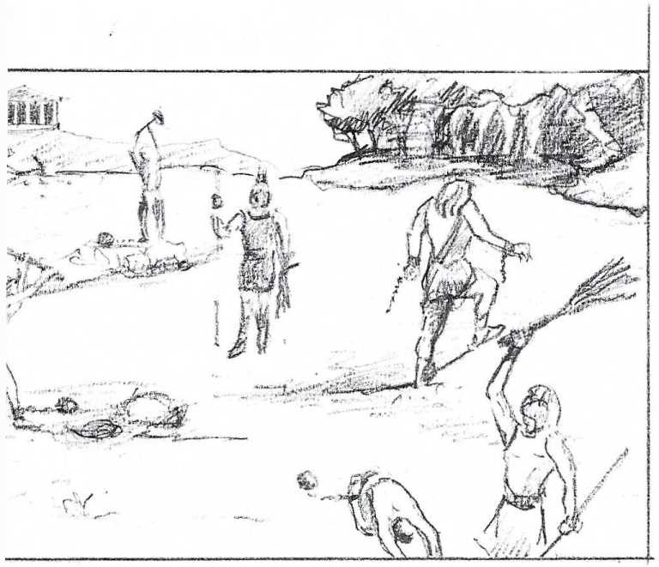
Appendix 5

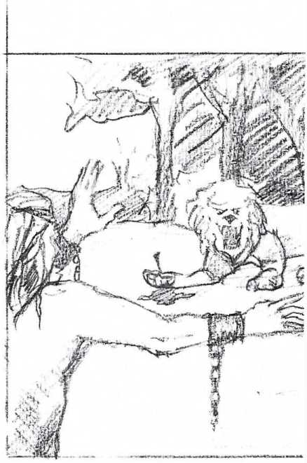

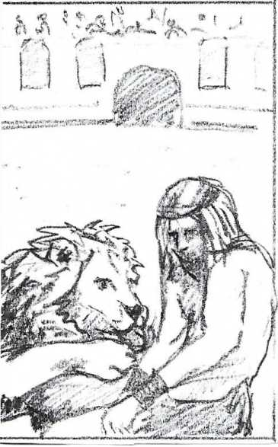

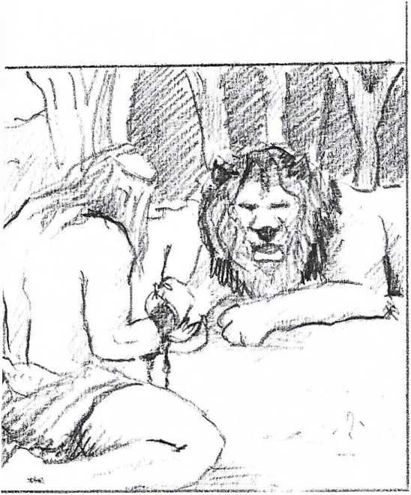

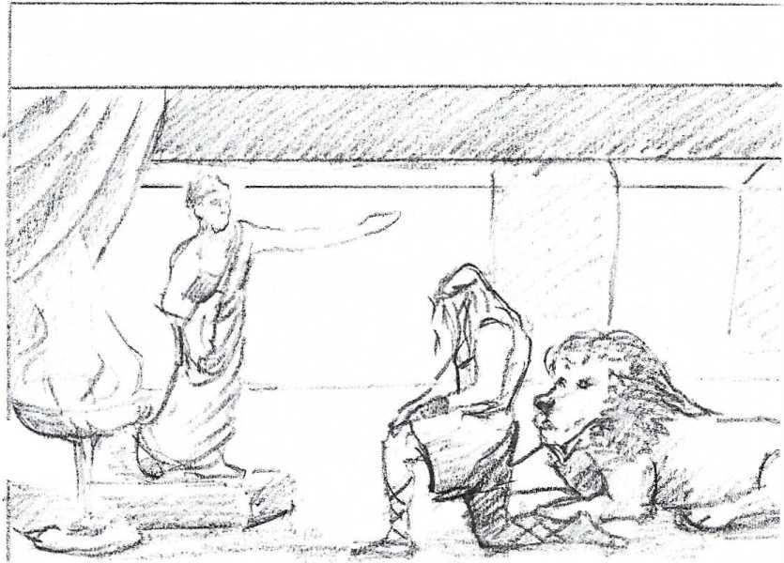

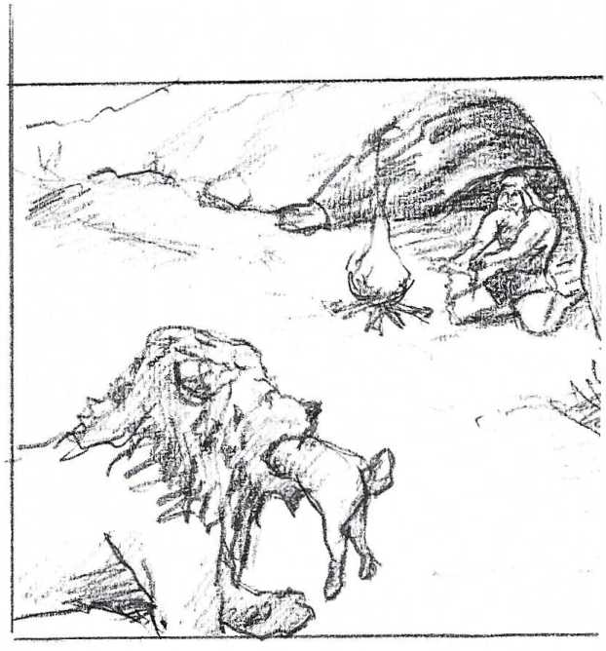

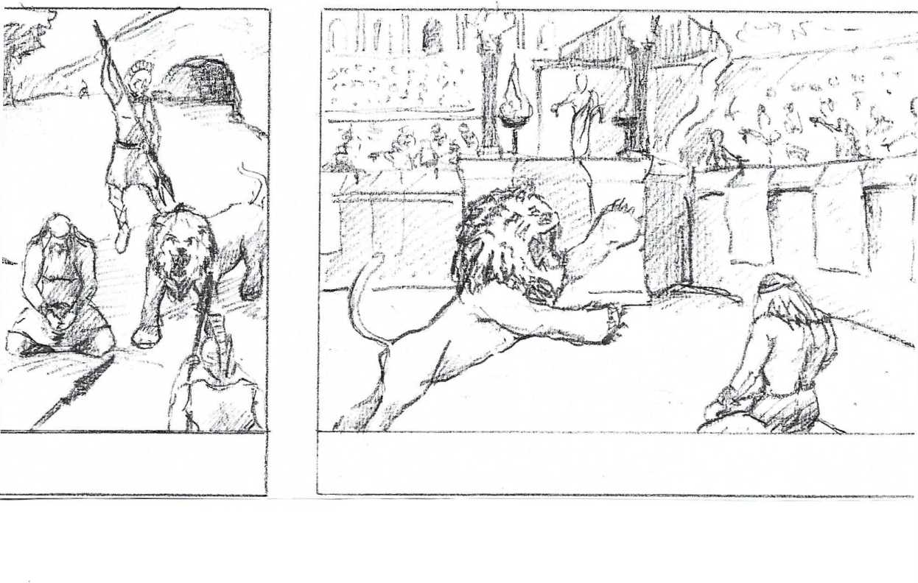

Appendix 6
IDENTIFY 5 SEQUENCES IN THE STORY (SEPARATE THE SEQUENCES USING SLASHES) AND ASSIGN A TITLE TO EACH SEQUENCE
Androcles
A slave named Androcles once escaped from his master and fled to the forest. As he was wandering about there he came upon a Lion lying down moaning and groaning. At first he turned to flee, but finding that the Lion did not pursue him, he turned back and went up to him. As he came near, the Lion put out his paw, which was all swollen and bleeding, and Androcles found that a huge thorn had got into it, and was causing all the pain. He pulled out the thorn and bound up the paw of the Lion, who was soon able to rise and lick the hand of Androcles like a dog. Then the Lion took Androcles to his cave, and every day used to bring him meat from which to live. But shortly afterwards both Androcles and the Lion were captured, and the slave was sentenced to be thrown to the Lion, after the latter had been kept without food for several days. The Emperor and all his Court came to see the spectacle, and Androcles was led out into the middle of the arena. Soon the Lion was let loose from his den, and rushed bounding and roaring towards his victim. But as soon as he came near to Androcles he recognised his friend, and fawned upon him, and licked his hands like a friendly dog. The Emperor, surprised at this, summoned Androcles to him, who told him the whole story. Whereupon the slave was pardoned and freed, and the Lion let loose to his native forest. Gratitude is the sign of noble souls.

Paragraph 1

Paragraph 2

Paragraph 3

Paragraph 4

Paragraph 5
Appendix 7
FIND TWO ADJECTIVES FOR EACH CHARACTER (ANDROCLES, LION, EMPEROR) AND EXPLAIN WHY THEY APPLY.

ANDROCLES:
1)

2)

LION:
1)

2)

EMPEROR:
1)

2)

Appendix 8
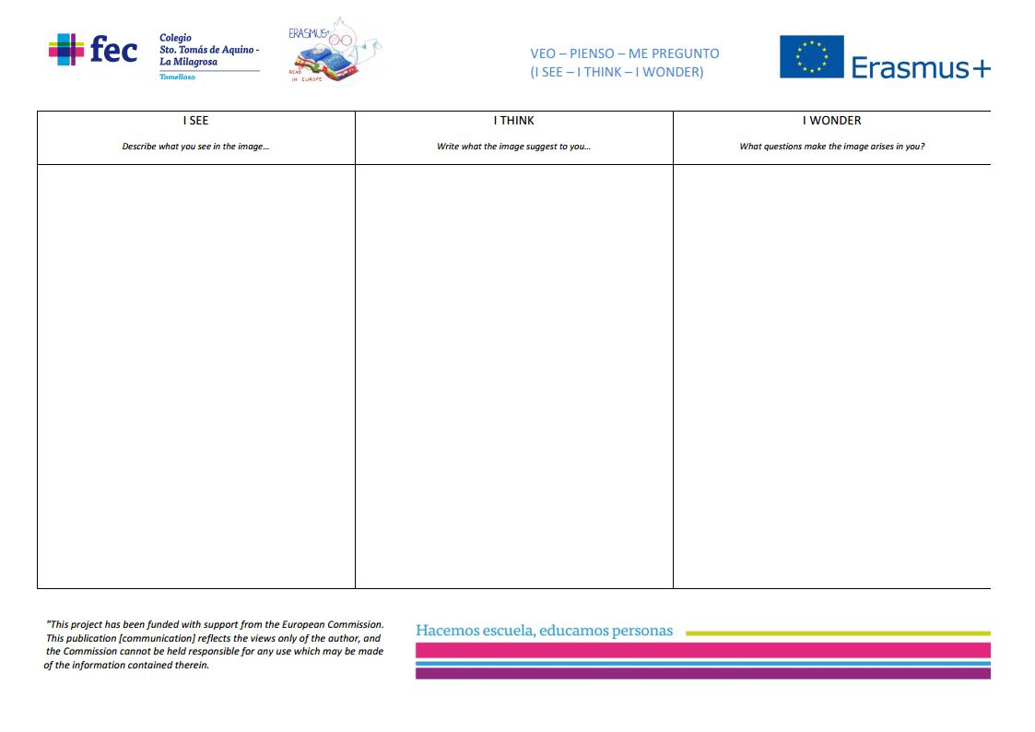
Appendix 9

Appendix 10

master - forest. - slave

Androcles, a __________, is mistreated by his ____________, so attempts to escape by running away into a _____________ .

lion - thorn - stops - red - paw - recaptured -

After a while, he ____________ to rest, but encounters a fiercely roaring ___________. Androcles fears that he will be eaten, but in fact the lion is roaring from the pain of a thorn in its __________. Androcles helps the lion by pulling out the ___________ and washing the wound. Soon afterwards, Androcles is ____________ by his master, and imprisoned. His punishment will be to be _____________ to a lion in the big arena, watched by the Emperador and a large crowd.

Androcles - friendship - lion

However, the lion turns out to be the one that __________had helped, and therefore greets the slave in a friendly way. The Emperor, impressed by the power of their ______________, frees both Androcles and the ____________.

Appendix 11
 | 1 | 2 | 4
Why does Androcles run away into the forest?

Why is the lion roaring when Androcles meets it?

How does Androcles help the lion?

How is Androcles to be punished?

