Short-term exchange of students program Stefanovikeio Greece- May 2019
Date | Program
19.5.2019 (Sunday) | -Hotel check-in/ Dinner ( teachers)  -Students welcomed by host families- dinner ( students)
20.5.2019  (Monday) | 8:00 - Departure for Stefanovikeio (teachers in Volos)  8:40 - School welcome- Logo exhibition in the main hall  9:00 – 13:30  Activity 1: “The power of propaganda as a motivating force in human emotion”  Activity 2: “ Interactive game on stereotypes”  Coffee break  Activity 3: “ Financial crisis workshop as experienced in all partner countries”  Activity 4: “ Interactive game on human rights”  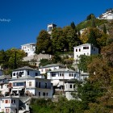  13:30- Music event with a live orchestra - Dances  14:30- Buffet lunch of traditional Greek dishes prepared by host families  15.30- Departure  16.15- Stop at Portaria (Cafe Veranda-panoramic view of Volos)  17.15- Makrinitsa village ( the balcony of Mt. Pelion)  19.30- Departure for Volos- Stefanovikeio  21.00- Dinner at “Gazi Live”with live music ( teachers, students and host families)  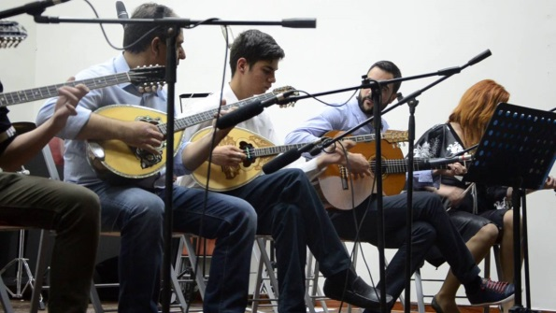
21.5.2019 (Tuesday) | 7:50 – Departure after breakfast for Stefanovikeio ( teachers)  8:30 - Activity 5: “ Polarisation and extremism in the aftermath of financial crises”  10:00 - Departure for the village of Milies  11:15 - Visit to the village square/ Church of Taxiarches ( 1741)  12:45 - Departure for lunch at “ To Aloni” with a view of Pagasitikos Bay  14:15 - Departure for the village of Tsagarada- tour of the village  15:45 - Mylopotamos beach- swimming  18.00- Departure for Volos and Stefanovikeio 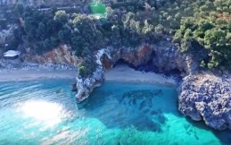  20.30- Dinner
22.5.2019  (Wednesday) | 6:45 - Departure for Stefanovikeio(teachers)  7.15 Departure with students for Achillio port  8:30- Boat cruise to the island of Skopelos  11:30 - Tour of the Chora ( the capital) of Skopelos  14:30 - Departure from Chora towards the beaches-Arrival at the “Kastani” beach  18.30- Departure for Achillio- Bus to Volos and Stefanovikeio  21.30- Dinner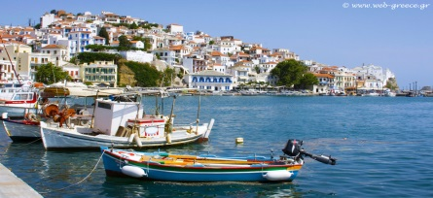
23.5.2019  (Thursday) | 8:00 - Departure for Stefanovikeio (teachers in Volos)  8:40 - Activity 6: “ Disentangling emotional perceptions towards immigration in times of financial crises” ( all partners present public attitudes to immigrants in their countries)  10:00 - Departure for Meteora ( 60-million-year-old rock formations with 14th century monasteries built on top of them)  12.00 - Guided tour of monasteries  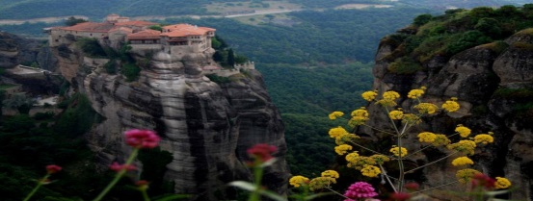  14.00 - Picnic lunch for both teachers and students  15.15- Departure for Stefanovikeio and Volos  20.30- Dinner
24.5.2019 (Friday) | 9.00- Departure for Stefanovikeio (teachers in Volos)  9:45 - Activity 7: “ The emotional imprint of the financial crisis on language” ( all partners present crisis-related vocabulary in their countries and native languages) Certificates of attendance for students and teachers  11:00 - Students’ evaluation of exchange( Google Form)  11.00- Teachers’ coordination meeting- evaluation of the implementation of the project  12.30- Departure for Volos ( teachers) for lunch by the sea- Farewell lunch for students with the host families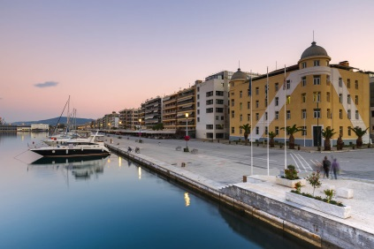  17:00 – Departure for Athens  21.30- Dinner in Athens
25.5.2019  (Saturday) | 9.00- Visit to the Acropolis museum ( guided tour)  10.30- Visit to the Acropolis and the Parthenon ( guided tour)  12.00- Tour of Plaka, the oldest section of Athens  13.00- Lunch at the traditional tavernas of Plaka  14.30- Departure for Stavros Niarchos Foundation Cultural Center  20.00- Dinner at “ Athens Street Food Festival 2019” Gazi ( street food from around the world)
 | 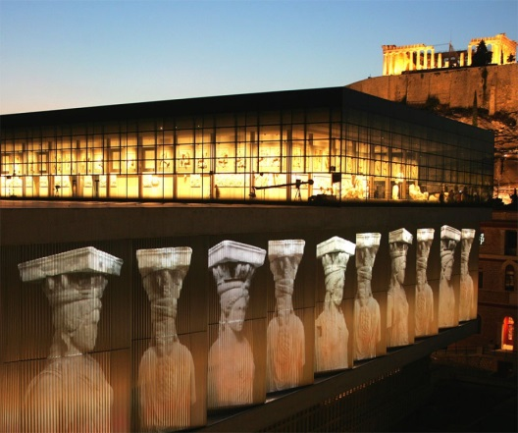
 | Visit to Monastiraki flea market for partners leaving in the afternoon
26.5.2019  ( Sunday) | Departure for the airport- Flights home
PHRASES IN GREEK
- Γειά σου/Γειά σας (giásou/giásas) - Meaning: Hello! But also goodbye.
- Καληνύχτα (kaliníhta)- Meaning: Good night
- Ευχαριστώ/Παρακαλώ (efharistó/parakaló)- Meaning: Thank you/You’re welcome
- Πόσο κάνει ? (Póso káni?)- Meaning: How much is this?
- Το λογαριασμό παρακαλώ (To logariasmó parakaló!)- Meaning: The bill, please!
- Γεια μας! (Yia mas!)- Meaning: Cheers
- Καλή όρεξη! (Kalí órexi)- Meaning: Enjoy your meal!
- Ναι/οχι (Ne/óhi): Yes/No
- Όpa! (when dancing) Ώπα! Opahh!

ENJOY YOUR STAY IN GREECE!

