_____________________________________________________________________________
Aim: to discover words from the ‘Enormous Crocodile’
E | N | O | R | M | O | U | S | E | C
F | O | R | E | S | T | P | K | L | R
R | H | W | G | U | A | O | Y | E | O
O | I | Q | F | N | I | U | O | P | C
A | N | I | M | A | L | S | L | H | O
L | O | T | E | E | T | H | K | A | D
D | A | H | L | A | S | N | B | N | I
Q | W | A | S | X | C | E | A | T | L
H | O | R | R | I | B | L | E | U | E
C | H | I | L | D | R | E | N | Y | Z

Words to find:
ROALD DAHL
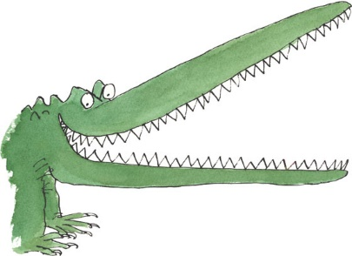
TEETH HORRIBLE
ENORMOUS CROCODILE
CHILDREN FOREST
ANIMALS ELEPHANT
SUN TAIL
SKY EAT

