GOLDEN APPLE CINEMA
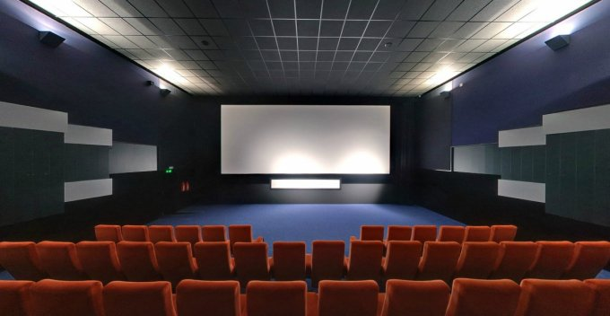
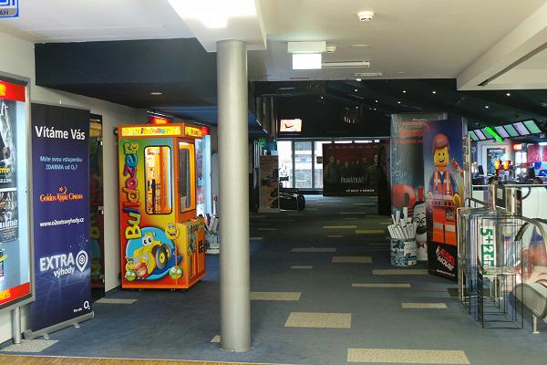
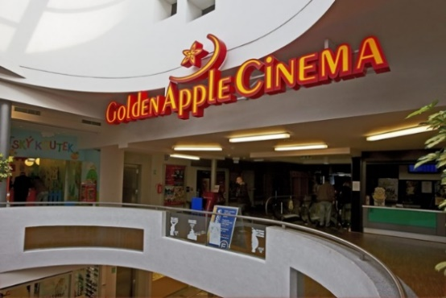
Golden apple cinema is in the heart of the city, in the shopping center Golden Apple. There are six cinema halls. Cinema capacity can be 800 seats. Cinema halls can be rented. There are organized various events. This cinema has got its partner in Liptovsky Mikulas. There can be played films either in 2D or 3D. You cen find there only nice staff. Except interesting films there are various events such as premieres. At the cafeteria you can sometimes find cups with the film character design.

