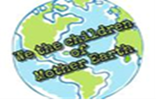

CULTURAL HERITAGE SITES AYDIN – TURKEY
EPHESUS
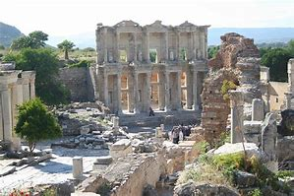
Ephesus which was established as a port, was used to be the most important commercial centre. It played a great role in the ancient times with its strategic location. Ephesus is located on a very fertile valley.
The site of a succession of great ancient civilizations, Ephesus, on the south-west coast of modern Turkey, embodied a peculiarly fertile synthesis of architecture and culture. In 356BC the Greeks built the Artemesium (a colossal Ionic temple dedicated to Artemis the fertility goddess) which was one of the Seven Wonders of the ancient world. During the 2nd century BC, Ephesus was the fourth largest city in the eastern Roman Empire, famous for its Artemesium, the Library of Celsus and its medical school.
Kusadasi is 19 km. far away from Ephesus and Pamucak beach is 5 km far away from Ephesus. The original site of Ancient Ephesus was most likely established on the Aegean coast, on the shores of that sea which is today llocated 8 km. away from the archaeological excavations. 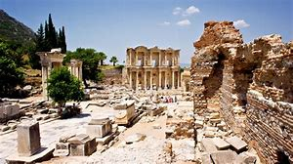
Did you know Ephesus is considered one of the great outdoor museums of Turkey?
Did you know the toilets in Ephesus were ranged side by side with no partition between them?
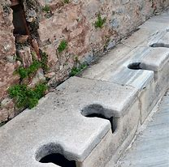
Did you know before the rich people used the toilets their slaves sat and heated toilets’ stone for their masters?
Did you know the ancient Romans knew the true shape of the world even back in the 1st century AD? It can be understood from the round shape on which one foot of Emperor Trajan is resting, symbolized his rule of the world.
Did you know the facade of Celsus Library has 2 stories but the interior facade has 3 stories because of original architecture?
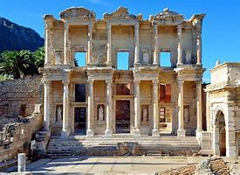
Did you know the Celsus Library in Ephesus was the third largest library with the capacity of 12,000 scrolls after the Alexandra and Pergamum?
Did you know one of the early philosophers Heraclitus was born in Ephesus and his famous motto that an individual can and can not step into the same river twice?
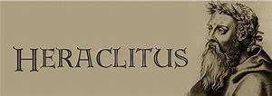

Did you know the first church dedicated to Virgin Mary is in Ephesus?
Did you know Ephesus which was once a seaport is now 6 miles away from the sea?
Did you know that The Virgin Mary lived her last years of her life in Turkey, here in a small cottage near Ephesus?
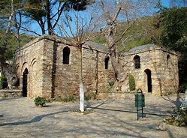
Did you know The Virgin Mary’s house in Ephesus is visited by Pope the 6th Paul and Pope Jean Paul as well?
Did you know The Third Ecumenical Council convened in the Church of the Virgin Mary? The same church is also known as one of the seven churches of the Apocalypse?
Did you know one of the seven wonders of the antiquity, Temple of Artemis, is at Ephesus?
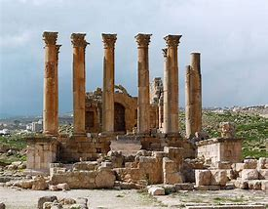
Did you know one of the seven wonders of the world is believed to be rebuilt 7 times?

Did you know St. Paul the Apostle was born in Tarsus, in southeast of Turkey, gave lecture in the Tyrannus Hall and the synagogue in Ephesus for two years in his third missionary journey? (Acts 19:8,9)
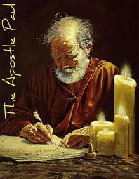
Did you know that the columns of Artemis was 30 meters high?
Did you know Artemis Temple covers an area of 125meters by 60meters, as big as a soccer field?
Did you know the first advertisement of the antiquity, which shows the way to the brothel, is on the Marbel Street in Ephesus?
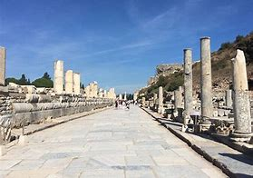
Did you know that The Marble Street is 800 meters long and Curetes Street is 1km long?

Did you know The Grand Theatre in Ephesus has seating capacity of 24000 and a high of 38meters?
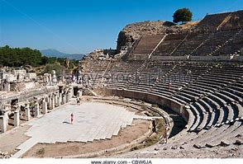
Did you know 7 Christians who fled Ephesus is believed to have slept in a cave near Ephesus for 200 years?
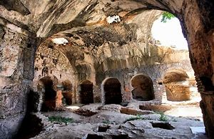
Did you know Ephesus is the best preserved classical city of the Eastern Mediterranean, and among the best places in the world enabling one to genuinely soak in the atmosphere of Roman times?
