CULTURAL HERITAGE
ROMANIA

Churches of Moldavia
These eight churches of northern Moldavia, built from the late 15th century to the late 16th century, their external walls covered in fresco paintings, are masterpieces inspired by Byzantine art. They are authentic and particularly well preserved. Far from being mere wall decorations, the paintings form a systematic covering on all the facades and represent complete cycles of religious themes.Their exceptional composition, the elegance of the characters, and the harmony of the colors blend perfectly with the surrounding countryside. The interior and exterior walls of the Church of the Suceviţa Monastery are entirely decorated with mural paintings of the 16th century, and this church is the only one to show a representation of the ladder of St John Climacus.

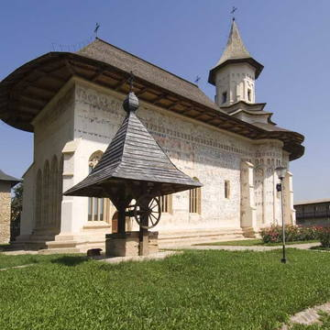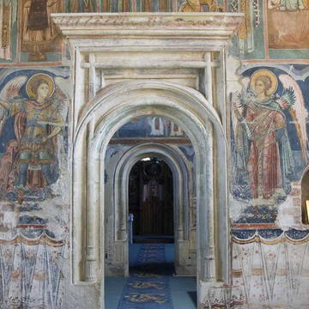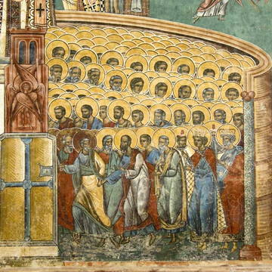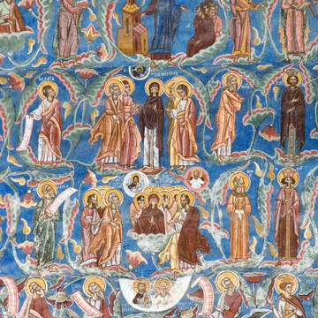

Sourcehttp://whc.unesco.org/en/list/598

Villages with Fortified Churches in Transylvania
These Transylvanian villages with their fortified churches provide a vivid picture of the cultural landscape of southern Transylvania. The seven villages inscribed, founded by the Transylvanian Saxons, are characterized by a specific land-use system, settlement pattern and organization of the family farmstead that have been preserved since the late Middle Ages. They are dominated by their fortified churches, which illustrate building styles from the 13th to the 16th century.

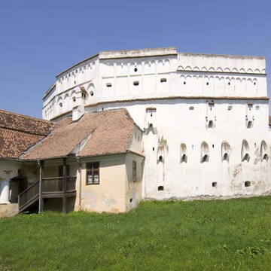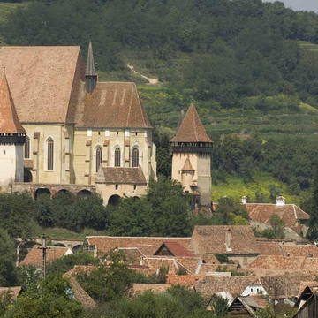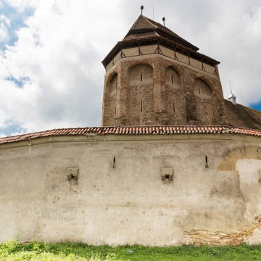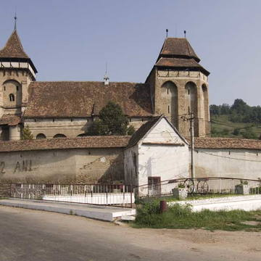
Sourcehttp://whc.unesco.org/en/list/596

Dacian Fortresses of the Orastie Mountains
Built in the 1st centuries B.C. and A.D. under Dacian rule, these fortresses show an unusual fusion of military and religious architectural techniques and concepts from the classical world and the late European Iron Age. The six defensive works, the nucleus of the Dacian Kingdom, were conquered by the Romans at the beginning of the 2nd century A.D.; their extensive and well-preserved remains stand in spectacular natural surroundings and give a dramatic picture of a vigorous and innovative civilization.

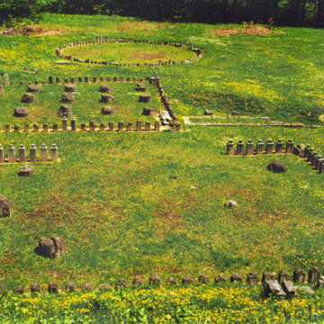
Sourcehttp://whc.unesco.org/en/list/906/

Historic Centre of Sighişoara
Founded by German craftsmen and merchants known as the Saxons of Transylvania, Sighişoara is a fine example of a small, fortified medieval town which played an important strategic and commercial role on the fringes of central Europe for several centuries.

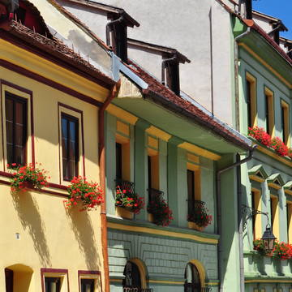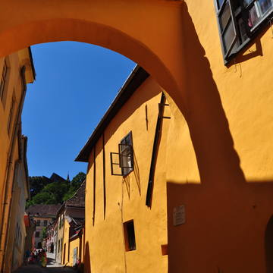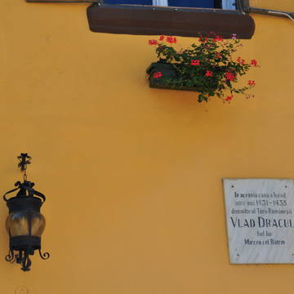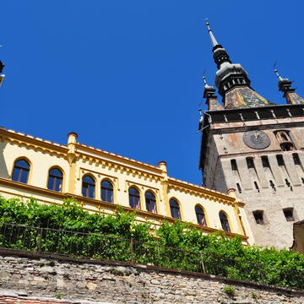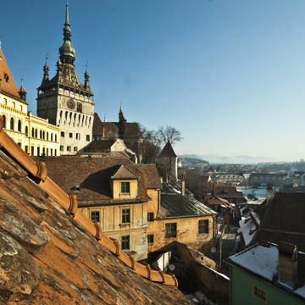

Justification for Inscription
Criterion (iii):Sighisoara is an outstanding testimony to the culture of the Transylvanian Saxons, a culture that is coming to a close after 850 years and will continue to exist only through its architectural and urban monuments.

Sourcehttp://whc.unesco.org/en/list/902/

