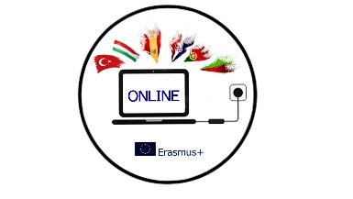

MINUTES
THE TEACHERS' MEETING OF ERASMUS+ PROJECT OUR NEW INNOVATIVE NETWORK FOR EDUCATION
Malaga, 18/02/2022

Attendees: Romana Zelda, Orhan Erdoðan, Rosanna Perillo, Juan Cruz Toledano, Yoana Konstatinova, Helena Ferreira, Dinka Kavalir, Maja Marić Prević

Time: 10:00- 12:00
Agenda:
1 Project outcomes
2 Dissemination activities (blogs, emagazine, boards)
3 Analasys of surveys
4 Etwinning
5 The next mobility
6 AOB

1 The project team discussed the project outcomes and agreed that we will start sharing presentations after the meeting in Spain.
The students and the teachers need to fill in the survey by March 15 and Portuguese team will make analysis of the before the meeting questionnaire and after the meeting questionnaire.
The Spanish team has to make a podcast about their mobility (the content of the podcast will be decided by them) by mid April.
The Spanish team will make a video after each mobility (the content will be decided by them). The video about the mobility in Spain will be done by mid April.
The Italian team has to present the first part for the ebook by mid April. We all have to collect all the materials and share them.
The host country is responsible for creating an emagazine and podcast about the mobility, so Juan and his team will create one by mid April.
The students who participated in the mobility in Spain will write their blogs and send them to Romana who will upload them. The deadline is mid April.

2 Each country will disseminate the mobility in Spain in school, at local and regional levels, and share the results. It can be in the media, school boards/corners, staff meetings, parents’ meetings, and any other way.

3 Analysis of the impact we have at local, regional and international levels will be done by the Bulgarian team, and they will compare the numbers when we started with the meeting and the current situation to see the strengths and weaknesses, and try to see how we can improve. It has to be done by mid April.
Portugal will do analysis of the questionnaires about the mobility in Spain. It has to be done by mid April.

4 The participating students have to fill in Forum part of our eTwinning page.

5 We discussed the following mobility (Italy or Croatia) The programme and the tasks are to be discussed on the following online meeting which will be held soon.

6 All the partners will send the information (name, date of birth) to Romana so she can fill in the mobility tool. It has to be done by the end of February.
Romana asked the partners to fill in the chart with the expenses from the mobility in Spain by mid April.
The next meeting is planned between 28 February and 5 March.

