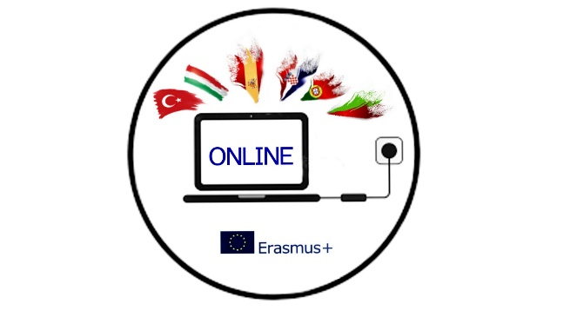

AGENDA FOR THE ONLINE MEETING 3/11/2021 7PM

1 Project outcomes (didactic materials, lesson plans, youtube channel with videos)
2 Dissemination activities (blogs, emagazine, boards)
3 Analasys of surveys
4 Etwinning (involving the students)
5 Mobility to Spain
6 Other mobilities
7 Mobility tool
8 AOB

