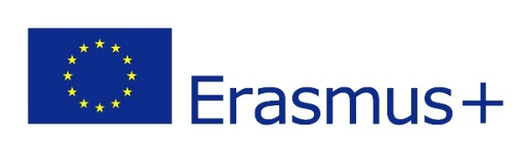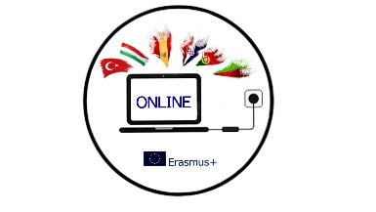

MINUTES
THE ONLINE MEETING OF ERASMUS+ PROJECT OUR NEW INNOVATIVE NETWORK FOR EDUCATION
3/11/2021

Attendees: Romana Zelda, Orhan Erdoðan, Anna Cariello, Rosanna Perillo, Juan Cruz Toledano, Yoana Konstatinova, Helena Ferreira

Time: 19:00- 21:00
Agenda:
1 Project outcomes (didactic materials, lesson plans, youtube channel with videos)
2 Dissemination activities (blogs, emagazine, boards)
3 Analasys of surveys
4 Etwinning (involving the students)
5 Mobility to Spain
6 Other mobilities
7 Mobility tool
8 AOB

1 The project team discussed the project outcomes and agreed that we will start sharing didactic materials from the meeting in Bulgaria.
- Helena will send a template for a lesson plan. The lesson plan has to have objectives, description of the activities, assignments, evaluation). The lesson plans will be uploaded to our google drive by the end of January.
- Each country will prepare a brochure ‘Digital tools used in online learning’ by the end of January.
- Orhan will make our youtube page using the project email and all the videos will be uploaded there.
- Yoana will organize Google drive and we all need to upload all the materials produced there.
- All partners need to scan the certificates from the mobility in Bulgaria and upload them on Google drive by the end of November.
- We all need to make a list of digital tools used so far and used in the classroom or online lessons. Share them in any form you like by the end of January.
- The students need to fill in the survey by November 15 and Portuguese team will make analysis of the before the meeting questionnaire and after the meeting questionnaire.
- The Bulgarian team has to make a podcast about their mobility (the content of the podcast will be decided by them) by the end of January.
- The Spanish team will make a video after each mobility (the content will be decided by them) and the final video. The first video about the mobility in Bulgaria will be done by the end of January.
- The Italian team has to start collecting materials for the ebook, which will include all important materials produced. We have to decide which app to use. Helena suggested using CoSpace. We will all participate and share materials. The first version of our ebook has to be done by the end of January.
- We all have to collect all the learning games we use during the project and share them.

2. The host country is responsible for creating an emagazine about the mobility, so Yoana and her team will create one by the end of December. Each country can choose the app they like for creating one. The magazine should include all important parts of the mobility, some interviews, students’ opinions.
The students who participated in the mobility in Bulgaria will write their blogs and send them to Romana who will upload them. The deadline is November 15.
Each country will disseminate the mobility in Bulgaria in school, at local and regional levels, and share the results. It can be in the media, school boards/corners, staff meetings, parents’ meetings, and any other way.

3 Analysis of the impact we have at local, regional and international levels will be done by the Bulgarian team, with the Turkish team, and they will compare the numbers when we started with the meeting and the current situation to see the strengths and weaknesses, and try to see how we can improve. It has to be done by the end of January.
Portugal will do analysis of the questionnaires about the mobility in Bulgaria. It has to be done by the end of January.

4 We all agreed that although we are all happy with our eTwinning page, it is essential to get all of our participating students on our twinspace and engage them in different activities. Romana suggested some of the activities done within her other eTwinning project like Name game, Nice to meet you, My advent calender, etc. Orhan will organize the activities and we will all invite our students to eTwinning by the beginning of December and involve them in these activities.

5 Juan and his team have already started planning the mobility to Spain (confirmed dates are 14/2-19/2, including travel dates). Juan already has an outline of the programme, and Juan and Romana will constantly keep in touch to discuss the details and workshops planned. The partners have to prepare a presentation (in any form they want) on cultural and natural heritage of their region or their country. When they have done their presentation, they will send 4 questions related to their presentation to Orhan, who will make a common Kahoot quiz for the students.
Romana reminded everyone to try to plan within the budget and bring more students/teachers if their budget allows that. The budget for Italy and Portugal is 3.691,00 EUR, and for Croatia, Turkey and Bulgaria it is 4.116,00 EUR.

6 It has been agreed that the mobility to Italy will be held from 19/5 – 24/5.

7 All the partners will send the information (name, date of birth) to Romana so she can fill in the mobility tool. It has to be done by the end of November.

8 Romana asked the partners to fill in the chart with the expenses from the mobility in Bulgaria by the end of November.
The next meeting is planned between 11-15 December.

