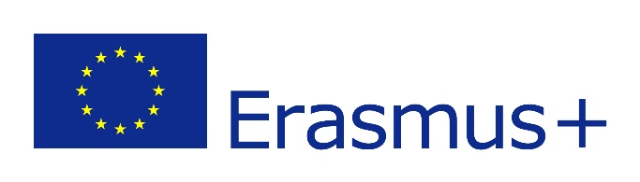

MINUTES
THE 3RD ONLINE MEETING OF ERASMUS+ PROJECT OUR NEW INNOVATIVE NETWORK FOR EDUCATION
3/06/2021

Attendees: Romana Zelda, Orhan Erdoðan, Helena Ferreira, Anna Cariello, Rosanna Perillo, Juan Cruz Toledano, Yoana Konstatinova

Time: 19:00- 20:00 Brussel’s time
Agenda:
1 Online meeting with students
2 Logo competition
3 Mobility to Bulgaria
4 AOB

1 All the partners agreed to hold the first online meeting with the students on Tuesday, 15 July 2021. During the meeting there should be 2 teachers and 2 students involved in the project, and they should present themselves shortly.
2 We all need to send two logos chosen in our countries for Facebook and Instagram posts by next Friday 11 July the latest. We will have a logo competition during the meeting with the students. 3 students and 2 teachers from each country will vote. We are going to use google form for the competition. Helena will make a chart and the participants will not be able to vote for their own logos.
3 Mobility for the teachers meeting to Bulgaria is set for 22 July, arrival day, to 27 July, departure day. The Bulgarian team will prepare a program for 4 days. We will discuss and plan the mobility with students for October.

