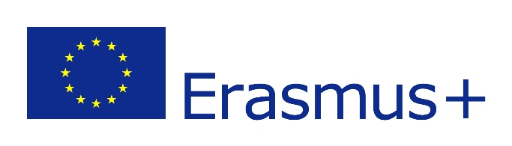
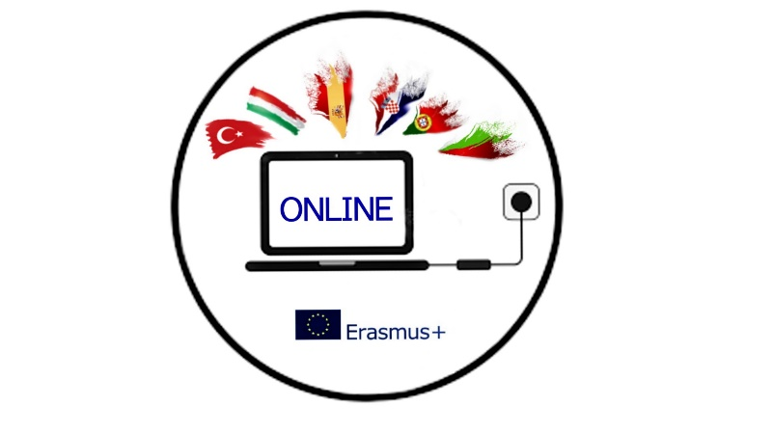

MINUTES
ONLINE MEETING OF ERASMUS+ PROJECT OUR NEW INNOVATIVE NETWORK FOR EDUCATION
4/09/2021

Attendees: Romana Zelda, Orhan Erdoðan, Helena Ferreira, Anna Cariello, Rosanna Perillo, Juan Cruz Toledano, Yoana Konstatinova

Time: 20:15- 21:20 Brussel’s time
Agenda:
1 Mobility to Bulgaria
2 Project tasks for the Bulgarian mobility
3 Erasmus Days

1 After exchanging the information about the situation in our countries related to the beginning of the school year and covid, all the partners agreed that we will continue as planned to organize the first short-term exchange of students and teachers in Bulgaria. We all agreed to adjust the dates to October 13-16. The arrival date should be October 12, the departure date October 17, or the partners can choose the most economical solution for them. Turkey and Croatia are planning to take 4 students and 2 teachers, and the other partners 3 or 4 students and 2 teachers, if the flight tickets are not too expensive. We all agree that we cannot travel with only 1 accompanying teacher as it is advisable to have at least 2 teachers in this situation.
Yoana will prepare invitation letters and the program, and also suggest 2 hotels where we can be accommodated. She will see how many Bulgarian students are willing to host, as we are aware of the benefits that hosting has, but in this situation with the rise in number of covid cases we might opt for the hotel solution.
The other partners will have Erasmus club meetings with their students and teachers to see how many students will apply for the mobility and then decide on the criteria how to choose the ones to travel.
All partners will send an email to their National Agencies to inform them about the mobility and to check if they encourage us to carry on with physical mobilities in partner countries and at home.

2 All partners will have to present their schools, towns, countries. Presentations can be made in any form like PPP or video or poster, but they have to be done and presented by the participating students. The students participating in the mobility as well as all participating students will fill in the survey about their current knowledge on the safety on the internet. The participating students will also have to prepare a poster or a brochure on the risks of the internet use and share their experience.
Evaluation form before and after the mobility will be shared by Helena.

3 Helena suggested celebrating Erasmus Days while we are in Bulgaria, and we all loved the idea, so we basically agreed on what to do. Yoana will register the event as her school will be hosting all of us at that time. The topic is Inclusion so we will all think of some activities we can do during our mobility and we will have to put them together by the end of September. We are going to organize a live event on October 15, showing what we have done, and each team will prepare a performance (dance, song, play…) that will be live streamed on our Facebook project site. This way, we will also disseminate the project activities on international level.
For that evening, the Bulgarian students and their parents will prepare their local dishes, while the partners will bring some sweets from their countries to have an international meal.

