Ajka
Ajka in a small town in Hungary, north-west of Lake Balaton. It is situated in the hills of Bakony, it has about 35,000 inhabitants.
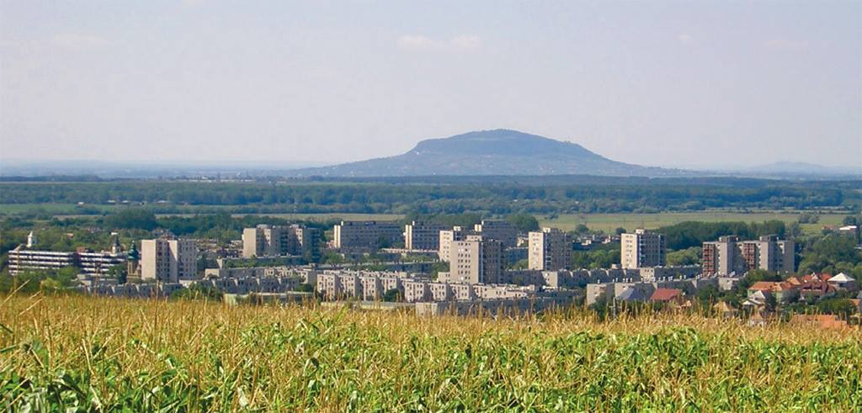
It used to be a town with mines (The first picture shows the mine museum).
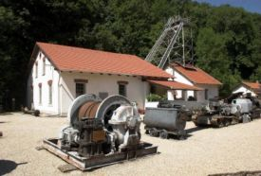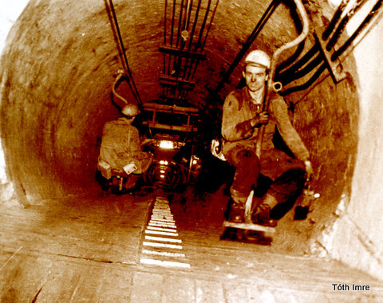

The settlement developed slowly during the first centuries. Prosperity came only in the 19th century when coal resources were found nearby. In the 1930s bauxite resources were found, too. In 1937 the world’s first krypton factory was built here.

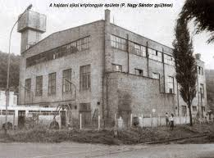
There are many churches, statues and museums. The most famous is the crystal museum next to the world-famous crystal works.
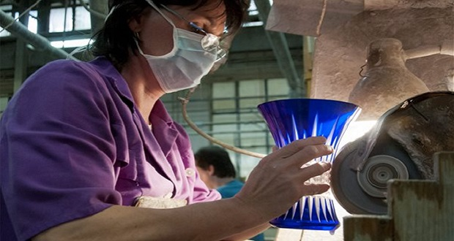

Ajka was the birthplace and the hometown of some famous Hungarians like the writer István Fekete and the traveller Gábor Molnár.
In the middle of the town there is a lake and an island where István Fekete’s statue and some of his animal figures can be visited.

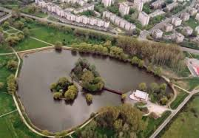
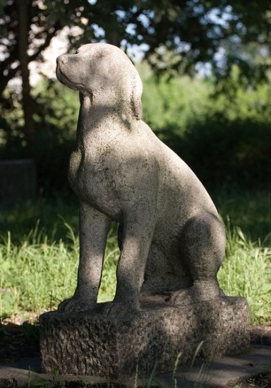

Ajka is famous for mining, you can visit a mining and a palaeontolgy museum.
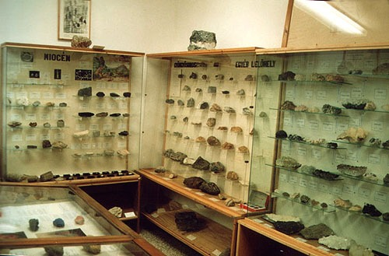

When bauxite was found, they built an alumina factory and an aluminum smelter. To serve them they created the power plant. Thus in the seventies it became an industrial town.

It became a town in 1960.

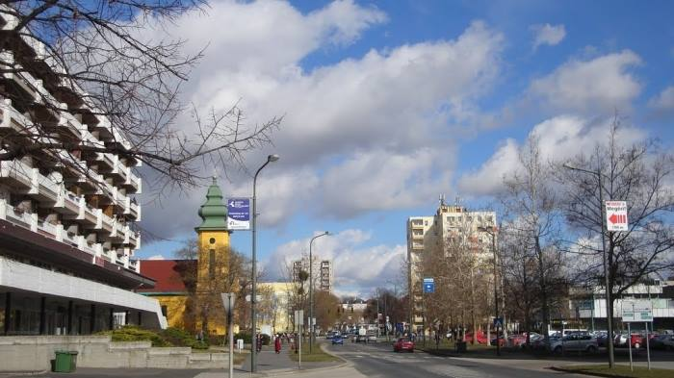

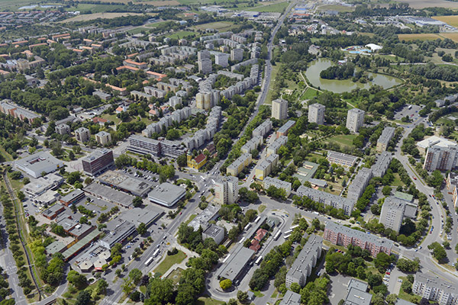
Today Ajka is the unification of several villages and suburban areas.

The town is twinned to Rovaniemi (Finland), Unna (Germany), Weiz (Austria) and Cristuru Secuiesc (Romania).

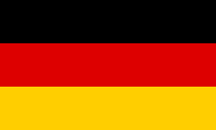

If you come to Hungary, you mustn’t miss Lake Balaton and Ajka!

