pH Scale

- Acidic and basic are two extremes that describe a chemical property chemicals. Mixing acids and bases can cancel out or neutralize their extreme effects. A substance that is neither acidic nor basic is neutral.
- The pH scale measures how acidic or basic a substance is.
- The pH scale ranges from 0 to 14.
- A pH of 7 is neutral.
- A pH less than 7 is acidic.
- A pH greater than 7 is basic.
The pH inside human cells (6.8) and the pH of blood (7.4) are both very close to neutral. Extreme pH values, either above or below 7.0, are usually considered unfavorable for life.

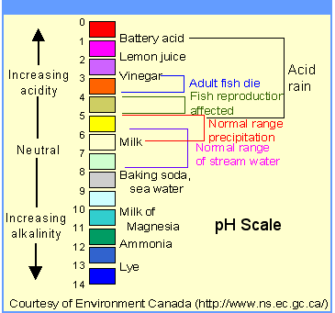

Student Objectives

- Use supporting evidence to predict if common household substances are acids or bases.
- Determine the pH of the substances.
- Describe the results of the investigation and characteristics of each substance.
Materials

- pH meter (if available)
- plastic cups (to hold the materials to be tested)
- distilled water
- lemon juice
- vinegar
- baking soda
- ammonia
- phenolphthalein (if available)
Procedure
. One student from each group can come up to a central area to collect the materials, or you can hand out the materials to each group. Each group will need the following materials:
- samples of these materials in a cup: distilled water, lemon juice, vinegar, baking soda, and ammonia
- pH meter (if available)
- Tell students that they are going to measure the pH of common household substances to determine if they are acids or bases. Explain that pH is measured on a scale of 0-14. Substances with a pH lower than 7 are acids; those with a pH higher than 7 are bases; and a substance with a pH of 7 is neutral
- In laboratory settings, a pH meter is used to measure the pH of a liquid. The probes of the pH meter are simply dipped into the liquid and the pH level is given on a digital screen. This is a much more precise measurement of pH than using pH papers.
- Determine the pH of each material. Record the pH on a chart, indicating whether the material is an acid or a base.
- Students may present their findings to their classmates and compare their results
Observations

Natural Fruit and Vegetable Indicators | pH meter
Apple skin (Red)
Red cabbage
Potatoes juice
Lemon juice
Oranges
Red onions
Milk
Peanut butter
Tea
Vinegar
Water drinking
Tomatoes
Meat
Cucumber

Context: Soap and other bases have a bitter taste, feel slippery to the touch, and do not react when combined with most metals.
indicator
Definition: A material that has the property of changing color in the presence of an acid or a base
Context: Litmus paper is an indicator; it turns from blue to red in the presence of an acid and from red to blue in the presence of a base.
pH
Definition: A scale that measures the concentration of hydrogen ions in a solution
Context: In general, acids have a pH below 7; bases a pH above 7; and neutral solutions a pH of

