Jean Sibelius
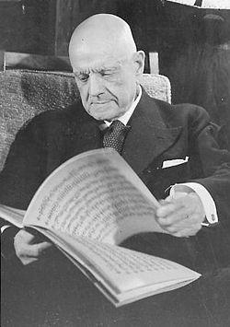

His name is Johan Julius Christian ”Jean” Sibelius. He was born in 8th of December in 1865. He died in 20th September in 1957. His career was classical music composer. His spouse was Aino Sibelius (Järnefelt). Then he started law studies. He learned one year and stopped it, because music took all his time. Then he got married with Aino. They got 6 girls: Eva, Ruth, Kirsi-Maria, Katarina, Margareta and Heidi. In the beginning of 1910 he did several concert trips to other countries. His famous arts is ”Finlandia-hymni” and ”Sydämeni laulu”.

