Subject: Science
Topic: Water Purification
Objective / Contents: To teach children the process of Water Purification.
Methodology:
Definition of Water Purification, Why do we need to purify water, will be answered. There are 3 main steps for Water Purification:
Explanation through a experiment.
Aim: To purify the given water.
Apparatus: Funnel, Glass beakers, bottle.
Materials: Filter paper, water, mud.
Method:
• Take some muddy water in an old bottle, shake it vigorously, leave it for a day.
• Next day the water in the bottle can be clearly demarked as it's on the top and the mud and dust particles have settled (sediment) down. This is the 1st step of water purification i.e. Sedimentation. Insert fig 1*
• Now without shaking decant (remove) the water layer into a glass beaker. This is the 2nd step of water purification i.e. Decantation. Insert fig 2 **
• Now take a funnel and keep the filter paper in shape of cone, and filter the decanted water in another glass beaker. We will see that water gets filtered in the form of drops in this beaker. This drops together is called as filtrate and the dust particles remaining in the filter paper is called residue/impurities. This is the 3rd step of water purification i.e. Filtration. Insert fig 3 ***
• Note: # Besides the filter paper, sand, gravel, clay , cotton and cloth are also used as
filtering agents.
# The water still is not free from bacteria. These bacteria can be killed by adding
KMNO_{4.}, Chlorine tablets , Alum or by boiling.

Sedimentation and decantation methods are used for the separation of insoluble substances which are heavier than liquid. In the sedimentation process, heavier components of the mixture settle on the bottom, due to gravity. Decantation is followed by sedimentation. The decantation process involves pouring clear, upper liquid out of the container, without disturbing the sediment.
This process of separation of solid impurities from the liquid solution is termed as decantation.
Decantation Definition
Decantation is the process of separation of liquid from solid and other immiscible (non-mixing) liquids, by removing the liquid layer at the top from the layer of solid or liquid below. The process can be carried out by tilting the mixture after pouring out the top layer. This process can also be used to separate two liquids that do not mix with each other for e.g., oil and water. When we leave the mixture of oil and water, two separate layers are formed, with water at the bottom and oil, being lighter, at the top. We can remove the oil layer from the top by pouring it into another vessel, which leaves us with the water layer at the bottom.

Some Mixtures That Can Be Decanted
- Oil and water – oil floats on top of water. Decanting the mixture allows the oil to be poured off the water.
- Dirt and water – muddy water can be cleared up by decanting. The soil will sink to the bottom of the tube allowing the clear water to be poured off.
- Cream and milk – Cream is separated from milk by decantation. Cream rises to the top of the milk mixture and is easily skimmed off.
- Blood and plasma – A centrifuge is necessary for this decantation. Plasma can be removed from blood by decantation.
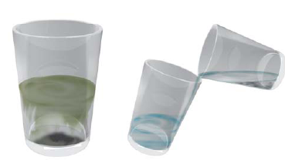
- Let us find a few other mixtures that can be separated through sedimentation and decantation.
- The same principle is used for separating a mixture of two liquids that do not mix with each other. For example, oil and water from their mixture can be separated by this process. If a mixture of such liquids is allowed to stand for some time, they form two separate layers. The component that forms the top layer can then be separated by decantation.
- Let us again consider a mixure of a solid and liquid. After preparing tea, what do you do to remove the tea leaves? Try decantation. It helps a little. But, do you still get a few leaves in your tea? Now, pour the tea through a strainer.

- Did all the tea leaves remain in the strainer? This process is called filtration (Fig. 5.2). Which method of separating tea leaves from prepared tea is better, decantation or filtration?
- Let us now consider the example of water that we use. Do all of us, at all times, get safe water to drink? Sometimes, water supplied through taps may be muddy. The water collected from ponds or rivers may also be muddy, especially after rains. Let us see if we can use some method of separation to remove insoluble impurities like soil from the water.

Activity
- Collect some muddy water from a pond or a river. If it is not available, mix some soil to water in a glass. Let it stand for half an hour. Observe the water carefully and note your observations.
- Does some soil settle at the bottom of water? Why? What will you call this process? Now, slightly tilt the glass without disturbing the water. Let the water from the top flow into another glass (Fig.1). What will you call this process?
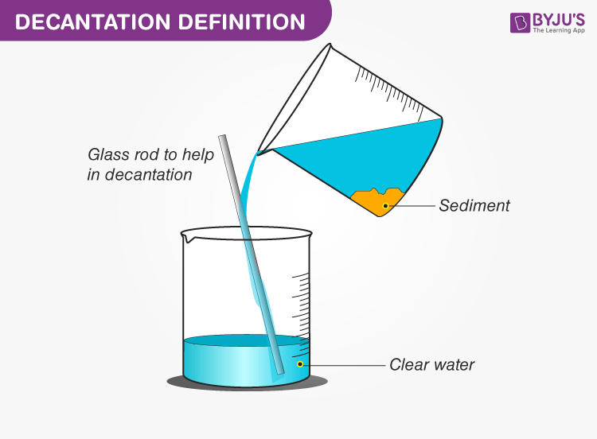
- Is the water in the second glass still muddy or brown in colour? Now filter it. Did the tea strainer work? Let us try filtering the water through a piece of cloth. In a piece of cloth, small holes or pores remain in between the woven threads. These pores in a cloth can be used as a filter.
- If the water is still muddy, impurities can be separated by a filter that has even smaller pores. A filter paper is one such filter that has very fine pores in it. (Fig.2) shows the steps involved in using a filter paper. A filter paper folded in the form of a cone is fixed onto a funnel (Fig.3). The mixture is then poured on the filter paper. Solid particles in the mixture do not pass through it and remain on the filter. Fruit and vegetable juices are usually filtered before drinking to separate the seeds and solid particles of pulp.
- 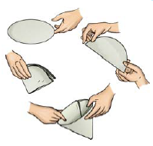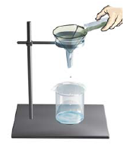
Fig.2

SUMMARY

- In a mixture of sand and water, the heavier sand particles settle down at the bottom and the water can be separated by decantation.
- Filtration can be used to separate components of a mixture of an insoluble solid and a liquid.
Sedimentation: Insoluble particles settle down at the bottom and the process is called sedimentation. For example; muddy water contains soil and sand in water. Soil and sand; being insoluble in water; settle down at bottom if water is allowed to stand for some time.
Decantation: This process is used after sedimentation. The upper layer; which contains water is slowly poured out from the container. It leaves the sediment behind.
Filtration: This method is used for separating fine insoluble solid particles from the liquid. In this process, the mixture is passed through a filter. The solid particles do not pass through the filter and clear liquid is collected.

