Albert Gustaf Aristides Edelfelt (21. July 1854 Porvoo - 18 August 1905 Porvoo) was a Swedish-speaking painter, graphic artist and illustrator. Edelfelt's production ranges from historical paintings and portraits to naturalistic descriptions of ordinary people's lives and impressionist scenes from Paris's urban life and beauty.
Edelfelt is one of the most prominent Finnish painters and artists of the arts who also received international recognition. He actively opened the way for other Finnish artists and younger generations to the golden age. Thanks to Edelfelt, the work of the Finns was at the Paris World Expo in 1900 in his pavilion, not representing the art of the Russian Empire

Edelfelt initially painted historical issues (Queen Blanka and Charles Duchess of Klaus Fleming's body). The style of painting gradually changed from historical romanticism to naturalistic (Childrens' corpse, Ruokolahti eukkaa kirkonmäellä). Later he also painted religious subjects. Edelfelt's most famous paintings are the service of worship in the archipelago, at sea, in the park in Luxembourg, in Christ and in Mataleena, and in the painting of the hall of the University of Helsinki.

Edelfelt also painted a lot of portraits, such as portraits of Louis Pasteur, Aino Ackté and Nikolai II. Many of them are, at that time, fashionable mood photographs in which the model was presented in its natural environment. Edelfel was skilled to bring out the best of its models.

He attended the exhibition of Russian and Finnish artists in St. Petersburg and Mir Iskusstva's international exhibition in St. Petersburg in 1899.

In addition to the paintwork, Edelfelt was a graphic artist and illustrator. In the 1890s he painted the stories of Vänrikki Stoolin, a poet's collection of Johan Ludwig Runeberg's Finnish War (1808-1809)

Older Edelfelt approached some impressionist. Larin Parasken's portrait was a step towards Karelianism, but when a group of impetuous young Finns took the development of Finnish art into his own direction, Edelfelt moved from the lead character of the country's art to a younger-looking role. He supported and encouraged, for example, Magnus Enckell and Juho Rissas.

Edelfelt is known to have had good relations with Russia and the Caucasus family, but they have not been spoken in public. The affair was confirmed when in 2017 Russia's museum of the Rybinsk city was found in Edelfelt's painting depicting the emperor Aleksander III's Grand Duke Vladimir's sons. Finland had been entrusted with the fact that the painting has disappeared.

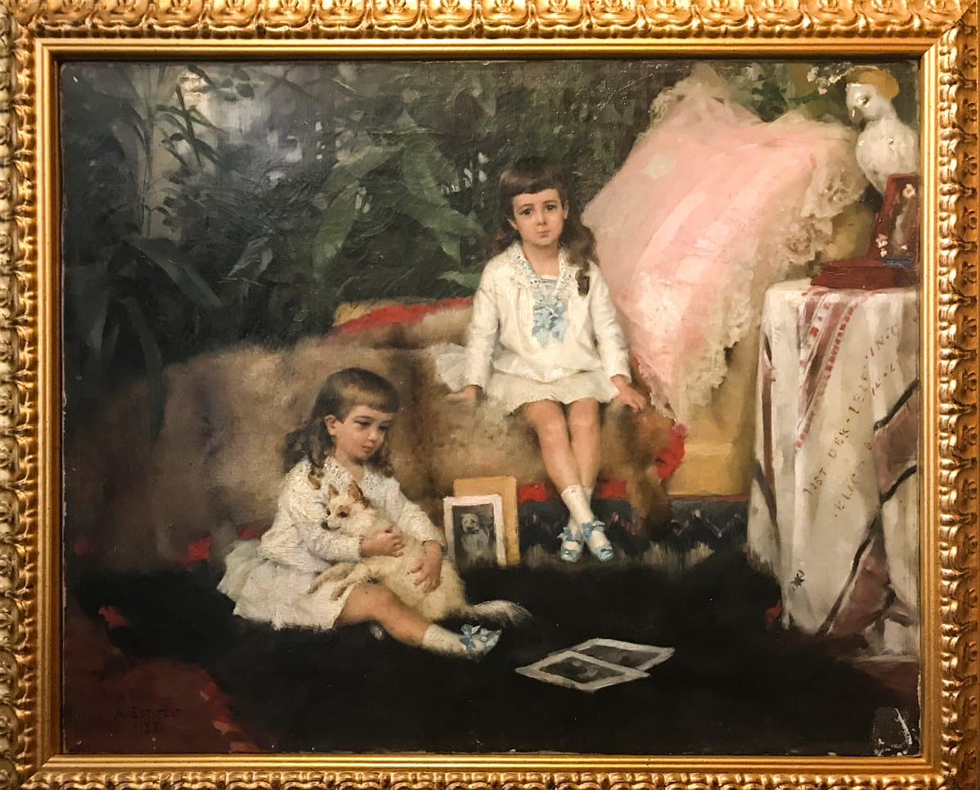
Albert’s disappeared painting
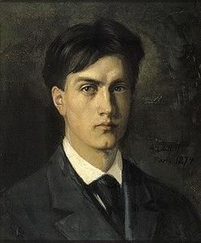
Albert in 1874.

