SOME GREEK TRADITIONAL INSTRUMENTS
- Cretan lyre: Its characteristic is its half-pear speaker. It is played in Crete as well as in many islands such as Dodecanese and Ikaria.
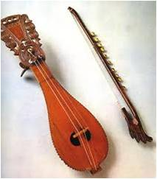
https://laikiparadosi.webnode.gr/_files/200000154-2cdea2dd8e/23%20%CE%9A%CE%A1%CE%97%CE%A4%CE%99%CE%9A%CE%97%20%CE%9B%CE%A5%CE%A1%CE%91.mp3
- Pontiac lyre: It is played by the Greeks of Pontos and Kappadocia. It has got three chords and its characteristic is its bottle shaped speaker.
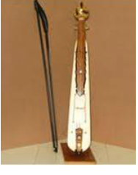
https://laikiparadosi.webnode.gr/_files/200000158-6eb986fb67/27%20%CE%A0%CE%9F%CE%9D%CE%A4.%CE%9B%CE%A5%CE%A1%CE%91.mp3
- Zither: The sound is produced if we hit the instrument with two batons. It became known in Greece by the Greeks of Asia Minor. It is played on mainland and in the islands.

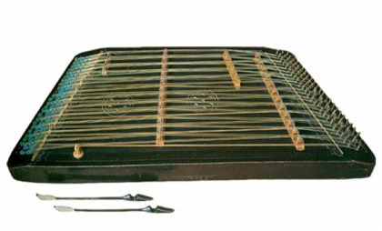
https://laikiparadosi.webnode.gr/_files/200000156-5a5455c446/25%20%CE%A3%CE%91%CE%9D%CE%A4%CE%9F%CE%A5%CE%A1%CE%99.mp3

- Lute: Its characteristic is its half-pear speaker and the fold-up tuning peg. Its plectrum is usually made by the feathers of an eagle, a hawk or a vulture.
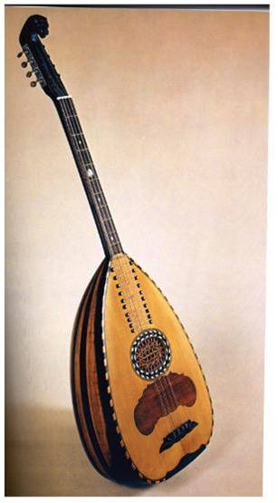
https://laikiparadosi.webnode.gr/_files/200000152-0dbaf0eb7a/21%20%CE%9B%CE%91%CE%9F%CE%A5%CE%A4%CE%9F.mp3
- Tabor: It has two membranes which are attached to the wooden skeleton of the instrument. It is played with two wooden sticks: the rod which is thin and the muller which is big.
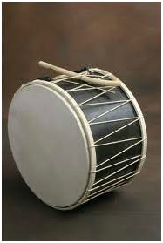
https://laikiparadosi.webnode.gr/_files/200000161-44a3c459aa/32%20%CE%9D%CE%A4%CE%91%CE%9F%CE%A5%CE%9B%CE%99.mp3
- Bagpipe: We can find it in the islands. It has two pipes: the mouthpiece from where we blow and the reed flutes where the fingers go.
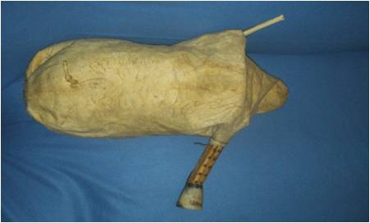
https://laikiparadosi.webnode.gr/_files/200000164-3a6d13b67b/tsampouna_mp3.mp3

