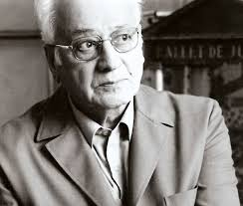

George Zoggolopoulos

The sculptor George Zoggolopoulos was born in Athens in 1903.
He studied at the Athens School of Fine Arts.
In 1949 he went to France on a scholarship by the French government and continued his studies on sculpture. He worked in Marcel Gimond’s workshop. He stayed in Paris for more than twenty years.
The “eternal teenager” as he was called looked for harmony and metre in his art. He received many awards as an artist. His works decorate important public places in Greece, Europe, America as well as Greek, foreign collections and museums.
He died in 2004.
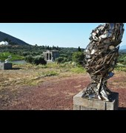
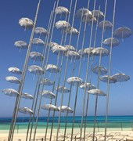

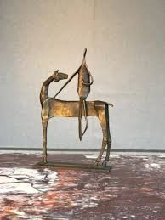
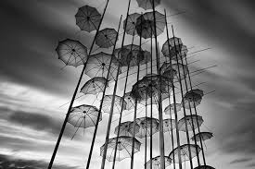
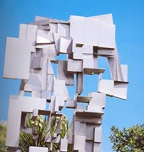
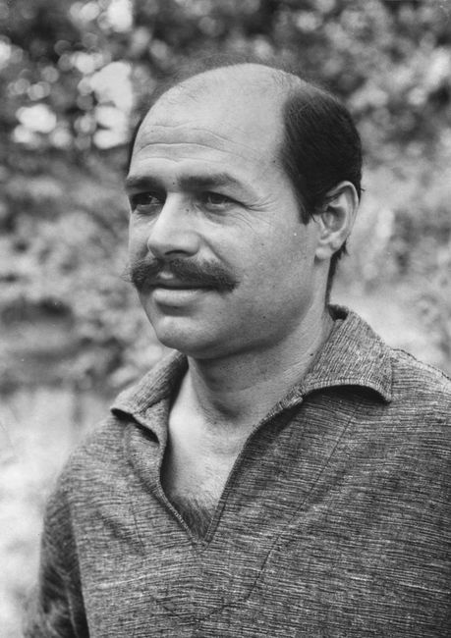

Yiannis Gaitis

He was born in 1923.
He studied at the Athens School of Fine Arts. One of his teachers was Konstantinos Parthenis.
In 1949 he took part with other artists in founding the artistic team of the so called “Extremists”. Its members dealt with abstract art.
In 1954 he went to Paris where he studied in the Academy Grande Chaumiere. At the same time he exhibited his work in Athens and Paris.
In 1967 he presented “The Little Men” which is a typical trait of his work. “The Little Men” were used as a means for irony and social criticism.
He died in 1984.

